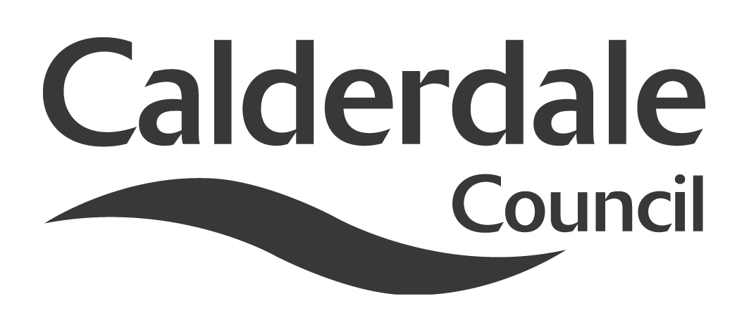
8(b)

Report to Use of Resources Scrutiny Panel
Meeting Date | Wednesday 22 August 2012
Subject | Shared Services
Wards Affected | All
Report of | Head of Finance
Type of Item  (please tick✓ ) | Review existing policy
Type of Item  (please tick✓ ) | Development of new policy
Type of Item  (please tick✓ ) | Performance management (inc. financial) | ✓
Type of Item  (please tick✓ ) | Briefing (inc. potential areas for scrutiny)
Type of Item  (please tick✓ ) | Statutory consultation
Type of Item  (please tick✓ ) | Council request
Type of Item  (please tick✓ ) | Cabinet request
Type of Item  (please tick✓ ) | Member request for scrutiny

Why is it coming here?
Use of Resources Scrutiny Panel asked for an update on progress with the development of shared services

What are the key points?
The report summarises the current position in relation to West Yorkshire wide initiatives on shared services and collaborative working.

Possible courses of action
The Scrutiny Panel may wish to:

- Note progress with the development of shared services and performance on achieving the savings target from these initiatives

Contact Officer
Nigel Broadbent
Assistant Head of Finance
Nigel.broadbent@calderdale.gov.uk
Tel. 01422 393505

Should this report be exempt?
No

Report to Use of Resources Scrutiny Panel
Shared Services

- Background

1.1 Use of Resources Scrutiny Panel considered a report on progress with the development of shared services at its meeting on 5th April 2012. A further progress report has subsequently been requested by the Chair of the Scrutiny Panel to update Panel members, including new members, on the current position.

1.2 As part of the Budget agreed in February 2011, Council decided to find £1million savings in £2012/13 and £1.5million in £2013/14. This report also provides an update on progress towards meeting these targets.

1.3 The Association of West Yorkshire Authorities (AWYA) has been working on identifying services where efficiencies could be identified through shared services and shared procurement.

- Main issues for Scrutiny

2.1 The Association of West Yorkshire Authorities has been considering the opportunities for shared services in the following areas as reported to the Use of Resources Scrutiny Panel at the April meeting:

- Joint Commissioning of Independent Children’s Residential Accommodation and Fostering Placements
- Legal Services – Collaborative Working and Shared Services
- HR Joint Working across West Yorkshire

2.2 Details of the latest position on the shared service work being undertaken across West Yorkshire have been circulated with the agenda. The information below summarises the latest position for Calderdale and looks at the savings achieved to date.

2.3 Joint Commissioning of Independent Children’s Residential Accommodation and Fostering Placements

2.3.1 The five West Yorkshire Authorities have been working, with Doncaster Council, on developing joint commissioning arrangements for independent children’s residential accommodation and fostering placements.

2.3.2 The tender for the fostering framework contract has been evaluated and will become operational from November 2012. An implementation plan for each authority to use the framework to ensure consistency across the authorities is being led by officers from Bradford MDC.
As well as the focus on price, there has been an emphasis on improving outcomes for children young people by developing joint arrangements for monitoring quality. A Quality Assurance Framework has been developed that local authorities will utilise to assess the quality of provision provided, that will ensure that providers that score highly will secure more placements. Mutual Assurance mechanisms developed will ensure that improved quality contract management and quality assurance will be secured from each authority leading on particular providers.
On the first anniversary of the framework agreement there is an option for other authorities from the region to join.
2.3.3 The residential framework agreement and the specification are still in development. Significant interest from other local authorities has been generated in the approach developed. This has resulted in Sheffield, Rotherham and Barnsley becoming associate members of the residential framework. This will significantly increase the purchasing power of the group. These authorities, like Doncaster have secured the necessary authority to ensure that the tender process is not delayed. It is expected that the invitation to tender for this contract will be made in October 2012 and will be operational early next year.
2.3.4 It is too early to say what the outcome of this collaborative approach might be in financial terms but a 5% saving would equate to more than £300k for Calderdale’s Children & Young People’s services.

2.4 Legal Services

2.4.1 The WYLaw Board has been set up with agreed terms of reference and has met regularly to agree and monitor the individual work streams and ensure cashable/non cashable savings are achieved and recorded. The memorandum of understanding was agreed and signed off in July 2011.

2.4.2 The main benefits of the collaboration to date have been:

- A Framework Agreement has been entered into for Counsel on behalf of all five authorities – and they are now going through a similar procurement process for panels of solicitors.

- Additional in house staff have been or are being recruited to reduce spend on agency staff.

- A shared costs draftsman post has been appointed to in Leeds.

- Shared work on the new Standards arrangements, Localism Act, Police and Crime Panels, legal advice to Independent Reviewing Officers and Independent Management Reviews and training for Members.

- A common database set up on GovX to share information, reports, documents etc.

2.5 Human Resources Services

2.5.1 Consideration has been given to examining shared services in the areas of pension advice (as opposed to administration of the West Yorkshire pension scheme) and human resources transactions.

2.5.2 It was agreed that these options would not be pursued and further collaboration is not, at this stage, envisaged.

2.6 Other collaboration

2.6.1 The Council is continuing to explore and develop collaborative working with other local authorities in the procurement of services and supplies. For example, a new regional framework has been developed for the employment of temporary staff which will deliver savings to services using these staff.

2.6.2 On a much more significant scale, Members will be aware of the collaborative work on waste where the Council is entering into a long term waste treatment solution under a PFI agreement with Bradford Council. The Council also continues to work with other local authorities through its membership and use of the Yorkshire Purchasing Organisation, the Integrated Transport Authority and the Leeds City Region/City Deal.

2.7 Current financial position

2.7.1 As stated above the Council has budgeted to achieve savings through shared services of £1.0m in 2012/13 and £1.5m from 2013/14. In the case of service specific initiatives on collaborative procurement, such as the joint commissioning of children’s residential and fostering placements, any savings realised have generally been retained by the directorate concerned. As savings have been realised through the budget process from our more formal shared service arrangements such as the Integrated Transport Authority, YPO and West Yorkshire Joint Services, these have been attributed to the shared services target.

2.7.2 The current position on savings achieved through this process is shown below:

 | Savings achieved to date
 | 2012/13  £000 | 2013/14  £000 | 2014/15  £000
Integrated Transport Authority | 421 | 386 | 386
YPO | 323 | ? | ?
West Yorkshire Joint Services | 133 | 135 | 149
Total | 877 | 521 | 535

The Integrated Transport Authority saving for 2012/13 includes £68k which has been returned to the Council as the unused element of travel support offered by the Council following the national withdrawal of the Education Maintenance Allowance. The saving attributed to YPO is the ‘dividend’ received in relation to the organisation’s performance in the previous financial year. Clearly the value of any dividends in future years are not known at this stage but could be anticipated based on performance in most recent years.

2.7.3 The table suggests that further savings of around £123k need to be identified in the current year to achieve the budget target. Officers are continuing to explore areas where this might be achieved. In future years there is currently a more significant shortfall even after taking into account the likely dividend from YPO. Again, officers will be continuing to work with the Association of West Yorkshire Authorities and other potential partners to identify other shared service opportunities and efficiencies.

- Appendices

None

- Background documents

Reports to the Association of West Yorkshire Authorities

- Documents available for inspection at

The Town Hall, Halifax, Crossley Street, Halifax, HX1 1UJ

