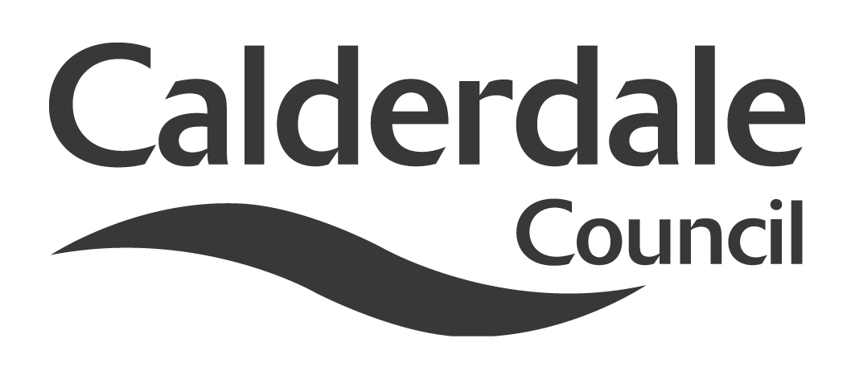
APPENDIX 1

Report to Use of Resources Scrutiny Panel
Meeting Date | Thursday 5 April 2012
Subject | Shared Services
Wards Affected | All
Report of | Senior Scrutiny Support Officer
Type of Item  (please tick✓ ) | Review existing policy | ✓
Type of Item  (please tick✓ ) | Development of new policy
Type of Item  (please tick✓ ) | Performance management (inc. financial)
Type of Item  (please tick✓ ) | Briefing (inc. potential areas for scrutiny)
Type of Item  (please tick✓ ) | Statutory consultation
Type of Item  (please tick✓ ) | Council request
Type of Item  (please tick✓ ) | Cabinet request
Type of Item  (please tick✓ ) | Member request for scrutiny

Why is it coming here?
Use of Resources Scrutiny Panel asked for a report on Shared Services to be considered at a future meeting of the Scrutiny Panel when it met on 12 January 2012

What are the key points?
The report summarises the current position in relation to West Yorkshire wide initiatives on shared services.

Possible courses of action
The Scrutiny Panel may wish to:

- Consider making recommendations on the current activity on shared services
- Making recommendations about actions the Panel may wish to see to ensure that the required budgets savings are achieved.
- Consider making recommendations about other service areas where there may be benefits from sharing services with other organisations

Contact Officer
Mike Lodge
Senior Scrutiny Support Officer
mike.lodge@calderdale.gov.uk
01422 393249

Should this report be exempt?
No

Report to Use of Resources Scrutiny Panel
Shared Services

- Background

1.1 Use of Resources Scrutiny Panel asked for a report on Shared Services to be considered at a future meeting of the Scrutiny Panel when it met on 12 January 2012.

1.2 As part of the Budget agreed in February 2011, Council decided to find £1million savings in £2012/13 and £1.5million in £2013/14.

1.3 The Association of West Yorkshire Authorities (AWYA) has been working on identifying services where efficiencies could be identified through shared services and shared procurement.

1.4 The Fresh Start for Calderdale Programme 2011 identifies “sharing services within the Council, with other local services and Councils” as a priority.

- Main issues for Scrutiny

2.1 The Association of West Yorkshire Authorities has been considering the opportunities for shared services in the following areas:

- Regulatory Services
- Joint Commissioning of Independent Children’s Residential Accommodation and Fostering Placements
- Legal Services – Collaborative Working and Shared Services
- HR Joint Working across West Yorkshire

2.2 Regulatory Services

2.2.1 AWYA has commissioned consultants to examine the opportunities that may arise from a shared service delivery model.

2.2.1 West Yorkshire Chief Executives have advised the West Yorkshire Leaders that a definitive case for shared services has not been made and that there are a number of key issues that a shared service solution would not address:

- Shared services model would not be responsive enough to deal with sensitive local issues and local priorities.
- There is insufficient evidence that any additional benefits will outweigh the costs and potential benefits.
- Issue concerning systems and IT were “undersized” as a problem by the consultants.
- Indicative management structures were too top heavy.
- The consultants had proposed a joint committee model but this would not be the most appropriate approach.

2.2.2 On the basis of Chief Executives advice, Leaders agreed not to pursue a shared service model for Regulatory Services at this time.

2.2.3 However, Leaders have agreed that the professional leads for Building Control should be tasked with reporting to Chief Executives and Leaders on their collaborative progress to date with a view to further formalising and progressing these arrangements.

2.2.4 Leaders have also agreed that the professional leads for Environmental Health, Licensing and Trading Standards should be asked to identify opportunities for increased collaboration, albeit on a less structured basis than a formal shared services model.

2.3 Joint Commissioning of Independent Children’s Residential Accommodation and Fostering Placements

2.3.1 The five West Yorkshire Authorities have been working on developing joint commissioning arrangements for independent children’s residential accommodation and fostering placements.

2.3.2 The objectives are:

- Secure in year discounts, rebates and improvements in the levels of service received (over the next 2 financial years)
- Plan and establish a new joint procurement process (over the next 2 financial years)
- Develop the internal market to reduce dependence on external provision (long term objective)
- Work with external suppliers to re-configure services to better meet the needs of looked after children and to support small and medium sized providers (long term objective.)

2.3.3 Good progress has been made on preparation for procuring both the independent fostering agencies and the residential accommodation frameworks.

Key dates for each of the procurements is set out below

IFA Tender

Market Engagement day 19th March 2012
Commence Tender Process April 2012
Award Tender October 2012

Residential Accommodation Tender

Market Engagement Day April 2012
Commence Tender Process June 2012
Award Tender December 2012

2.3.4 Doncaster Council has indicated that they wish to add their purchasing power to the West Yorkshire exercise. It is also planned to establish the framework agreements so that other Yorkshire and Humber authorities can join the agreement on an annual basis.

2.3.5 There is an anticipated 2.5% saving arising from the fostering negotiations, which equates to over £700,000 across West Yorkshire.

2.4 Legal Services

2.4.1 The WYLaw Board has been set up with agreed terms of reference and has met regularly to agree and monitor the individual work streams and ensure cashable/non cashable savings are achieved and recorded. The memorandum of understanding was agreed and signed off in July 2011.

2.4.2 Budget information is being shared and a central record of individual and collective savings (both cashable and non cashable) is being kept.

2.4.3 All firms of solicitors and Counsels Chambers with existing contracts were asked to review their fees. This resulted in an average reduction in fees rates of 20%. Kirklees undertook a joint procurement process for a panel of barristers on behalf of the West Yorkshire Authorities, which saved on the procurement process and the rates achieved by the combined purchasing power were also more competitive. Before work is outsourced enquiries are made first as to whether it can be picked up by one of the other authorities and on some occasions this has been possible. Agency staff have been replaced where possible which has reduced costs but there are difficulties in recruiting to some areas of work e.g. child care.

2.4.4 Discussions on demand management and quality have taken place with team leaders and examples of good practice shared. A workshop on this issue is planned for spring 2012.

2.4.5 The shared costs draftsman resource has been agreed and is being hosted by Leeds. Recruitment is underway. The virtual talent pool is being developed on governance issues and more specialist areas such as ICT, advocacy, employment and the use of third party vehicles to deliver services. All new staff are appointed on terms and conditions that they can be required to undertake work for any one of the five West Yorkshire authorities.

2.4.6 Significant savings (up to 35%) have been achieved by rationalising and renegotiating contracts for library and research resources. An electronic hub has been set up, GovX, which is gradually being populated with information e.g. legal services structures, contacts and key reports which can then be used/adapted by other authorities rather than them all having to start from scratch. Examples of such reports are in relation to: Bribery Act, Localism Act, Police and Crime Panels and the new Standards regime.

2.4.7 By taking advantage of training provided by firms/chambers on the panels training and development costs have been significantly reduced. In-house training has also been provided on behalf of all the authorities for both officers and Members – again achieving savings whilst providing good quality training.

2.4.8 The project has been submitted for various awards. It was shortlisted for the LGYH Making a Difference Awards 2011 and the LGC Awards 2012. The project has also been entered into the MJ Awards 2012.

2.4.9 Representatives of the project were invited to meet at the Ministry of Justice (along with other local authority representatives) to share information and ideas. Other local authorities have also contacted the project for information regarding the approach in West Yorkshire.
2.4.10 In two particular areas of child care law, agreement has been reached to provide each other with support – as independent reviewing officers and in relation to serious case reviews – individual management reviews. The opportunity to share a resource on pension advice, between the five authorities and the Pensions Authority is also being pursued.

2.5 Human Resources Services

2.5.1 Consideration has been given to examining shared services in the areas of pension advice (as opposed to administration of the West Yorkshire pension scheme) and human resources transactions. This will be considered further at a meeting on 29 March 2012.

2.5.2 On pensions, the following options have been considered:

Option 1 – Joint provision with staff transferred to West Yorkshire Pension Service (WYPS)

Option 2 – Joint provision with staff employed by each district, but with a joint working agreement including WYPS

Option 3 – Joint provision between mutually interested Councils

2.5.3 The cost savings have been identified as a saving of £12,000 for each district. There may also be some service provision benefits, such as reduced duplication, consistency of advice and the ability to move capacity to meet needs. Ina specialist sector, career development and succession planning could be developed, where a fragmented approach currently exists.

2.5.4 Given the marginal cost savings identified, the implementation timescales, and potential changes in pensions management arrangements from both regional and national perspectives in the near future, there was not felt to be a business case for progressing. However the project has improved knowledge sharing and informal joint working between the various pension teams, and as such has improved service delivery.

2.5.5 Benefits in human resource services transactions could accrue through shared processes and systems for processing HR transactions – pay, leave, overtime, employee, management information etc. Each Council uses its own HR/payroll system to undertake these tasks, in some cases linked to a combined payroll/finance system.

2.5.6 Some joint service provision has been explored, for example between Leeds and Wakefield, but significant barriers exist, such as;

- Different existing systems, most provided by an external supplier through either purchase or rental, with supporting maintenance agreements
- Significant development and set up costs, with ongoing contract management costs
- Differing priorities for business and service development
- Technical issues around data migration, data security, and different hardware configurations
- Existing contractual arrangements with system suppliers
- Differing contract end dates and procurement timescales
- Differing requirements - for example Kirklees are looking for a whole back office approach, where Wakefield have implemented different bespoke solutions in HR, Finance, and Benefits

- Appendices

None

- Background documents

Reports to the Association of West Yorkshire Authorities

- Documents available for inspection at

The Town Hall, Halifax, Crossley Street, Halifax, HX1 1UJ

Mike Lodge
Senior Scrutiny Support Officer
28 March 2012

