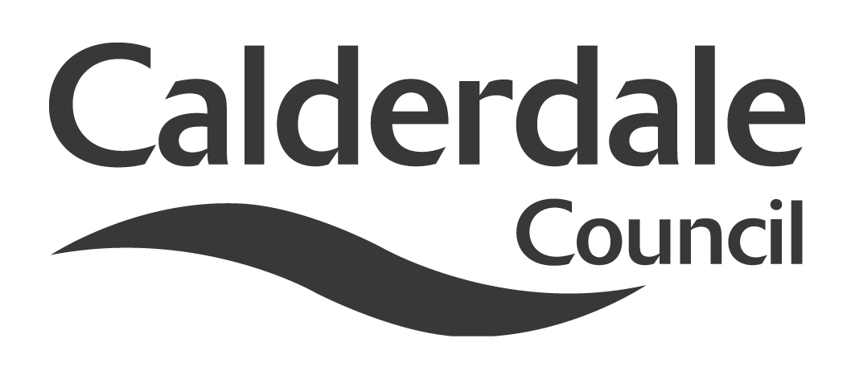
8(a)

Report to Use of Resources Scrutiny Panel
Meeting Date | Wednesday 22 August, 2012
Subject | Shared Services
Wards Affected | All
Report of | Scrutiny Support Officer
Type of Item  (please tick✓ ) | Review existing policy | ✓
Type of Item  (please tick✓ ) | Development of new policy
Type of Item  (please tick✓ ) | Performance management (inc. financial)
Type of Item  (please tick✓ ) | Briefing (inc. potential areas for scrutiny)
Type of Item  (please tick✓ ) | Statutory consultation
Type of Item  (please tick✓ ) | Council request
Type of Item  (please tick✓ ) | Cabinet request
Type of Item  (please tick✓ ) | Member request for scrutiny

Why is it coming here?
Use of Resources Scrutiny Panel asked for a report on Shared Services to be considered at a future meeting of the Scrutiny Panel when it met in April, 2012

What are the key points?
The Chair of the Use of Resources Scrutiny Panel (Councillor Beacroft-Mitchell) has asked that as there are five new Members serving on this Panel this Municipal Year, the Panel be provided with the attached background report and minute relating thereto of the last report on Shared Services submitted to this Panel for consideration in April, 2012.

Also attached is a recently received report from the Association of West Yorkshire Authorities (AWYA) which summarises the current position in relation to West Yorkshire wide initiatives on shared services.

The Head of Finance has also been asked to inform the Panel on what progress the Council is making towards the £1m savings that have already being identified in the 2012/13 budget to be achieved from Shared Services. This is the subject of a separate report from the Head of Finance on the agenda for this meeting.

Possible courses of action
The Scrutiny Panel may wish to:

- Consider making recommendations on the current activity on shared services
- Making recommendations about actions the Panel may wish to see to ensure that the required budgets savings are achieved.
- Consider making recommendations about other service areas where there may be benefits from sharing services with other organisations

Contact Officer
Paul Preston
Scrutiny Support Officer
paul.preston@calderdale.gov.uk
01422 393250

Appendices?
Appendix 1 – Shared Services report to Use of Resources Scrutiny Panel – 5th April, 2012

Appendix 2 – Extract of minute - Shared Services report to Use of Resources Scrutiny Panel – 5th April, 2012

Appendix 3 – AWYA report – West Yorkshire Approach to Shared Services – May, 2012

Should this report be exempt?
No

