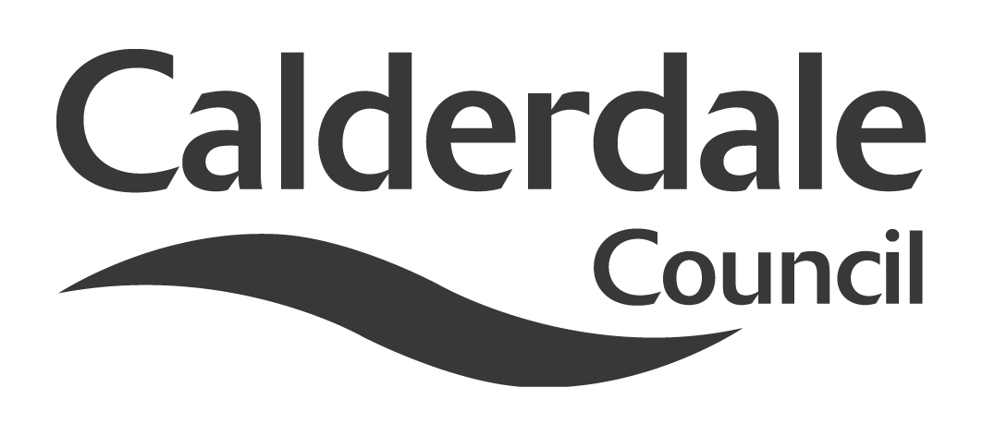
5

Report to Use of Resources Scrutiny Panel
Meeting Date | Wednesday 22 August 2012
Subject | Local authority bonds
Wards Affected | All
Report of | Head of Finance
Type of Item  (please tick✓ ) | Review existing policy
Type of Item  (please tick✓ ) | Development of new policy
Type of Item  (please tick✓ ) | Performance management (inc. financial)
Type of Item  (please tick✓ ) | Briefing (inc. potential areas for scrutiny) | ✓
Type of Item  (please tick✓ ) | Statutory consultation
Type of Item  (please tick✓ ) | Council request
Type of Item  (please tick✓ ) | Cabinet request
Type of Item  (please tick✓ ) | Member request for scrutiny

Why is it coming here?
Use of Resources Scrutiny Panel asked for a report at its meeting on 1st September 2011 on the bond issue by Wandsworth Council

What are the key points?
The report summarises the current position in relation to local authority bonds

Possible courses of action
The Scrutiny Panel may wish to:

- Monitor progress on the options available to the Council with regards to local authority bonds

Contact Officer
Nigel Broadbent
Assistant Head of Finance
Nigel.broadbent@calderdale.gov.uk
Tel. 01422 393505

Should this report be exempt?
No

Report to Use of Resources Scrutiny Panel
Local authority bonds

- Background

1.1 Use of Resources Scrutiny Panel, when it met on 1 September 2011, asked for a report to a future meeting on local authority bonds in light of publicised developments within Wandsworth Council.

1.2 Much of local authority capital expenditure, particularly the major education, highways and housing blocks, is funded by Government grant. If local authorities want to fund other capital expenditure they have three main options:
  - Use of their own cash resources – this is however limited by the amount of cash that the Council has available to invest.
  - Borrow from the Public Works Loans Board (PWLB) – according to Government figures, the PWLB lent more that £50bn in 2010/11 for capital projects and as a lender of last resort would appear to be the most obvious option for local authorities.
  - Borrow from the bond market – Councils can obtain a credit rating and approach the bond markets for capital in a similar manner to the Government to be marketed to financial institutions, pension funds and other investors. Historically, the risks involved with this and the relative cost of finance from the PWLB has prevented local authorities from following this approach.
  - Borrow from banks using Lenders Options Borrowers Options (LOBOs) – long term borrowing from banks with options to repay at various stages

1.3 On 20 October 2010 the Government announced that the Public Works Loans Board (PWLB) interest rate for loans to local authorities would be increased from 0.2% to 1% above gilt rates. This significantly increased the interest cost on loans borrowed by local authorities and prompted a number of Councils to consider financing capital expenditure by raising their own bonds. To date we are aware that Birmingham, the Royal Borough of Kensington & Chelsea and the Greater London Authority have received credit ratings in order to allow them to issue bonds.

- Main issues for Scrutiny

2.1 The local authorities which have considered or issued bonds to date have primarily done this to fund large scale projects e.g. Crossrail in the case of the Greater London Authority. In these cases the additional cost, work and risk involved in a bond issue may be outweighed by the reduced borrowing cost relative to the PWLB. The option is not generally open to most authorities because bond issues are typically over £150m in size.

2.2 The position has become more unclear with the announcement from Government in the March 2012 that it would reduce the PWLB rate by 0.2% for those authorities who were prepared to provide additional information to Government about their capital spending and financing plans over the next three years. Details of this ‘’certainty rate’’ have only just been released. Although it potentially reduces the cost of borrowing to local authorities and makes the case for local authority bonds less viable, it further illustrates the vulnerability of lending rates for local authorities and makes financial planning more difficult.

2.3 Following the increase in the PWLB rate in 2010, the Local Government Association (LGA) pulled together a group of senior councillors and finance experts to investigate the feasibility of establishing a collective agency to raise and on-lend funds to local authorities at a competitive rate. Agencies of this type operate in other countries in Scandinavia, and are being developed in France and New Zealand. The LGA has just published its proposals.

2.4 The proposed local authority collective agency would raise funds from capital markets at regular intervals and on-lend to participating authorities. The agency would look to secure an AAA/Aaa credit rating with at least two credit rating agencies. The business case for the agency suggests that it would be able to make available to local authorities funds at a broadly comparable rate to the PWLB certainty rate.

2.5 The main benefits of a collective agency would be:
- to make available competitive rates for borrowing by local authorities
- independence from central Government changes to the PWLB rate
  - It would create a new class of bonds of likely interest to insurance companies and pension funds.

The risks involved in this approach would be:
- Further reductions in the PWLB may make the collective agency rates uncompetitive
- Government support for the agency would required in order for the financial markets and bond investors to have confidence in it
- It would be subject to the vagaries of the bond market
- Local authority borrowing continues to decline as public spending cuts strengthen.

2.6 Further work will be undertaken on the collective agency by the LGA should the principle attract sufficient support from local authorities.

2.7 Calderdale Council has not borrowed from the PWLB to finance capital expenditure since 2008/09. This is because short term money market rates (at between 0.25% and 1.25% last year) have been running significantly below the longer term PWLB rates (averaging 4.67% last year). This position is kept constantly under review as interest rates fluctuate, as cash resources available to invest reduce, and as the Council looks to significantly increase its prudential borrowing to fund its priority investment projects such as the Piece Hall and the Halifax town centre office strategy.

2.8 Officers will continue to monitor progress with the collective agency as it would protect the Council from the significant costs and risks associated with attempting to develop its own bond scheme. Approval to participating in a collective agency would require changes to the treasury management policy and would require the approval of Cabinet and Council.

2.9 Use of Resources may wish to receive further update reports as progress develops.

- Appendices

None

- Background documents

LGA publication, ‘’Local authority bonds – A local government collective agency’’.

- Documents available for inspection at

The Town Hall, Halifax, Crossley Street, Halifax, HX1 1UJ

