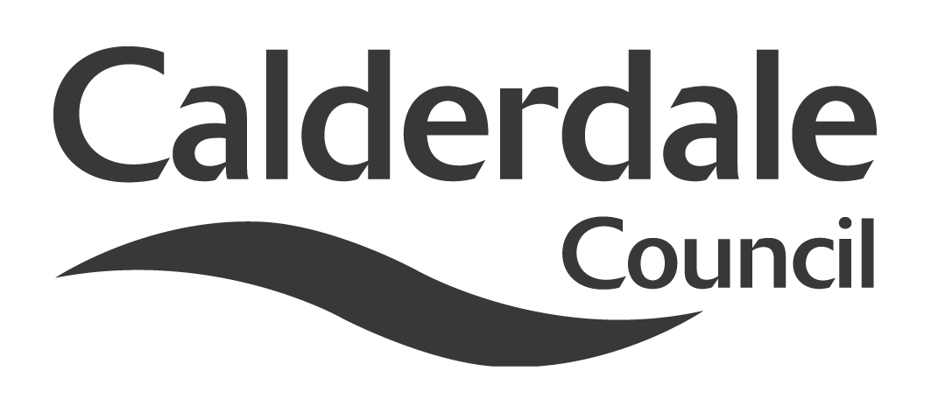

Report to Scrutiny Panel
Name of Scrutiny Panel | Children & Young People’s Scrutiny Panel
Meeting Date | 15 August 2012
Subject | Progress on the White Rose Framework Agreements for the purchase of external placements for Looked After Children
Wards Affected | All
Report of | Group Director, Children & Young People’s Services
Type of Item  (please tick✓ ) | Review existing policy
Type of Item  (please tick✓ ) | Development of new policy
Type of Item  (please tick✓ ) | Performance management (inc. financial)
Type of Item  (please tick✓ ) | Briefing (inc. potential areas for scrutiny) | x
Type of Item  (please tick✓ ) | Statutory consultation
Type of Item  (please tick✓ ) | Council request
Type of Item  (please tick✓ ) | Cabinet request
Type of Item  (please tick✓ ) | Member request for scrutiny (CCFA)

Why is it coming here?
The CYPS Scrutiny Chair requested a report on the progress of Calderdale’s involvement in the Sub-Regional Procurement of external placements for Looked After Children. Calderdale’s representative on the Strategic Commissioning Group was requested to attend Scrutiny and present the report and progress made.

What are the key points?
- Cabinet approved Calderdale’s participation in the development of two Framework Agreements to support the purchase of external placements for looked after children.
- Independent Fostering Agencies (IFA) were invited to tender for the first of these Agreements.
and evaluation of bids is currently underway.
- The specification for the Residential Fostering Agreement is currently being developed and tendering for this contract will take place in October 2012.

Possible courses of action

Contact Officer
Karen K Smith, Service Manager, Strategic Commissioning

Should this report be exempt?
No

Report to Scrutiny Panel

- Background
- In June 2011 the Association of West Yorkshire CEO’s directed officers to collaborate to achieve savings in the purchase of external placements. This was further mandated by the Association of Leaders of West Yorkshire Local Authorities. The local authorities of Bradford, Calderdale, Leeds, Kirklees, Wakefield and Doncaster agreed to join this collaborative approach.
- Across the West Yorkshire sub-region, the local authorities of Calderdale, Bradford, Kirklees, Leeds and Wakefield collectively spent £36.7m (Calderdale spent £3.9m) with Independent Fostering Agencies (IFA’s) and £37.9m (Calderdale spent £2.6m) on external residential placements for looked after children during 2010/11.
- The plethora of different purchasing arrangements across the member Authorities has resulted in financial terms and conditions being negotiated for individual cases on a daily basis. The pricing tariffs across IFAs and residential children’s home providers varied considerably and purchasing on demand provides neither the best negotiating approach or best value for the Council.
- Cabinet approved Calderdale Council’s participation in the procurement exercise, led by Leeds City Council’s Pubic Private Partnerships Unit (PPPU), for the establishment of Framework Agreements for Independent Fostering Agencies and Residential Children’s Homes.

Officers within each Authority, supported by the PPPU in Leeds City Council, have developed a project management framework under which to progress and deliver the procurement project. Leeds City Council is leading the overall procurement, with consultation and support provided from commissioning, legal and procurement specialists in each Local Authority represented on the Strategic Commissioning Group for this project. The Framework Agreements will, therefore be tendered and let by Leeds City Council on behalf of the participating Authorities. The Strategic Commissioning Group report back to the Association of West Yorkshire CEO’s (AWCEO) on a regular basis.
- The Strategic Commissioning Group proposed the development of two framework agreements to support the improvements in quality and price of external placements. This was on the basis that the Yorkshire and Humber region as a whole lags behind many other regions in England by not operating a consistent regional or sub-regional procurement approach for LAC placements. The overall aim of the project is to deliver a contractual basis for each Local Authority to purchase IFA and Residential Care placements from Framework Agreements in line with the demand for LAC placements.
- This approach builds on intelligence from the wide use of other Framework Agreements across Engalnd. In many instances these have reported that the collaborative procurement approach has delivered efficiency within these markets, in comparison to independently purchased placements by single Authorities. The level of efficiency savings reported through these arrangements differs depending on the specifics of the model implemented. However, savings of between 3 –11% have been reported.
- Main issues for Scrutiny
- What is a Framework Agreement

A Framework Agreement is a mechanism under which the Council will agree with providers the terms within which they will provide services. The actual services will be provided under call-off agreements (pursuant to the Framework) between the Council and individual providers for the provision of specific services. The Framework does not guarantee levels of business for providers.
Both of the Framework Agreements will be for a period of two years, with an option
to extend for a further year.

- What does it mean for Calderdale

Calderdale will be able to use the Framework to purchase placements as and when required. A consistent approach across the sub-region is expected to realise a minimum of 5% reduction in the cost of external placements. This represents a potential minimum saving to Calderdale of £325k per annum.

The specification is based on the ‘National Contracts’ in place for Independent Fostering Agencies and Residential Children’s Homes, with input from each local authority to ensure it best meets the need of children. Children in Care Council’s across the sub-region have been consulted, to ensure their views shape the specification and the diversity of needs for looked after children will be best served.
- Update on progress
  - Fostering Framework Agreement
The tender for the Fostering Framework contract was released in April 2012. These bids are currently being evaluated. Each Local Authority is leading on the evaluation of particular questions from the tender. In addition, each Local Authority has taken a lead within the project. For example, Calderdale has the lead for the development of the terms and conditions for the Framework Agreements. Within Calderdale, Legal Services and the Corporate Procurement Unit have provided specialist advice to the Service Manager, Strategic Commissioning, who attends the Strategic Commissioning Group.
The Fostering Framework Agreement will be operational from 18 November 2012. An implementation plan for each authority to use the Framework, to ensure consistency across the authorities, is being led by officers from Bradford MDC.
As well as the focus on price, there has been an emphasis on improving outcomes for children and young people by developing joint arrangements for monitoring quality. A Quality Assurance Framework has been developed which local authorities will utilise to assess the quality of provision provided; this will ensure that providers who score highly will secure more placements.

Assurance mechanisms developed between White Rose Local Authorities will ensure that improved quality contract management and quality assurance will be secured, byeach authority leading on particular providers.
On the first anniversary of the Framework Agreement there is an option for other authorities from the region to join.
3.2 Residential Framework Agreement
The Residential Framework Agreement is still in development. In June a market day for residential providers was held in Leeds, where the aims of the Framework Agreement were shared with the market and feedback received to inform the development of the specification. The specification is currently being developed.
Significant interest from other local authorities has been generated in the approach developed. This has resulted in Sheffield, Rotherham and Barnsley becoming associate members of the Residential Framework. This will significantly increase the purchasing power of the group. These authorities, like Doncaster, have secured the necessary authority to ensure that the tender process is not delayed.
It is expected that the invitation to tender for this contract will be made in October 2012 and will be operational early next year.
- Background documents
4.1 Cabinet Report 2nd April Calderdale’s involvement in the Sub Regional Procurement of external placements for Looked After Children.
- Documents available for inspection at
Northgate House, Halifax, HX1 1UN.

