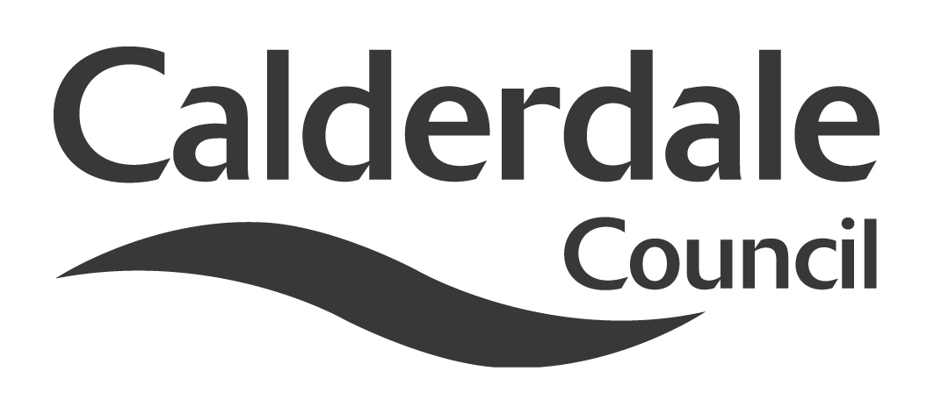
5

Report to Scrutiny Panel
Name of Scrutiny Panel | Communities Scrutiny Panel
Meeting Date | 1st March, 2012
Subject | Scrutiny implications of the Police Reform and Social Responsibility Act 2011
Wards Affected | All
Report of | Scrutiny Support Officer
Type of Item  (please tick✓ ) | Review existing policy
Type of Item  (please tick✓ ) | Development of new policy | √
Type of Item  (please tick✓ ) | Performance management (inc. financial)
Type of Item  (please tick✓ ) | Briefing (inc. potential areas for scrutiny) | √
Type of Item  (please tick✓ ) | Statutory consultation
Type of Item  (please tick✓ ) | Council request
Type of Item  (please tick✓ ) | Cabinet request
Type of Item  (please tick✓ ) | Member request for scrutiny (CCFA)

Why is it coming here?
Request of the Chair

What are the key points?
The Act includes a number of elements which have implications for the scrutiny function locally

Possible courses of action
Members may wish to consider how the roles and relationships of this panel with the Local Community Safety Partnership, the Police and Crime Commissioner and the Police and Crime Panel may develop over time.

Contact Officer
Steve Barnbrook, Scrutiny Support Officer 01422 393252
steve.barnbrook@calderdale.gov.uk

Should this report be exempt?
No

Report to Scrutiny Panel
- Background

  - The Police Reform and Social Responsibility Act passed into legislation on 15th September, 2011.

  - The Bill covers five distinct policy areas: police accountability and governance; alcohol licensing; the regulation of protests around Parliament Square; misuse of drugs; and the issue of arrest warrants in respect of private prosecutions for universal jurisdiction offences.

- Main issues for Scrutiny

2.1 There are a number of areas of the Act which will have implications for Local Authority Scrutiny Functions. The key area is around the establishment of Police and Crime Commissioners, which will form the focus of this report.

2.2 The Act abolishes police authorities and replaces them with an elected Police and Crime Commissioner (PCC). The Commissioner will be responsible for holding the Chief Constable in the Force area to account. The PCC is perceived as having a more high profile and responsive role in relation to the public. Innovations such as crime mapping, and mandated neighbourhood meetings, along with direct elections, are designed to make the PCC more accountable

2.3 The PCC will have wide-ranging powers and responsibilities. On consultation and engagement, he or she will have a duty to consult local people – including victims of crime. There is a statutory requirement for the PCC to work in partnership with a range of other local agencies.

2.4 The PCC will have sole responsibility for disbursing community safety funding from the Home Office (currently provided through a range of funding streams to local authorities, police and community safety partnerships), and will also have responsibility for a range of other budgets. The PCC will be able to direct this funding where he or she wishes, in the form of grants, either to Community Safety Partnerships or other bodies.

2.5 The PCC will also have wider powers over criminal justice, in partnership with criminal justice bodies, under section 10(3). The precise scope of this work is as yet unclear and may be subject to more detailed discussions at local level.

2.6 PCCs are to be scrutinised by police and crime panels (PCPs). These will be formed of a minimum of 10 representatives from the local authorities in the force area. The key powers of PCPs are:

- Confirming or vetoing the PCC’s appointment of Chief Constable
- Confirming or vetoing the level of the council tax precept.

For both of these functions, at least two thirds of the panel will have to agree.
The PCPs can also:

- Require the attendance of the PCC at a meeting
- Suspend the PCC if he or she has been charged with an offence punishable by at least two years in prison.

In addition to attending meetings when required, the PCC will have to provide information which the PCP “reasonably requires”, and must provide the PCP with an annual report, and present this to them at a public meeting.

2.7 The relationship between the PCC and Community Safety Partnerships (CSPs) – and, consequently, with this panel as the Crime and Disorder Committee – is potentially complicated.

2.8 As noted above, the PCC will have sole responsibilities for making grants of cash on community safety issues. There is consequently a funding accountability relationship between the PCC and those CSPs in receipt of this money. This is backed up by a formal power for the PCC to call CSP chairs to meetings to discuss Force-wide issues. This could be seen as a way for the PCC to enforce control over chairs for the spending of money.

2.9 This will see community safety moving to a more commissioning-led approach, depending on the ambition of the individual PCC. Ringfencing seems likely to be removed. With this widespread power, the PCC may choose innovative business models for the delivery of certain services – involving the third or private sector in certain areas. Whatever happens, it seems likely that contract management will take a more central role in the delivery of community safety priorities. It may result in mergers of some CSPs, the adoption of shared services between some partners, potential TUPE issues for community safety staff, and a renewed focus on “value for money” – as well as more data transparency.

2.10 These powers should be seen in the context of the remaining CSP scrutiny powers for local government, as well as the likely role of the PCP in scrutinising the PCC’s commissioning activities. The CSP scrutiny powers will not be amended but it is clear to see that the wider accountability arrangements in play will have a profound impact on the way that CSPs operate.

2.11 Elections for Police and Crime Commissioners will be held in November 2012. The Home Office has established a Transition Board that has commissioned a number of projects that cover the main transition arrangements that need to be addressed before PCCs come into post. Further Home Office Guidance is expected shortly.

2.12 In the West Yorkshire Region meetings have been held at various levels to plan for the transition. These have been led by the Association of West Yorkshire Authorities (AWYA). Work has been progressed in a number of areas, including the drafting of draft protocols and agreements between the five West Yorkshire Local Authorities covering PCP issues such as Membership, Governance and Support Arrangements.

- Consultation

3.1 West Yorkshire was one of three areas nationally which took part in Home Office “deep dive” consultation events toward the end of 2011.

3.2 Members and officers of Calderdale Council are involved in AWYA meetings on an ongoing basis.

3.3 Members and officers of Calderdale Council are involved in Home Office briefing meetings.

- Further action and timescales

4.1 The Home Office is expecting each Force area to have a Shadow PCP in place by June 2012.

4.2 Elections for Police and Crime Commissioners will take place on 15th November, 2012.

- Conclusions

5.1 Along with the Localism Act (and the Health & Social Care Bill eventually), the Police Reform and Social Responsibility Act represents a shift in the way that scrutiny is undertaken. Large-scale commissioning, more joint working and different attitudes to procurement will mean that the way that services are delivered will be subject to profound change in the coming months and years.

5.2 This may involve a number of changes:

- More proactive consultation and discussion with partners about the scrutiny work programme;
- A better understanding of scrutiny by partners more generally. Future expansion of partnership powers may provoke scrutiny functions to engage with partners to discuss mutual expectations from the process, and if necessary develop a protocol to define relationships in the future, focusing on improvement and the avoidance of duplication;
- More scrutiny on specific issues, that may involve partners, rather than “scrutiny of partners”. Traditionally, partners may have been invited to give evidence to scrutiny committees to give an account of their general work. It may make more sense to integrate evidence from partners into scrutiny reviews of “issues” affecting local people;
- More joint scrutiny. The administrative boundaries of some partners or partnerships may not be coterminous with those of the local authority. More informal or formal joint working may be necessary.

- Appendices

Home Office Frequently Asked Questions – Police & Crime Commissioners
Home Office Frequently Asked Questions – Police & Crime Panels

Local Government Association – Police and Crime Panels: Guidance on Role and Composition

- Background documents

The Police Reform and Social Responsibility Act 2011
Centre for Public Scrutiny Policy Briefing 14 – New Legislative Framework

- Documents available for inspection at

Halifax Town Hall, Crossley Street, Halifax HX1 1UJ

