CALDERDALE MBC

WARDS AFFECTED: CALDER

CABINET
11

9 JANUARY 2012

TRANSFER OF LAND AT GREAT ROCK, BLACKSHAWHEAD AND CHARLESTOWN TO BLACKSHAW PARISH COUNCIL

REPORT OF THE DIRECTOR FOR COMMUNITIES

- ISSUE

1.1 To consider a request from Blackshaw Parish Council for the transfer of two areas of land from Calderdale Council to the Parish Council. The first of these is at Great Rock, Higher Eastwood, Todmorden and is public open space (see Appendix 1). The second is for the establishment of allotments at a site on the Burnley Road, Charlestown (See Appendix 2).

- NEED FOR A DECISION

2.1 As Blackshaw Head Parish Council has requested the transfer at nil consideration Members are asked to make a decision on whether to transfer the asset as per the Framework from Community Management of Assets.

2.2 Calderdale Council is under a legal duty contained within s123 of the Local Government Act 1972 to obtain best consideration when disposing of land and property assets. Furthermore, the Council’s Corporate Property Policy and Strategy requires that land and property assets should normally be sold or leased at full market value. This report allows Cabinet to consider whether the provisions contained within the General Consents Disposal Order 2003 should be exercised in order to facilitate transfer of the land at less than best consideration.

- RECOMMENDATION

3.1 It is recommended that Cabinet:

- Approve a freehold transfer of the land at Great Rock, Higher Eastwood, Todmorden (Appendix 1) at nil consideration to Blackshaw Parish Council, subject to the necessary procedures being followed and consents being obtained.

- Approve the transfer of the land at Burnley Road, Charlestown (Appendix 2) on a 125 year lease at nil consideration to Blackshaw Parish Council, subject to the necessary procedures being followed and consents being obtained.

- Delegate to the Director of Communities (in consultation with the Cabinet Member for Communities, the Head of Democratic and Partnership Services and the Director of Economy and Environment) authority to complete a transfer agreement with Blackshaw Parish Council which will permit the Parish Council, rather than Calderdale Council, to manage allotment provision within their area.

- BACKGROUND

4.1 Cabinet approved a Framework for Community Management of Assets on 6 April 2009. This laid out a method of evaluating bids from community groups who wished to acquire assets (buildings or land) belonging to the Council. The framework provides a structure for determining the suitability of the asset, the robustness of the organisation proposing to acquire the asset and, ultimately, the likelihood of success of any subsequent transfer.

4.2 This framework was updated and a new framework approved by Cabinet on 30th August 2011. However, this application is being assessed under the original framework, as Blackshaw Parish Council applied for the Asset Transfer while that version of the framework was in place.

4.3 The proposal envisages developing the two areas of land as follows:

Land at Great Rock, Higher Eastwood, Todmorden: To develop the site as accessible public open space. The site is adjacent to the Calderdale Way and has superb views across the Calder Valley looking towards Stoodley Pike. It is a popular picnic spot and viewpoint.

Land at Burnley Road, Charlestown: Proposal for allotments and potentially a community garden as determined through further consultation

These proposals are supported by the Blackshaw 2010 Parish Plan. These plans have been developed in consultation with residents in the parish and have already led directly to the establishment of Blackshaw Optimistic Gardeners (BOGS), Blackshaw Local History Group, SHED, and a host of community building activities. These transfers will support the Parish Council’s ambition to Blackshaw to be a good place to live and work.

4.4 Across the UK, local authorities are encouraging town and parish councils to take on the ownership and responsibility for various assets and services. However, a request to transfer a Calderdale Council asset to a town or parish council must meet the same criteria for transfer as any other community based organisation and be able to evidence that their proposal has the support of the local community and is financially viable.
4.5 Officers’ evaluation of the two proposals indicate that they are a good fit against the Asset Transfer Framework as summarised below:

Asset 1 - Land at Great Rock, Higher Eastwood, Todmorden (Map at Appendix 1)
The Land: | The land at Great Rock, Higher Eastwood, Todmorden is currently owned by Calderdale MBC but was formerly owned by Hepton Rural Council but part of Blackshaw Parish since 1894 and as featured on the Blackshaw Parish letterhead.  The site has had minimal maintenance since it was transferred to Calderdale Council in 1974. The renovation of the site will be determined following consultations with local residents including those living across the nearby parish boundary with Todmorden. There is an issue with degradation of the site boundaries against the roadway and a need for occasional car parking for nearby residents concerned about being snowed in on the lanes below Great Rock.
The Community Group: | Blackshaw Parish Council was established by statute as tier of local government in 1894. The Council has 7 elected councillors who are elected every 4 years in a process governed by statute and organised by Calderdale Council. The Parish Council does not have Quality Parish and Town Council Status (quality standards for parish and town councils) but has provided evidence of how it provides a voice and leadership for the small communities of Blackshaw Head and Charlestown of approximately 1,000 residents, over 1/3 of whom are in contact with the Parish Council though an e-mail group.  The current Blackshaw Parish Plan (2010) sets out a clear vision for the community that has been developed with residents. This puts significant emphasis on caring for and nurturing the fragile and iconic local landscape, of which Great Rock is a key feature.
Impact on the Wider Community and Our Objectives | The Parish Council has provided strong evidence of the impact of proposed transfer and officers believe this project would assist in achieving a range of wider strategic objectives of the Council and partners, especially in relation to devolving services to localities, encouraging tourism and increasing opportunities for community engagement and volunteering.
Financial Impact | The land at Great Rock is currently not used and has had limited maintenance in recent years. It has a land value of £500 and has had negligible investment in recent years.  The financial impact for the Council of transferring the land at Great Rock would therefore be based on the land value alone.  The financial impact on the community would be negligible. It is estimated that approximately £100 will be needed to install a picnic bench or similar. It is intended that basic maintenance work is undertaken by local residents who have offered volunteer labour and other resources for any work required. Blackshaw Environmental Action Team, BEAT and Blackshaw Optimistic Gardeners, BOGS, have both offered their help with the project.
Risk | The main risk from the transfer would be from Blackshaw Parish Council ceasing to exist and /or not being able to maintain the land. In this instance the Council would have to take back management of the land which may not be in the same state as when transferred. However, Blackshaw Parish Council has been operating as the first tier of local government since 1894 and in recent years has developed active community involvement in a range of activities such as the Blackshaw Fete, village clean ups and protection of the Colden Clough Nature Reserve. The levels of investment needed in the assets are very low and are likely to be met mainly through volunteer labour and other resources. As both areas of land have had limited maintenance since transferring to Calderdale in 1974 it is difficult to imagine that they will be in worse repair following transfer. However, any failure of Blackshaw Parish to meet the terms of the management agreement would result, as with other asset transfers, in the asset reverting to Council control.  Overall, the level of risk to the Council is considered to be low.

Asset 2 - Land at Burnley Road, Charlestown (Map at Appendix 2)
The Land: | The land lies next to the Burnley Road (A646) in the community of Charlestown. The site was formerly owned by Blackshaw Parish Council and has had minimal maintenance since it was transferred to Calderdale Council in 1974.  The proposal will transform the land into allotments and potentially a community garden depending on final consultation with local residents about the best use of the land.  Renovation of the site will have to be determined following a contamination survey and an assessment of the trees that have grown on the site since it was used as a tennis court.  There are two benches that were erected on the site by Blackshaw Parish Council one of which is covered in brambles and needs to be uncovered.  Renovation is likely to include clearance of trees that are diseased, near the end of their life or starting to overhang the A646 highway.  Transferring the asset to community ownership would unlock potential to develop the site far beyond its current condition.
The Community Group | As above.
Impact on the Wider Community and Our Objectives | The Parish Council has provided strong evidence of the impact of proposed transfers and officers believe this project would assist in achieving a range of wider strategic objectives of the Council and partners, especially in relation to devolving services to localities, encouraging community growing and increasing opportunities for community engagement and volunteering.
Financial Impact | The land at Charlestown is currently not used and has had limited maintenance in recent years. It has a land value of £4,500 and has had negligible investment in recent years.  The financial impact for the Council of transferring the land at Charlestown would result in a small annual budget saving but the loss of the land value.  There would some financial impact on the community from the transfer. It is estimated that approximately £10,000 will be needed to conduct an environmental survey and restore the condition of the site including removal of diseased trees etc. In the longer term. It is intended that this will be sourced through grants and Parish Council Reserves. It is intended that basic maintenance work is undertaken by local residents who have offered volunteer labour and other resources for any work required. However, an ongoing revenue funding requirement to run the allotment of £500 per annum maximum has been identified by the Parish Council. Blackshaw Environmental Action Team, BEAT and Blackshaw Optimistic Gardeners, BOGS, have both offered their help with the project.  Accounts have been provided by the Parish Council in support of their application, which indicate that these sums can be met by the Parish.  Blackshaw Parish continue to develop their funding portfolio as new opportunities arise and the asset transfer strengthens their opportunity to draw down funding.
Risk | As above.

4.6 In summary these transfer of assets should be seen as a positive opportunity by Calderdale Council. It will provide the opportunity for local communities to develop and sustain locally important assets and provide much needed investment of resources, in terms of maintenance, for both sites which have been lacking over a number of years.

4.7 The transfer will be at no extra cost to the Council and there will be steps made, with the support of Blackshaw Parish Council to minimise risks with regular open dialogue between officers and the Parish. There are also limited risks for the transfer due to the low value and limited use currently made of both assets.

4.7 The Localism Act actively encourages decentralisation and the transfer of services/assets to local communities. The Council has already transferred a number of assets to community groups following the adoption of a Calderdale Council policy on Community Management of Assets in April 2009, and the transfer of other small pieces of land, such as the Banksfield site to Hebden Royd Town Council, together with the responsibility for allotment provision within their area, fits well into this agenda.

- OPTIONS CONSIDERED

5.1 Option 1: Transfer both the land at Great Rock and the land at Charlestown to Blackshaw Parish Council on either a freehold or long term lease at nil consideration.

It is recommended that Calderdale Council takes the opportunity to transfer both areas of land in line with its wider agenda of empowering local communities to manage their own local assets.

In terms of the land at Great Rock: It is recommended that Calderdale Council consider transferring the land to Blackshaw Parish Council on a freehold basis. This is for the following compelling reasons:
- The land has limited value beyond its iconic status in the landscape Blackshaw Parish and associated benefits in terms of tourism;
- The land has very limited alternative use and negligible market value to Calderdale Council;
- Transfer of the asset to Blackshaw Parish is very low risk due to the long-standing history of the Parish as the first tier of local government and substantial community support for sustaining and improving the asset.

In terms of the proposal to turn the land at Charlestown into allotment: It is , recommended that Calderdale transfer the land on a 125 leasehold basis, in line with other recent transfers for allotment use and reflecting the recent commitment to devolving allotment provision to first tier authorities. It would also appear to be the best way to protect and enhance the site at a time when budgets are severely constrained.

5.2 Option 2: Grant a 5 year lease in line with other self managed allotment sites in Calderdale:. This would mean that Calderdale Council would retain responsibility for non-routine maintenance and the infrastructure of the site. It may also constrain the ability of the Parish Council to attract external funding.

5.3 Option 3: Dispose of the site on the open market in order to generate a capital receipt. LPS have not advised that the land is shown on the UDP as being within the Charlestown Village envelope. Its value on the Open Market is estimated at £4,500.

5.4 Option 4: Do nothing and continue to manage the site as it is now. This would restrict any enhancement of the land and likely deterioration. It would also impact negatively on the perception of the Council within the local community and with partners supporting the application.

- CONSULTATION

6.1 The Council has not carried out its own consultation on the future of either the land at Great Rock or Charlestown. However, Blackshaw Parish Council has carried out considerable consultation with local residents and beyond in adjoining communities about the future of both sites.

- FINANCIAL IMPLICATIONS

7.1 The current income from the land is nil. If it is transferred at nil consideration then this income will be lost.

7.2 If the site at Charlestown was let for allotment use on a self managed basis in line with other sites then the income to the Council would be £90.

7.3 There are no records of that any significant funds have been spent by the Council on improvements at either site. In previous years some limited routine maintenance was carried out on the land at Charlestown but with limited budgets this has now ceased.

7.4 The combined open market valuation of both sites is £5000.

- CORPORATE IMPLICATIONS

8.1 The bid was assessed using the Community Asset Management Framework, by a working group of officers from Communities (Neighbourhoods & Community Engagement and Safer, Cleaner, Greener), Economy and Environment (Land and Property), Finance and Legal Services.

- CONCLUSION

8.1 Transferring Great Rock and the land at Charlestown to Blackshaw Parish Council at nil value will enable the Parish Council to deliver the ambitions in their Parish Plan and deliver allotment provision to better suit the needs of the local community of Blackshaw Head and Charlestown.
Robin Tuddenham
Director for Communities

Date: 31 July 2026

FOR FURTHER INFORMATION ON THIS REPORT CONTACT:
Sian Rogers, Performance Manager
Tel 01422 393227
Email sian.rogers@calderdale.gov.uk

DOCUMENTS USED IN PREPARATION OF THIS REPORT:
Service files

DOCUMENTS ARE AVAILABLE FOR INSPECTION AT:
WestgateHouse, Halifax
Appendix 1 - Great Rock, Higher Eastwood, Todmorden (The land in question is outlined in red)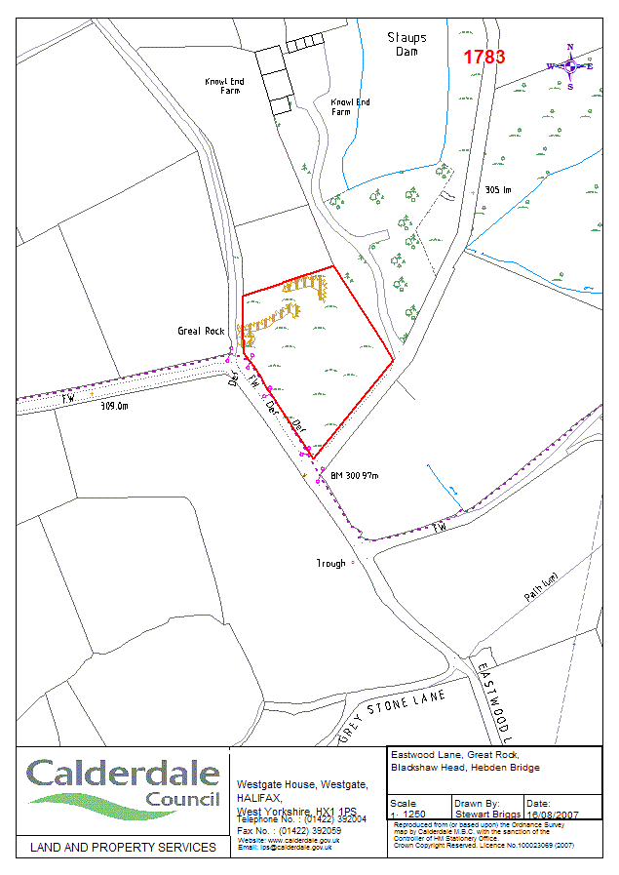
Appendix 2 - Land at Burnley Road (A646), Charlestown
(The land in question is hashed in black)

