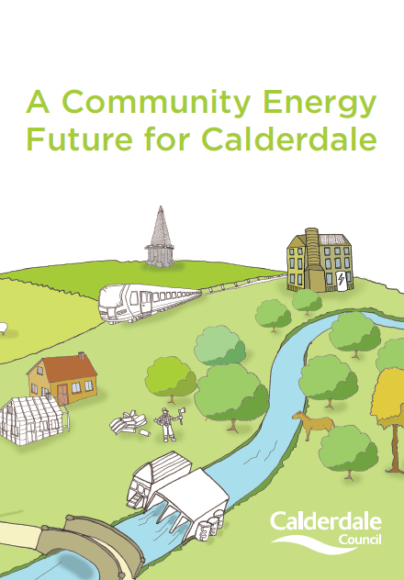
Calderdale’s
Energy Future

Foreword - Calderdale’s Energy Future
Increasing the pace of change, 2020 and 2050

This strategy sets out how Calderdale Council and its partners can transform our current thinking to support a resilient low carbon economy, which will lead the Borough to achieve a 40% reduction in carbon emissions by 2020 from a 2005 baseline. It focuses our attention on priority actions that will have the biggest carbon reduction impact while protecting our communities and landscapes. We want to achieve these targets in a way that delivers the maximum social, economic and environmental benefits to the community.

The strategic focus is a move to a low carbon economy which supports the following key areas:
- Resilience
- Improved Health and Well Being
- Preserved and Enhanced Natural Landscape
- Everyone Involved

Whilst the 2020 target is important we must not lose sight of the fact that this is just a milestone on the way to a more challenging target of an 80% reduction by 2050. This is a challenging target and we need to increase the pace of change to achieve it. Financial and policy decisions must be aligned to reach this common goal and an attitude shift is required. It is no longer possible to continue with our current way of thinking - the opportunities and impacts of carbon reduction must be taken into account at every stage of our Borough’s development.

It is difficult to imagine that we can achieve these things unless there is wide scale buy-in to a low carbon way of living across the community. An immediate priority is to co-ordinate action across the borough and to share knowledge, which will initiate joint action between private, public and community sector partners. This document has emerged from a series of community and business engagement events and is supported by computer modelling. We have encouraged as many people as possible to contribute to the strategy and everyone has a role in delivering it.

Calderdale Council is committed to reducing its own emissions in line with the Borough wide target. It is important that the Council provides strong and effective leadership so that our communities have a role model to follow.

Councillor Barry Collins,
Cabinet Member for Economy & Environment
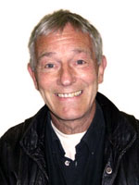

Contents
- Summary .................................................................4

- Vision – what we will have achieved by 2020……….5

- Everyone Has A Role…………………………………..7

- Where We Are Now…………………………………….9

- Designing a Carbon Reduction Trajectory………….11

- The 2020 Plan ..........................................................13
  - A Resilient Low Carbon Economy
  - Improved Health and Well Being
  - Preserved and Enhanced Natural Landscape
  - Everyone Involved

- From Vision to Action…………………………………..25

- Concluding Remarks..………………………………….26

- Methodology…………………………………………….27

- Summary of Objectives and Actions……………….28

1. Summary

Our strategy recommends:

- Priority actions to increase the energy efficiency of our buildings, based on the modelling research carried out by Leeds University for Leeds City Region;
- Potential to increase our local renewable energy infrastructure, based on regional studies and carbon modelling delivered in-house using Vantage Point software;
- The integration of the above actions within a framework that is inclusive and enhances our natural landscape.

The purpose of our strategy is to:

- Help co-ordinate actions across the Borough towards a common goal;
- Demonstrate Calderdale’s commitment to an ambitious target, which underpins a business case for future investment;
- Help position Calderdale Council to take a bold leadership role by declaring its commitment to reducing its own emissions. Calderdale Council will facilitate action with partner organisations by joint project working and also reducing barriers to investment and infrastructure delivery through coordinating funding mechanisms and reforming planning.

Must do’s:

We MUST set out a clear and ambitious action plan based on evidence gathered from local modelling, community and business engagement and national case studies and the detailed work that has been undertaken for Leeds City Region;

We MUST fully integrate low carbon thinking throughout the decision making processes, align policy and financial agendas, review planning guidelines and develop a strong steer for action through the local plan (Local Development Framework);

We MUST ensure the local community have the skills to deliver low carbon enterprises so that the people of Calderdale are able to benefit personally from a strong, local, low carbon economy.

We MUST demonstrate what is possible by setting ambitious targets within the Council, providing the resources to deliver them and promoting our successes;

We MUST develop an investment mechanism to deliver a revolving programme of funds;

We MUST work with the local community, enabling and supporting community action across the Borough and encouraging communities to develop their own plans for renewable energy;

We MUST enhance and maintain our existing assets including our moors, which act as natural carbon sinks, and our woodlands, which are a valuable resource.
2. Vision – what we will have achieved by 2020

The vision for Calderdale’s Energy Future is of a low carbon economy which supports the local landscape and its communities. Calderdale has a bold and diverse enterprise culture among the business community and the emerging low carbon economy must reflect this. There is no one solution that will make the difference; the success of this transformation will be in our ability to match our local strengths with national and global opportunities. Calderdale is visited by tourists from all over the world, and our landscape performs many functions as an energy generator, a carbon sink, a place for recreational pursuits and a visual amenity. All of these demands on a local area must be taken into account within this plan. Overall, four areas have emerged which will shape the focus of the actions in this strategy and will ensure that decisions are made within an integrated framework.

In 2020 we will see a Calderdale Energy Future that has achieved:

A Resilient Low Carbon Economy

- An enhanced building stock which has improved energy efficiency and reduced the amount of heat consumed by our buildings;
- Upgraded appliances and energy systems throughout residential homes and commercial buildings, reducing the amount of electricity consumed in our buildings;
- Large scale renewable energy infrastructure, compatible with our local landscape, producing local energy and contributing to the decarbonisation of the national grid;
- Locally owned renewable energy systems which directly fund community enhancements;
- An enhanced transport system which provides less carbon intensive alternatives to current modes and reduces the need to travel;
- Local residents and businesses accessing skills provision and jobs provided within the low carbon economy;
- Common access to growing space for children and adults to grow their own food;
- Aligned policy and financial agendas supporting a low carbon economy;
- A finance mechanism which continues to support low carbon developments;
- A plan to continue delivering actions that will meet an 80% reduction in carbon emissions by 2050.

Improved Health and Well Being

- The elimination of fuel poverty;
- Low income communities benefitting from locally produced renewable energy;
- Improved access to cycling and walking infrastructure;

Preserved and enhanced natural landscape

- Joint working and communication between partners to minimise flooding, conserve carbon sinks and increase biodiversity;
- An increased understanding about the impact of development on the natural carbon sinks on the moors and knowledge about how to preserve this resource;
- Tourism benefits from our enhanced natural landscape and energy demonstration projects;
- Well-managed woodlands that produce fuel for local biomass consumption.

Everyone Involved

- An increased understanding within the local community about where our energy and food comes from and how individuals can be actively involved in its production;
- Key leaders demonstrating what is possible, including Calderdale Council having achieved a 40% reduction in carbon emissions from a 2005 baseline;
- A transparent and co-ordinated working group keeping everyone informed of the opportunities, developments and progress of Calderdale’s Energy Future;
- A local sense of pride in Calderdale’s Energy Future.

3. Everyone Has a Role

Calderdale’s Energy Future will be achieved through actions delivered by individual residents, businesses, community groups, public sector organisations and national initiatives and policies. Everyone will have a different but complementary role to play, from a householder who replaces their washing machine with a more energy efficient one to a manufacturing business who supplies the valves for a wind turbine.

Calderdale Council’s Role will be to lead by example and to support action through Council services, land, buildings and communication channels which have an indirect influence within the Borough to help us reach the collective target.

Calderdale Council can directly affect the 2020 target through:

- Improving its own estate’s energy efficiency;
- Using land and assets to generate renewable energy;
- Redirecting income generated from renewable energy infrastructure to deliver further community energy schemes which focus on low income communities;
- Providing services, grants and information directly to householders and businesses to improve their building energy efficiency using local initiatives, or becoming a Green Deal provider.

Calderdale Council and Strategic Partners’ Role:

- Up-skilling local business and residential communities to work in a low carbon economy;
- Setting up an investment framework that provides access to cost effective capital for low carbon projects within the Borough, recycling the income generated to create a revolving fund;
- Unlocking land assets within the Borough suitable for renewable energy generation;
- Reforming local planning policies and guidelines;
- Providing information and guidance to householders and organisations through communication campaigns;
- Supporting regional plans and policies such as the Green Investment Bank proposals;
- Contributing to national policy consultations and providing case studies to inform and influence national policy.

The Role of Calderdale Residents and the Business Community

Everyone matters in the strategy, and without the commitment of our communities, residents and businesses, progress towards a secure and affordable energy future will not be possible. Alongside the Council and its strategic partners, residents and businesses will have a role in adopting energy improvements and changing behaviour. Calderdale Council, its partners and national government will be responsible for enabling change, but only through a joint programme of action with residents and businesses can we realise the full benefit of a low carbon economy.

A Cross Sector Group will be set up with members from the community, business and public sector. The purpose of this group will be to monitor and review our progress towards the target and access investment opportunities.

- Where We Are Now

Accurate measurement of carbon dioxide (CO₂) emissions in Calderdale began in 2005, when they were 1.583 million tonnes CO₂ (equivalent to 8.1 tonnes per capita). By 2010, in line with the national picture, Calderdale’s emissions had reduced to 1.385 million tonnes (6.9 tonnes per capita). However, it is important to note that two thirds of this reduction occurred in 2009 as a result of the economic downturn. Possibly due to the specific nature of Calderdale, its 2009 emissions per capita are lower than the regional average of 8.2, and national average of 7.4.

There is an imperative to act now

The UK government is committed by the Climate Change Act 2008 to an 80% reduction in greenhouse gas emissions by 2050, and to 15% of energy coming from renewable resources by 2020. Between the 1990 baseline year and 2010, UK emissions of greenhouse gases fell from 782 to 564 Mt of CO₂ equivalent (CO₂e) per annum, towards a 2050 maximum emissions target of 160 MtCO₂e. With around two thirds of the target still to be met, this still leaves a major challenge to be overcome. In addition to this, over the next 5 years around a quarter of UK generating capacity is due to be decommissioned and this could lead to energy shortages. If we fail to act now and play our part, there will be significant negative consequences for the people of Calderdale.

Carbon emissions fell by nearly 10% in 2009 alone at the height of the recession and it is unlikely that emissions will have ‘bounced back’ in 2010¹. Although this suggests that Calderdale emissions may have reduced by around 12.5% since the 2005 baseline, emissions may increase again in line with future economic growth. Only through achieving growth in a low carbon economy now can we retain these savings.

A further 10% fall in emissions is expected in Calderdale by 2020 through energy price increases and decarbonisation of the national grid. However, if no further measures are taken the desired reduction of 40% by 2020 will not be achievable. With effectively only eight years before the 2020 target, once the underlying economic conditions are taken into account, we will have to reduce carbon at a rate significantly faster than in the last five years.
¹Provisional figures from the Department of Energy & Climate Change show that carbon emissions for the UK as a whole actually rose by about 3% in 2010.

Calderdale’s Energy Future: Our Potential

Calderdale has good local renewable resources, particularly for large scale wind energy, biomass and solar. We have the capacity to increase installed wind generation capacity from around 25MW to around 110MW and to increase the number of Combined Heat & Power installations from the current one to potentially four.

The strategy must aim to maximise local renewable resources to enable the possibility of supplying a significant part of our energy needs.

There is active and vocal support for the development of a low carbon economy in Calderdale, from many strong and knowledgeable community organisations and innovative projects such as Calderdale Sustainability Forum, Incredible Edible and the Alternative Technology Centre.

The strategy must harness local expertise and enthusiasm to enable excellent public engagement and community action.

There are significant opportunities opening up for development of green energy projects and initiatives through the Feed in Tariff, Renewable Heating Incentive, Renewable Obligation Certificates and the Green Investment Bank.

The strategy must prepare Calderdale to make the most of the opportunities and enable local people and organisations to access opportunities through adequate support.

Calderdale’s Energy Future: Our barriers

There are perceived obstacles to implementation of low carbon measures from planning policy and the difficulty of obtaining planning permission. This applies not only to large scale wind energy projects but also to small scale energy efficiency improvements in older buildings. This is of particular importance since Calderdale has a large number of older buildings with low energy efficiency.

The Strategy must align planning policies so that the Local Development Plan combines the needs of development management whilst securing Calderdale’s energy future.

There is a lack of information. Both the public and businesses say there is a lack of information available to help them make good decisions about the best technologies to use. There is a need for reliable and comprehensive information about what works, what is cost effective, where to get help and where to go for reliable installers.

To enable local people and organisations to make the most effective choices, information and support must be of a high quality

Cutting carbon could have negative side effects. There are concerns that implementing green energy solutions, such as large scale wind farms, could have negative side effects on biodiversity and also damage the carbon sinks we have on the moors.

The strategy must support a balanced approach to secure our energy future whilst safeguarding biodiversity and carbon sinks.

- Designing a Carbon Reduction Trajectory
This strategy has been prepared with the benefit of two modelling exercises, which align with the national work undertaken by the Committee on Climate Change and the Government’s carbon reduction plans. Carbon Descent’s Vantage Point software and research undertaken by Leeds University have been used to model options for an optimum Calderdale carbon reduction scenario based on the analysis of technologies and measures, and to establish interim and end targets. The research also identifies the relative cost-benefit of the various measures and scenarios.
Cost-benefit modelling of potential reduction measures can inform choices about which mix of measures will reduce the greatest amount of carbon at the least cost, avoiding expensive and marginal options. This approach was supported by a pioneering exercise undertaken by Leeds University as part of the government funded Local Carbon Framework pilot project. This work has analysed and prioritised the top ten potential reduction measures, and established the overall cost-benefit and payback period of the programme as a whole.

There is a need for proactive and ambitious leadership on climate change and it is expected that Calderdale Council, its partners and the district’s major employers can take the lead with an ambitious strategy, within which many other organisations and communities can then participate.

The Stern Report published in 2006 indicated that acting now could limit the costs of mitigating climate change to around 1% of GDP, whilst if we do nothing the impact of climate change could cost 5 to 20 times that figure.

In 2010 it is estimated that Calderdale spent £368 million on energy. This energy bill is expected to rise to over £500 million per annum by 2020.

There is considerable potential to substantially reduce carbon emissions in Calderdale through cost effective measures that would more than pay for themselves over their lifetime.
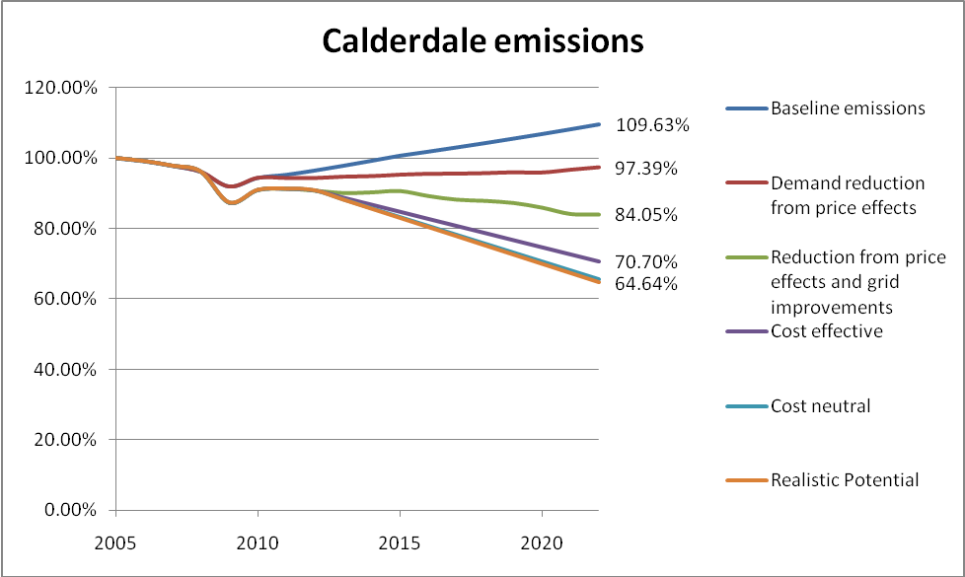

Notes for above graph:

Reduction from price effects and green grid: energy price increases and a lower carbon national electricity supply will lead Calderdale’s carbon footprint to fall by 15.95% between 2005 and 2022.

If Calderdale then exploited the cost effective options which more than pay for themselves over their lifetime, its carbon footprint would fall by 29.3% between 2005 and 2022.

If Calderdale then recycled the savings from the cost-effective options, and implemented further cost neutral measures that would pay for themselves over their lifetime, the carbon footprint would fall by 34.4% between 2005 and 2022.

If Calderdale then exploited all of the remaining realistic potential, the carbon footprint would fall by 35.4% between 2005 and 2022.

If Calderdale then exploited a percentage of community and large scale renewable energy opportunities, the carbon footprint would fall by a further 7% between 2005 and 2022.

- The 2020 Plan

6.1 A resilient low carbon economy is one which can adapt to change and is quick to turn challenges into opportunities. While a 40% carbon reduction target can be achieved by opening up the Borough to developers, it is also possible to maximise the resilience of our local economy by using this opportunity to improve skills, create local jobs and increase local ownership of resources.

Calderdale’s Energy Future will measure resilience through:

- Percentage of food grown locally;
- Number of businesses locally owned;
- Number of businesses using a local supply chain;
- Average commuting distance for workers;
- Percentage of energy produced locally ;
- Percentage of household income spent on energy;
- Quantity or proportion of building materials made from natural or recycled materials;
- Proportion of compostable waste composted and recyclable waste recycled;
- Number of children and adults who understand where their energy and food comes from;
- Number of people working in diverse low carbon enterprises;
- Number of people skilled to work in the low carbon economy.

The 2020 plan focuses on key activity areas to enable a move to a resilient low carbon economy. To reach our 40% carbon reduction target the 2020 Plan must include a mix of measures including:

- Energy efficiency and small-scale renewable energy within the domestic, commercial, transport and industrial sectors;
- Community- and commercial-scale renewable energy;
- Natural resource management.

Energy efficiency and small-scale renewable energy within the domestic, commercial, transport and industrial sectors could result in a 33% reduction in carbon emissions

Existing measures that pay for themselves through reductions in energy consumption would cost around £320 million over ten years, but would also leave a legacy of other social, economic and health benefits. Investing £9 million a year for ten years in measures such as small-scale solar energy, energy efficient appliances and improved insulation would reduce household energy bills by £28 million a year, paying back the investment in 3.3 years before generating savings for many more years. The graph on page 11 shows the impact of the introduction of different measures in stages, resulting in a 33% reduction in CO₂ emissions from a 2005 baseline.

The Leeds City Region Mini Stern report reviewed thousands of options for energy efficiency and small scale renewable energy measures. The report provides a realistic assessment of the costs and energy savings (and hence carbon savings) associated with each measure. These measures have been reviewed once again to assess the scope for the deployment of these measures in households, commerce, transport and industry in Calderdale. The result is the identification of the most cost- and carbon-effective options and the development of league tables and least-cost pathways. The results are all based on conservative assessments and realistic projections.

A league table showing the most cost effective measures can be found in Appendix A: Leeds City Region Mini Stern League Tables.

Industrial - Cost effective investments of £20 million in industry would result in an annual fuel cost saving of £10 million and a carbon saving of 54 kTCO₂.

Commercial - Cost effective investments of £150 million in commercial (public and private) buildings would result in annual fuel cost savings of £30 million and carbon savings of 77 kTCO₂.

Domestic - Cost effective investments of £90 million would result in annual fuel cost savings of £30 million and carbon savings of 64 kTCO₂. A detailed analysis of the number of measures required to meet this proposed carbon saving can be found in Appendix B.

Transport - Cost effective investments of £50 million would result in annual fuel cost savings of £10 million and a carbon saving of 13 kTCO₂.

Community and commercial scale renewable energy projects could provide more than the remaining 5.5% reduction in carbon emissions

A shift to a low carbon economy will require a focus on local production of renewable energy as well as energy efficiency measures. A report delivered by Carbon Descent has identified some key areas of renewable energy delivery and measured their impact on reaching a 40% reduction target. The following table shows the CO₂ savings that could be achieved by installing our theoretical maximum local capacity for biomass CHP, wind and hydro electric power:

Measure | CO₂ Savings (kTCO₂pa) | CO₂ Savings as % of target | CO₂ Savings as % of total emissions
Biomass CHP | 102.482 | 18% | 7%
Wind | 86.965 | 15% | 6%
Hydro | 2.32 | 0.3% | 0.16%
Total | 191.767 | 33.3% | 13.16%

These results show that we can exceed our targets if the full potential for renewable energy infrastructure is deployed in addition to the small scale renewable energy and energy efficiency measures detailed in the Mini Stern report.

The report showing these results can be found in Appendix B: Calderdale 40% Target Scenario Report.

The deployment of large scale renewable energy infrastructure will require careful planning and a greater understanding of the capacity of local landscapes to provide energy as well supporting biodiversity and community priorities. However, these broad brush figures provide a focus for further investigation.

Wind power is the conversion of the energy contained in the wind into electricity using a wind turbine. It is a tried and tested form of renewable energy generation that has existed for centuries. The Government’s Renewable Energy Strategy highlights that the UK is the windiest country in Europe and that wind power (on and off shore) could provide a contribution of up to 30% towards the Government’s 15% target for energy generated from renewables by 2020. The upland landscape of much of Calderdale coupled with the current ‘push for wind’ means that Calderdale can expect interest from developers seeking suitable locations to build wind farms for the foreseeable future.

Hydro Electricity is not as cost effective as wind energy per kW produced. However, there are additional benefits - hydro is linked to Calderdale’s industrial heritage and can have direct positive benefits for local wildlife where a fish pass is included in the construction.

Calderdale ranks among the top five districts in the Yorkshire and Humber Region for hydro potential. Hebden Bridge is also home to Power From The Landscape, an initiative which has delivered feasibility studies in key sites throughout the South Pennines. There is considerable opportunity for partners to develop old mill sites to generate electricity using the expertise within the Borough along with the natural resource capacity.

Biomass energy can be derived from farm waste, industrial waste, waste wood, municipal waste, wood or energy crops. Studies have suggested the limit of feasibility for accessing biomass is within 40km of the generating plant where it is to be used (Oxera Environmental, 2002). Therefore the biomass plant needs to be located near the heat load or electricity demand. Calderdale currently has limited managed woodland which is capable of providing fuel for biomass plants. An increase in dependence on wood as a fuel source would require a commitment to improving the local woodlands and the route to market.

Reducing our consumption: Each year UK food travels nearly 20 billion miles at the cost of an estimated 18 million tonnes of CO₂ per year. Yet according to WRAP (Waste Resources Action Program), the UK household on average buys a third more food than it actually needs, which ends up in the bin. Sound choices in what and how much we consume will have a major positive effect in lowering carbon emissions. In addition, local shopping reduces product miles, supports our local community directly and is one of the best ways of connecting with our neighbours.

Accessing Finance is a key element for successful delivery of this strategy. The opportunity to generate an income through savings and through initiatives such as the Feed in Tariff, Renewable Heat Incentive, Renewable Obligation Certificates and power purchase agreements means that it will be possible to set up revolving fund from an initial capital injection. This fund can then be used for continual reinvestment in new measures using the income generated. Commitment to a low carbon economy offers a highly attractive opportunity for investors and the potential for local partners to investigate new funding streams.

National initiatives will also provide a route to finance. The proposed Green Deal and the Green Investment Bank both offer access to new funding.

Jobs provision in the low carbon economy is predicted to double in the Leeds City Region by 2020. The main sectors that, without support and innovation, are potentially at risk from a shift to a low carbon economy are chemicals, metal manufacture, construction and road haulage. To put this in a local context, the 2008 figures from the Annual Business Survey show that 4.7% of Calderdale is employed in the construction sector, 4.1% in transport and communications.

A further 18.8% are employed in the manufacturing sector, which will provide opportunities for adaptive businesses. Calderdale businesses already have a growing influence within the low carbon manufacturing sector; local technology is being developed in areas such as heat pumps, LED lighting, small wind turbines, PV components and small scale hydro schemes. The creative industries and small businesses within Calderdale could also take advantage of environmental consultancy opportunities and knowledge transfer. This growing market indicates potential for further growth.

Supply chains offer opportunities for major areas of investment in the low carbon economy, for example offshore wind (bearings and gears), biomass and carbon capture & storage (CCS – pumps and valves).

Skills provision will enable local people to access opportunities arising from the low carbon economy. Partnerships to deliver training in schools and higher education facilities will provide existing businesses and young people with clear pathways to pursue low carbon careers.

Energy Security will be affected by the introduction of new energy supplies unless it is managed effectively. A local understanding of the potential effects of changing energy supplies will improve our ability to protect local communities from the threat of an intermittent supply.

Renewable Energy Actions:

- Focus initially on a discrete number of exemplar commercial and community-owned renewable energy schemes as a pilot for future projects;
- Build on initial schemes to create strong partnerships which will develop and drive a co-ordinated programme of energy efficiency and renewable energy campaigns throughout the Borough, focused on community benefit;
- Work with local communities and partners to identify suitable sites for community renewable energy projects and provide support and guidance for delivery;
- Work with partners to set up a funding vehicle for renewable energy and energy efficiency investments. The fund should aim to provide the initial costs to develop key renewable energy infrastructure and energy saving measures across the district that will provide a return to reinvest in a revolving fund;
- Deliver a woodland management programme to maximise production of local wood fuel;
- Align planning policies to encourage the installation of both commercial-scale renewable energy infrastructure and decentralised networks owned by our communities. The policy should establish a balance between the land needed for energy generation, leisure activities and biodiversity preservation;
- Influence regional policies to support Calderdale’s Energy Future;
- Develop influential partnerships with energy distribution companies to ensure they have effective strategies for resilience, adaptation and upgrading of networks to enable connection of locally owned renewable energy systems.
Building Energy Efficiency Actions:

- Work with partners to develop and drive a co-ordinated programme of schemes for retrofitting Calderdale’s housing stock, utilising the Green Deal and other national initiatives;
- Influence developers to deliver standards for new build and refurbishment of commercial premises towards zero carbon;
- Support research, technological development and best practice and enable business-to-business opportunities to participate in the Green Deal, Green Investment Bank and other national initiatives in Calderdale;
- Provide information to residents and businesses on options for reducing energy consumption in buildings.
Transport Actions:

- Ensure that the health benefits of reducing local air pollution and active travel modes are maximised by working in partnership with the Calderdale Transport Strategy (Transport Futures) and the Local Transport Plan.

Food Actions:

- Investigate options and deliver a co-ordinated programme that increases access to growing space for people to grow their own food;
- Work with communities to increase the knowledge and experience of local residents about how to grow food and where our food comes from;
- Provide information on foods with lower energy requirements such as seasonal foods and less meat.
Jobs and Skills Actions:

- Build partnerships between low carbon businesses and education institutions to increase knowledge transfer and the provision of appropriate low carbon skills;
- Support informal learning of practical low carbon skills through working with communities to share knowledge and set up exemplar projects;
- Provide support and information to local businesses on the opportunities within the low carbon economy, how to diversify and how to access the supply chain.
Continuing Action:

- Develop an action plan that identifies priority actions and the funding and resources required to deliver them within an agreed timeline. This will be developed by the cross sector working group;
- Develop a continuation plan which maps out the priorities for action to reach an 80% reduction in carbon emissions by 2050.

6.2 Improved health and well being

Improving health by reducing poor housing conditions associated with fuel poverty

Households suffering from fuel poverty are defined as those which spend more than 10% of their disposable income on fuel bills. This disproportionately affects the more vulnerable members of our community such as older people, disabled people and those suffering from long-term illness, as well as families with young children. Inadequately heated homes can lead to health issues such as respiratory illness, arthritis and increase risk of falls. Calderdale experiences Excess Winter Deaths of 0.61 per 1000 population, which is higher than the England average. The difference can be directly linked to fuel poverty.

There are clear financial benefits for society in reducing winter related illness. Research carried out in 2008 by the Chartered Institute of Environmental Health and the Buildings Research Establishment found that every £1 spent improving energy efficiency, where residents are likely to require treatment due to excess cold, saves the NHS £34.19 over 10 years, per 100,000 homes.

The 2008 Calderdale Private Sector Stock Condition Survey estimated that 24% of Calderdale households are suffering from fuel poverty. As the local population increases, a particular trend will be growth in the number of vulnerable older people and it is these vulnerable people who are likely to be living in hard to heat homes. Without intervention, fuel poverty across all property types is likely to increase significantly by the end of the decade. Early adopters of energy efficiency improvements are not likely to be those who could benefit the most from reduced energy bills. The financial investment required to improve the efficiency of a home may be out of reach for many households suffering from fuel poverty.

Reducing the health impact of local air pollution from energy and travel emissions

A low carbon economy will reduce reliance on coal and heavy oil in power plants, local commerce, industry and transport. The Expert Group on Climate Change and Health in the UK recognises that this will reduce air pollutants and the associated impact on public health.

Inefficient plant and transport will be replaced to an accelerated timetable as low carbon measures take effect. These changes in fuel mix and plant inventory will reduce emissions of sulphur dioxide (SO₂) and oxides of nitrogen (NO_{X}). Emissions of fine particles are also expected to reduce. Because of their health impacts, all three major pollutants are subject to air quality standards, which are set with advice from the government’s Expert Panel on Air Quality Standards.

Maximising the health benefits of sustainable travel through the promotion of healthy lifestyle choices and sensible driving

There is strong evidence that the health benefits of exercise from walking and cycling greatly outweigh the risks. In a London study, for example, it was calculated that a 10% shift from cars to cycling and walking might prevent 100 deaths and 1000 hospital admissions in London each year.

Health and Well Being Actions:

- Recognise that carbon reduction cannot be taken as a single issue and the provision of energy will have an increased impact on low income communities and people already experiencing fuel poverty;
- Work with communities and partners to deliver creative solutions to enable low income communities to share ownership of local renewable energy;
- Provide information to local residents on energy providers, local options and energy saving measures;
- Work with partners and communities to promote the health benefits of walking and cycling;
- Work with partners and communities to improve access to cycling and walking routes to work;
- Influence local transport planning objectives to provide a focus on low carbon modes of transport and reducing the need to travel.

6.3 Preserved and enhanced natural landscape

High carbon landscape – Low carbon economy

The natural assets within Calderdale provide a complex network of cultural, economic and biodiversity value. Calderdale’s landscape has developed over the last two centuries and shows the impact of industrial, agricultural and residential change. Some changes have led to increased flood risk, erosion and landslips, loss of carbon sinks and poor water quality. This unique landscape has great cultural and biodiversity value and has competing demands on it in these changing times.

In making decisions about future renewable energy and energy efficiency programmes, it is critical that the distinctive character and value of the landscape is recognised. The Calderdale landscape has local and national importance connected to the low carbon economy through:

- Woodlands for biomass and biodiversity, cooling, shelter, resilience and flood management;

- Water management and waterways;

- Moorlands which provide carbon sinks within the extensive peat and moss land areas, and are also important biodiversity assets;

- Cultural value attached to our green and blue infrastructure.

Preserved and Enhanced Natural Landscape Actions:

- Work with local communities to deliver low-tech monitoring of the impact of commercial scale wind turbines;
- Provide a strategic overview of the landscape capacity for renewable energy infrastructure and the competing demands on the land, including for preserving biodiversity and carbon sinks;
- Work with partners and communities to deliver an action plan that will minimise flooding and protect biodiversity;
- Work with the tourism industry to develop a co-ordinated approach towards the low carbon economy and the positive impact on the cultural value of our landscapes.

6.4 Everyone involved

Tackling climate change and realising our energy future will only happen if the goal becomes part of the way we all think. We will not be able to reach the challenging goal of an 80% reduction in carbon emissions by 2050 unless there is large scale buy-in to a low carbon way of living across the community. Calderdale Council is committed to the principle “Everyone Different, Everyone Matters”; Calderdale’s Energy Future strategy must therefore address the different situations and needs of everyone in the district. For the strategy to achieve its potential it must recognise that everyone matters and that everyone must be a part of the solution. This will be achieved by working with local people and partners in the following areas:

Localism: Empowering the community
The maxim “thinking globally, acting locally” rightly implies that one of the most effective ways to combat global climate change is by maximising the positive contribution of local communities. One of Calderdale’s strengths is often said to be its community base, with over 1000 voluntary organisations established across the borough. Realising the potential in the community is key to getting everyone involved, and this localism approach is already forging ahead with the third sector taking over management of local buildings and land, bringing positive benefits to the people of Calderdale. We also have a strong business community with small and medium sized businesses dominating local employment.

Support for community campaigns
Community organisations are well placed to get across the message about the positive things people can do to reduce carbon emissions. In conjunction with the Council, they can offer impartial advice about the most effective things householders can do and direct householders to sources of finance. Campaigns will maximise the take up of various initiatives by the local community such as energy efficiency and small scale renewable energy, linked to specific offers of financial support through the carbon reduction funding vehicle and other sources of finance, such as Feed-in Tariffs and the Green Deal.

Community-owned low carbon schemes
The Strategy will help to enable the development of community owned schemes that cut carbon such as renewable energy installations, district heating schemes and woodland development. The Local Development Framework will play a key role in enabling local community renewable schemes to happen.

Demonstrating what is possible
There is concern amongst some residents and businesses in Calderdale that nothing will happen as a result of developing Calderdale’s Energy Future strategy, that there will be a lack of pace and therefore carbon reduction will happen too slowly.

Previous experience with the Calderdale Climate Challenge project 2006-8 demonstrated that organisations and households are less likely to take action on their own without leadership from the Council, as well as from a wide partnership of public, private and community organisations.

Proactive leadership on climate change is therefore required and Calderdale Council will set out an ambitious plan. The Council and its partners in this strategy will demonstrate what is achievable, thereby providing a case study as well as gaining the experience needed to advise others.

Transparency
Keeping everyone informed of the opportunities, developments and progress of Calderdale’s Energy Future is crucial to the success of the strategy. Calderdale Council will encourage partners and the community to support the review process, celebrate success and disseminate opportunities that unfold with the strategy’s delivery.

Everyone Involved Actions:

- Work with community organisations to provide energy information and initiate energy campaigns throughout the Borough;
- Work with schools and colleges to engage young people on energy projects and to help them understand where their energy comes from;
- Influence the supply chain through the Council’s sustainable procurement strategy;
- The strategy partners will aim to establish finance and support options to facilitate community-owned low carbon schemes;
- Establish an Energy Future Working Group to identify new opportunities and assess threats as the strategy is delivered. The group will conduct an annual review and publish an annual progress report to identify where the strategy is succeeding and where it needs to improve or alter course;
- Establish a Calderdale Carbon Club – local businesses have come together to set up a club, helping share ideas and best practice about reducing carbon emissions;
- Use public buildings as low carbon demonstrations. Make sure that the possibilities for reducing carbon emissions in public buildings are fully exploited and that these are used to educate people about the potential for carbon saving;
- Lead the way with public sector emissions. The Council will set an internal carbon emissions reduction target of 40% by 2020. By implementing a range of measures across its own operations and buildings, the Council will demonstrate that it is possible to significantly reduce emissions. Public sector partners will be encouraged to set appropriate emissions targets;
- The Energy Future Working Group will help promote a local sense of pride by publicizing Calderdale’s achievements and identifying opportunities to celebrate success.
- From Vision to Action

This strategy sets out a basic framework for action to secure our energy needs, improve the economic future and combat climate change. More detailed work will be needed to deliver an implementation plan:

Clarify a more detailed programme of work – This strategy identifies the priority areas for action arising from the initial modelling work. These priority actions need to be developed into a detailed programme of works with lead implementers identified. Evidence from preliminary modelling reveals that carbon reduction measures are cost effective and will attract investment and growth into the Borough. The next step will set project timescales and provide a detailed cost analysis.

Set up a strong and influential Cross Sector Group to monitor progress and steer direction – This ambitious strategy can only be met through the co-ordinating action of organisations and individuals across the Borough. A steering group will ensure that the carbon agenda is embedded throughout key organisations and will also ensure that progress is monitored. This group will be able to respond to national opportunities and channel funding into Calderdale.

Alignment with policy and budget setting – All key strategies and new work delivery must be aligned with the priority actions set out in the strategy. The Local Development Framework has already adopted the overall carbon reduction target as part of its evidence base. However further work is required to align regional strategies.

Ongoing engagement with communities and business – This document has been strongly influenced by a business and public engagement process, however there is more to be done to engage residents, small to medium size businesses and other stakeholders. To ensure that the actions outlined in this strategy provide maximum opportunities for all business and individuals across the Borough, it is paramount that all are given the opportunity to be engaged at every stage.

Adapt to change – This strategy sets a framework for us to increase the pace of change for carbon reduction; as national policies change, more detailed work will be needed to develop the strategy further. When Carbon Reduction Commitment (CRCEES) guidelines are amended, the Green Deal comes into play and more officers embed the low carbon agenda into their work, the strategy will need to grow with these changes. Successive action plans will need to keep pace with progress and adapt to policy changes and opportunities as they arise.

- Concluding Remarks

This is an exciting time. At least £320 million of inward investment has been identified, as well as opportunities to provide local jobs within an emerging industry.

The next step will be to identify a detailed action plan under each of the delivery sectors; domestic, industry, commercial, transport and renewable energy.

This will identify severe resource deficiencies within our current delivery capacity, which will need to be addressed quickly and efficiently.

It requires a commitment from Calderdale Council and partners that has not been seen to date to enter into a low carbon economy. Such a commitment offers a return on investment that provides not only a clear financial advantage but also a lasting legacy of environmental, social and infrastructure benefits.

The 2020 Plan does not mark the end of investment into this sector; rather it signifies the beginning of a longer journey to 2050.

This is a challenging target and we need to increase the pace of change to achieve it. Financial and policy decisions must be aligned to reach this common goal and an attitude shift is required. It is no longer possible to continue with our current way of thinking – the opportunities and impacts of carbon emission reduction must be taken into account at every stage of our Borough’s development.

- Methodology

This document has been produced based on the following studies and Reports:

- Leeds City Region Mini Stern for Calderdale, Leeds University, 2011
- Vantage Point Modelling, Calderdale Council, 2011
- Maslen Renewable and Low Carbon Study, 2010
- Landscape Capacity Study for Wind Energy Developments, Julie Martin Associates, 2010
- Low Carbon and Renewable Energy Capacity in Yorkshire and Humber, AECOM, 2011

This document has been influenced by the following engagement events and consultation:
Business Lunch, 14th September 2011
Public Event, 14th September 2011
Key Deliverers’ Meeting, 7th October 2011

- Summary of Actions
An enhanced building stock reducing the amount of heating consumed by our buildings

Upgraded appliances and energy systems throughout housing and commercial buildings reducing the amount of electricity consumed in our buildings

Resilient Low Carbon Economy
Co-ordinated programme of schemes for retrofitting Calderdale’s housing stock

Standards for new build and refurbishment of commercial premises
Provide information to residents and businesses on the options for reducing energy consumption in buildings

Enable business to business opportunities to develop participation in investment initiatives

Large scale renewable energy infrastructure, compatible with our local landscape, producing local energy and contributing to the decarbonisation of the national grid

A finance mechanism which continues to support low carbon developments
A discrete number of exemplar commercial and community-owned renewable energy schemes

Build on initial schemes to develop and drive energy efficiency and renewable energy campaigns throughout the Borough, with a focus on community benefit

Identify suitable sites for community renewable energy and provide support and guidance for delivery
Work with partners to set up a funding vehicle for renewable energy and energy efficiency investments
Deliver a woodland management programme to maximise production of local wood fuel

Partnerships with energy distribution companies to enable connection of locally owned renewable energy systems
Influence regional policies to support Calderdale’s Energy Future

Aligned policy to support a low carbon economy

Align planning policies to encourage commercial scale renewable energy and decentralised networks owned by our communities

Work in partnership with the Calderdale Transport Strategy (Transport Futures) and the Local Transport Plan

An enhanced transport system

Local residents and businesses accessing skills provision and jobs provided within the low carbon economy
Education institutions and low carbon businesses form partnerships to increase knowledge transfer and provision of low carbon skills

Practical low carbon skills through working with communities to share knowledge and set up exemplar projects

Provide support and information to local businesses on the opportunities within the low carbon economy, how to diversify and how to access the supply chain

Common access to growing space for children and adults to grow their own food

Resilient Low Carbon Economy (continued)
Deliver a co-ordinated programme that increases access to growing space for people to grow their own food

Increase knowledge and experience of local residents about how to grow food and where our food comes from

Provide information on foods with low energy requirements
A plan to continue delivering actions that will meet an 80% reduction in carbon emissions by 2050

Energy Future Working Group to develop an action plan that identifies priority actions and the funding and resources required to deliver them within an agreed timescale

Develop a continuation plan which maps out the priorities for action to reach an 80% reduction in carbon emissions by 2050

Everyone Involved

Community area enhancements directly funded by locally owned renewable energy systems

Establish finance and support options to facilitate community owned low carbon schemes

An increased understanding about sources of energy and food and how we can be actively involved in their production

Work with community organisations to provide energy information and initiate energy campaigns throughout the Borough
Work with schools and colleges to engage young people

Key leaders demonstrating what is possible
Public buildings as low carbon demonstrations

CMBC to reduce its consumption of key resources
CMBC to influence the supply chain through implementing a sustainable procurement strategy

Establish a Calderdale Carbon Club
CMBC reduction target of 40% by 2020

Transparency

Establish the Energy Future Working Group

A local sense of pride in Calderdale’s Energy Future

Promoting and celebrating Calderdale’s successes

Improved Health and Well-being
Focus improvements on low income communities and vulnerable people experiencing fuel poverty through schemes such as the Green Deal and ECO, outreach and other initiatives

The elimination of fuel poverty

Provide information to local residents about energy providers, energy efficiency and renewable energy campaigns

Low income communities benefiting from locally produced renewable energy
Deliver solutions to enable low income communities to share ownership of local renewable energy

Work with partners and communities to promote the health benefits of walking and cycling

Improved access to cycling and walking infrastructure

Work with partners and communities to improve access to cycling and walking routes to work

Influence local transport planning objectives to provide a focus on low carbon modes of transport and reducing the need to travel

Preserve and Enhance the Natural Landscape
Joint working and communication between partners to minimise flooding, conserve carbon sinks and increase biodiversity

Work with partners and communities to deliver an action plan that will minimise flooding and protect biodiversity

Increased understanding about impacts of development on the natural carbon sinks and how to preserve this resource

Work with local communities to deliver low-tech monitoring of wind turbines

Energy Future Working Group will provide a strategic overview of landscape capacity for renewable energy and the competing demands on the land for preserving biodiversity and carbon sinks

.
Work with the tourism industry to provide a co-ordinated approach to a low carbon economy and the positive impact on the cultural value of our landscapes
Ensure that our enhanced natural landscape and energy demonstration projects benefit from tourism potential.

Calderdale woodlands are well managed and produce fuel for local biomass consumption

Managed local woodlands to develop biomass fuel

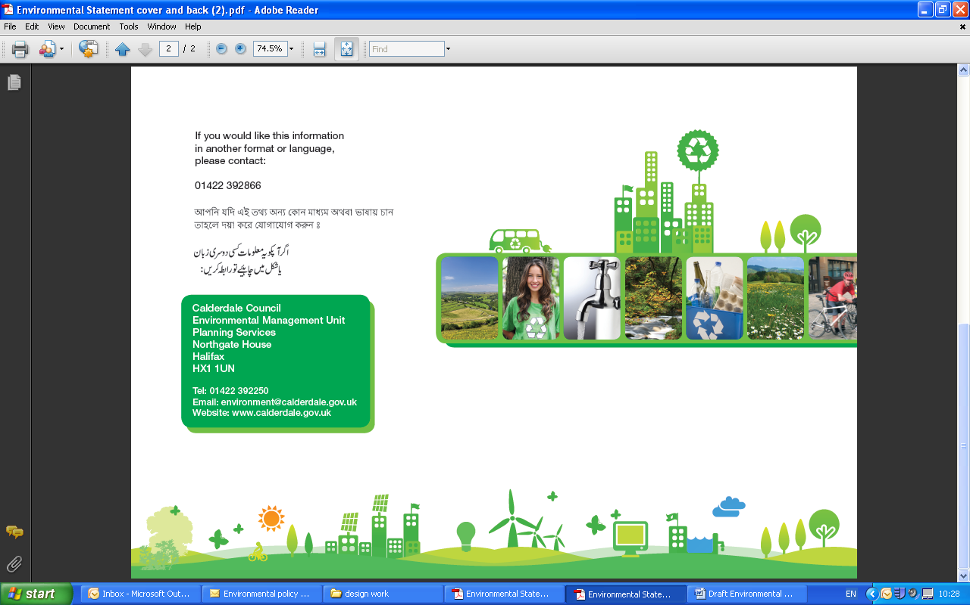

Leeds University Mini Stern for Leeds City Region, Calderdale focus, 2011
Green Jobs Report, Yorkshire Cities, 2011

