Everyone different everyone matters


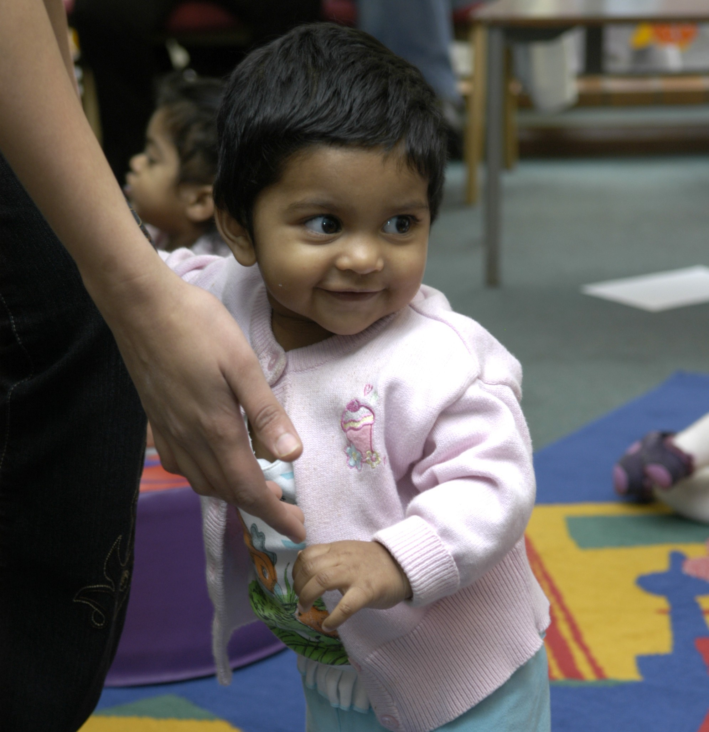



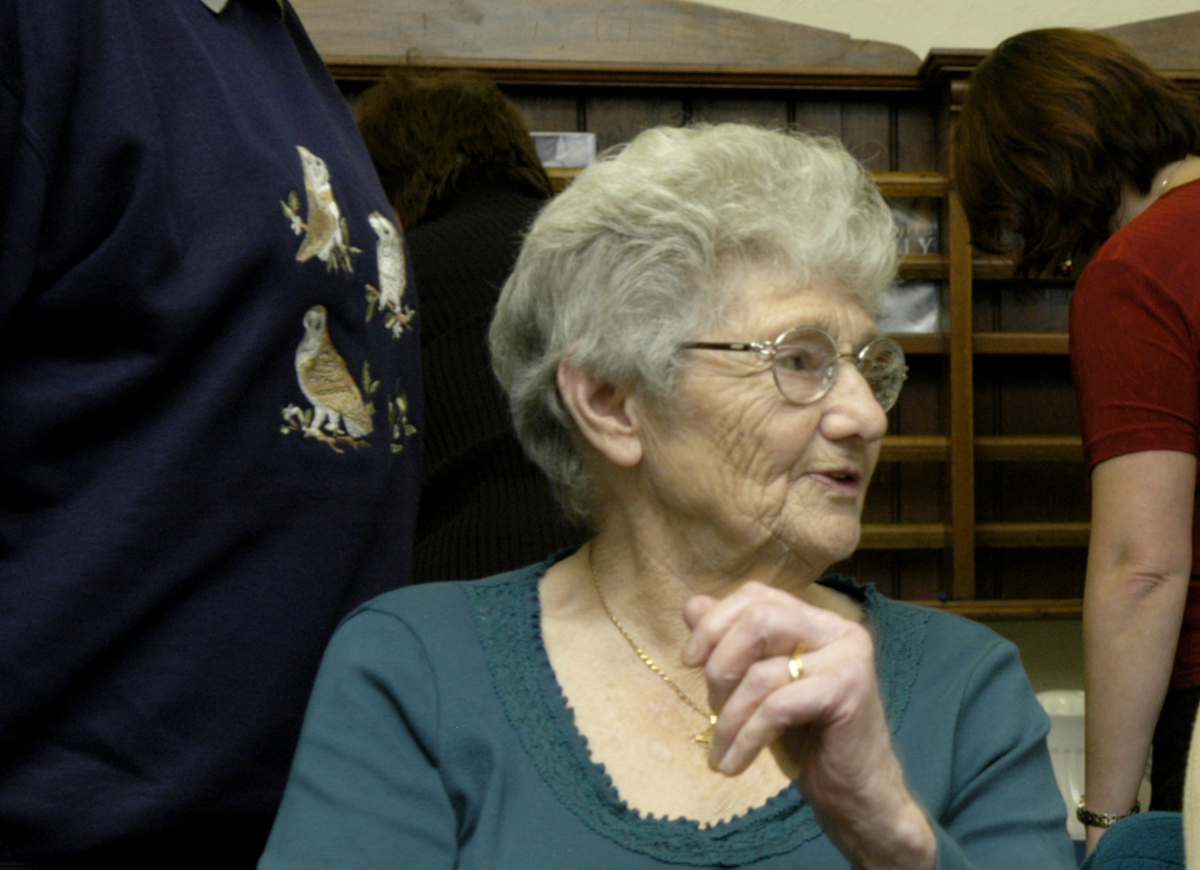


Equality & Community Cohesion Impact Assessment (EIA)
VgVov.uk
www.calderdale.gov.uk
Outcome of the Library Facilities Review

Safer and Stronger Communities
December 2011
Equality Impact Assessment (EIA)

PART A : Initial Assessment to determine relevance if a full Impact Assessment is required

Directorate: Communities  Service Area: Cultural Services  Service / Policy / Function or Procedure to be assessed:  Outcome of the Library Facilities Review  Is this: New / Proposed, Existing or Changing | Date commenced: 10/11/2011  Date completed:  Lead Officer: Carole Knowles

What are the aims and objectives / purpose of this?
The Library Facilities Review is phase 2 of the Library Service transformation and focuses on buildings and vehicles. There is a requirement to save £150,000 from 2012/ 2013 budgets. In order to achieve the saving there is a recommendation to reduce the opening hours of district and medium sized libraries and to reconfigure the mobile library service to concentrate on the housebound and those is residential care. There will therefore be changes to the way the service is currently delivered and made available.

The options presented in the Library Facilities Review offer a strategic choice between maintaining the current network of 22 libraries or a reduced number supplemented by mobile services. Library closures can be avoided and the required savings achieved by reducing opening hours (£45k) and reshaping the mobile services (£105k).

However, in order to achieve the required savings a reduction in service will result. This will mean reducing opening hours at district and some community libraries and reconfiguring the mobile library service. The alternative option would have meant library closures and feedback from the public consultation was that this would be the least preferred of the options.

- The revised pattern of opening hours will take into account feedback from the consultation and also ensure that libraries within a neighbourhood have complementary opening times in order to maintain ease of access to a library facility.

Reduced opening hours also spreads the impact more widely and fairly. Moreover the effects can be mitigated by involving communities in the delivery or enhancement of their local services.

- The mobile library service will be reconfigured to focus on those who are housebound or in residential care, ensuring that priority groups are not disadvantaged.

Taking these options demonstrates the Council’s commitment to fulfilling its statutory duty to provide a comprehensive and efficient library service while achieving the required saving. The service will also retain strategic flexibility into the future because reduced opening hours can be reversed and a mobile library service can be reintroduced.

Please indicate its relevance to equality by selecting YES / NO / NOT SURE in each box below:
Is this relevant to: | Age | Disability | Gender | Race | Religion & belief | Gender Reassign-ment | Pregnancy and Maternity | Sexual orientation
Eliminating unlawful discrimination, victimisation and harassment | Yes | Yes | Yes | Yes | Yes | Yes | Yes | Yes
Advancing equality of opportunity | Yes | Yes | Yes | Yes | Yes | Yes | Yes | Yes
Fostering good community relations | Yes | Yes | Yes | Yes | Yes | Yes | Yes | Yes

If NOT RELEVANT, the Impact Assessment is now complete - please send a copy to your Directorate Equality Champion & to the Cohesion and Equality Team.

If RELEVANT, a full Impact Assessment needs to be undertaken (PART B).

Level of priority (if new/proposed policy/service): High Medium Low

PART B : Full Impact Assessment

Who benefits and how do they benefit? | The overall purpose of the library service is to provide community facilities and services, whose purpose is to encourage individuals or groups of individuals to gain unbiased access to a wide range of information, knowledge and works of creative imagination in books and other media to:  - Promote access and participation  - Provide routes to information, learning, knowledge and skills  - Promote reading, literacy, creativity, inspiration and the enjoyment of leisure time  - Support personal, community and economic well-being  - Provide accessible and inclusive library service for all those living, studying or working within the Borough.  Libraries are a visible symbol of community provision, neutral welcoming spaces and much valued by users, providing a majority of its services free of charge.
What outcomes are sought and for whom? | - Promotion of reading, informal learning and supporting literacy and pre-school learning.  - Providing access to information and knowledge  - Providing access to digital information via the People’s Network.  - Offering neutral and welcoming space open to all in the community supporting cohesion and community identity.
Are there any associated policies/functions/services or procedures? | - To deliver a service which is ‘comprehensive and efficient’ under the Public Libraries and Museums Act 1964  - Volunteer Policy  - Library Stock Policy  - CMBC Equality & Diversity Policy
How will this service be delivered (e.g. direct service delivery, outsourced etc.)? | - Direct delivery  - Partnership working
If external partners are involved in delivering the service, who are they? | N/A
How is the service publicised and how do people access and/or request it? | Libraries are one of the most valued and well used of Council services with high satisfaction ratings. They are high profile in their communities and are also publicised by using a wide range of media and accessible formats, leaflets, Council website and Intranet, word of mouth, via partners, presentations to schools and groups in the community, newspaper promotions and stories.

What evidence/data already exists about the service and its users? (In terms of its impact on the ‘equality strands’, i.e. ethnicity, gender, disability, age, religion/belief, sexual orientation etc)

Evidence |  | Details
Research:  Any local, regional or national research available to help inform this EIA? |  | Comprehensive data about all library service points was assembled for the Facilities Review. This included:  - Annual running cost of each static library and mobile library, including frontline staffing, rates, energy, cleaning and communications.  - Performance information, for all libraries and mobile libraries including annual visits, active borrowers, age range of users, items issued, cost per visit and cost per issue.  - Community profiles of the 21 district community libraries, including the plotting of other council or partner services, within a 2 mile radius.  - Information from surveys undertaken on opening hours in 2010 and satisfaction in 2011.  All the above information was made available as part of the consultation to assist respondents in submitting an informed view on which services should be retained whilst making the saving.
Consultation:  Has there been any consultation with, or input from, service users, staff or other stakeholders?  If so, with whom, how were they consulted and what did they say? |  | Public consultation on the Library Facilities Review was conducted from 9th September until 23rd October 2011 via a variety of methods:  - Printed response form placed in libraries and other community venues  - Online form  - Ward Forums  - E-Talkback survey  - Drop in sessions at Halifax Central, Brighouse and Todmorden Libraries.  Readers Groups had an opportunity to feedback as both individual members and as a group.  Library staff have been included in the development of the proposed savings methods.  The survey results have been published on the Council website.
Monitoring:  What equality monitoring information/data is currently gathered? Are there any significant gaps?  What is the profile of current users/beneficiaries, and staff compared to the local demographic profile? |  | Currently age, gender and ethnicity are gathered as part of the library enrolment process. The level of use of the service by people who consider that they have a disability is monitored through the Public Library User Surveys (PLUS). Specific information in terms of disability can be added to a library user’s record if necessary in terms of any specialist materials needed  Age information was compiled from member information for each library and included on the data sheets linked to the consultation process.  By the very nature of their inclusiveness there is a broad representation of the population using libraries.  Communities vary geographically, the most diverse communities living in the Central Halifax neighbourhood, with a significant number of the LGBT community residing in Hebden Bridge.  Library stock is selected to reflect the profile of the local community and issues monitored to ensure continuing relevance. Suggestions from service users are received and acted upon.in order to cater for local and changing needs.
Quality Assurance:  Any complaints, compliments, satisfaction surveys or customer feedback to help inform the EIA? |  | PLUSs are carried out regularly and the results were included on the data sheets. The latest survey was in March 2011.  PLUS covers both adults and children and asks users about specific services and invites them to input suggestions and recommendations for improvement.  A number of written comments also accompanied the return of the Library Facilities Review consultation forms with various suggestions on how the savings might be made.  Any complaints and service suggestions are logged on the Directorate complaints and compliments database and monitored and acted upon as appropriate.
If information/data gaps are uncovered from the above assessment, what are they and how will you address them? |  | At present it is not felt that there are information/ data gaps. We will continue to review and analyse the availability of information to determine any gaps However, should these emerge actions will be developed to resolve.
Barriers:  What are the potential or known barriers for the different ‘equality strands’ set out below?  Consider:  - Where you provide your service, e.g. the facilities/premises;  - Who provides it, e.g. are staff trained and representative of the local population/users?  - How it is provided, e.g. do people come to you or do you go to them? Do any rules or requirements prevent certain people accessing the service?  - When it is provided, e.g. opening hours?  - What is provided, e.g. does the service meet everyone’s needs? How do you know?  * Some barriers are justified, e.g. for health or safety reasons, or might actually be designed to promote equality, e.g. single sex swimming/exercise sessions, or cannot be removed without excessive cost. If you believe any of the barriers identified to be justified then please indicate which they are and why. |  |  | Solutions:  What can be done to minimise or remove these barriers to make sure everyone has equal access to the service? Consider:  - Other arrangements that can be made to ensure people’s diverse needs are met;  - How your actions might help to promote good relations between communities;  - How you might prevent any unintentional future discrimination.
Age | All ages are well represented with a concentration of those in the 55 to 74 age group. Libraries have large collections of targeted stock, for example Large Print and Talking Books  Parents with young children are also regular users of the service, many attending events targeted at pre-school children.  After school use is also popular at some libraries. |  | Changes to the library opening hours will need to take into account needs and use patterns of the various user groups, whether of school age, unemployed, economically active or retired.  Discover, the children’s library service will be able to maintain their programme for pre-schoolers as a majority of sessions are mornings and early afternoon.
Disability | A majority of Calderdale libraries are fully accessible and the housebound service currently supports those unable to travel independently to a static library.  Staff are trained in Disability and Equality Issues. |  | The proposed changes in terms of the mobile library service will protect those who are housebound but may affect those who might use the mobile library as an alternative to travelling to a static library.  Housebound people however may benefit from an even greater personalised service.  All but 2 (Hipperholme and Rastrick) of the 22 libraries are DDA compliant. However people are signposted as necessary to alternative sites.
Gender | The gender balance of users tends to be higher in terms of females. |  | The proposed changes to the service to meet the savings will not disproportionately affect library users of different genders.
Race | The library user profile reflects closely that of the population profile of Calderdale but can vary significantly between community libraries. |  | Changes to the library opening hours will take into account needs and use patterns of the various user groups
Religion or belief | We respect the faiths of all service users and library staff in terms of materials and facilities available. |  | The proposed changes to the service to meet the savings will not disproportionately affect people of different faiths.
Gender Re-assignment | Libraries welcome and provide services for all communities. |  | The proposed changes to the service to meet the savings will not disproportionately affect people who have undergone or are undergoing gender reassignment.
Pregnancy and Maternity | Libraries actively promote services for under 5s and they are particularly well provided for at the static libraries in terms of activities and materials. |  | The proposed changes to the service to meet the savings will not disproportionately affect those who are pregnant or raising young families.
Sexual orientation | Libraries regularly work in cooperation with the LGBT community in terms of events and making relevant materials available at most libraries. |  | The proposed changes to the service to meet the savings will not disproportionately affect people of different sexual orientation.

If posts are affected or deleted, please list how this may affect how the Council ensures that its workforce is reflective of the community we serve. (Please note that if these numbers are so small it is important the individuals are not identified).

Employee Characteristic | No Negative  Impact | Negative Impact/barriers – please state what this may be | Solutions: are there any ways in which you could mitigate the impact
Age | No
Disability | No
Gender | Yes | A majority of those staff affected by the proposed changes are female and work on a part-time basis. | Vacancies have been held open pending the outcome of the Review to ensure that there will be sufficient available vacant hours to maintain contracted hours of any staff affected by the changes.  Affected staff will be consulted on any changes to their timetabled hours following the finalisation of the revised opening hours.  This will be completed by March 2012 in preparation for introduction from April 2012.  Frontline staff will be asked their opinion on revised opening hours as they are in an informed position to comment.
Gender reassignment | No
Pregnancy & maternity | No
Marriage and Civil Partnership | No
Race | No
Religion or belief | No
Sexual Orientation | No

Further Consultation:
Having established the barriers and potential solutions, do you need to consult with users/beneficiaries or others to ensure your response is appropriate?
YES X NO

If YES, how will this be done?
Continued visitor surveys plus recording of feedback to frontline teams to check that solutions introduced are satisfactory and meeting needs in light of the changes, as far as possible.

If NO, how can you be sure you know enough?

If a new/proposed policy: Will the policy be adopted? Yes No

If an existing policy: Are changes necessary? Yes No

If a changing policy: Are the changes necessary? Yes X No

Monitoring:
If you have answered ‘Yes’ above, how you are going to ensure the solutions you have identified are effective?

By continuous monitoring of the feedback from both library users and non users.

PART C : Equality Action Plan

Barriers identified | Solutions identified | Action required | Resource implications | Timescale | Lead Officer
Decrease in availability of the static libraries following reduction in hours. | In revising the opening hours consideration will be given to:  - Daily and hourly usage patterns  - Geographical location in terms of ensuring that libraries in adjacent neighbourhoods have complementary opening times.  - Local schools  - Local market days and early closing.  Local community groups and other partners making use of the library space outside of the formal opening hours, ensuring best use of the facility. | Analysis of the wealth of up to date information that is available in terms of use patterns for all those libraries identified for reduction in opening hours. Information on the hourly usage patterns are available including:  - PC bookings  - headcount  - Issue and return of materials.  A programme of improvements for each community library will be drawn up in consultation with the community, seeking to develop interest from local people in the delivery of their library services.  An individual impact assessment will be undertaken for each affected library. | Within existing resources.  Within existing resources.  Within existing resources. | January 2012  April 2012 onwards  January 2012 | Jayne Watkinson/ Jon Medcalf  Carole Knowles  Jon Medcalf/ Jayne Watkinson
Reduction of regular mobile library services to those who do not receive home deliveries. | 88.3% of households in Calderdale are within 1 mile of a static service point.  Highlight to current mobile library users their nearest static library. | A communication plan to be drawn up to inform mobile library users of alternative service points. | Within existing resources. | January 2012 | Carole Knowles/ Jayne Watkinson with support of Communications Unit.
Reconfiguring mobile library services to focus on those priority groups who are unable to visit a static library. | The current number of users of the housebound service is c200. The service may need to be widened to encompass additional clients to ensure inclusion of all those needing a home delivery service. | Define and plan the new service to include those already in receipt of home deliveries.  Look to widen the coverage up to 300 clients.  Broaden the current home delivery service volunteer base. | Within existing resources. | January 2012 | David Duffy/ Jayne Watkinson

PART D : Summary for Publication

Directorate: Communities  Service Area: Cultural Services  Service / Policy / Function or Procedure to be assessed:  Outcome of the Library Facilities Review  Is this: New / Proposed X Existing Changing | Date commenced:  Date completed:  Lead Officer:

What are the aims and objectives / purpose of this?
The Library Facilities Review is phase 2 of the Library Service transformation and focuses on buildings and vehicles. There is a requirement to save £150,000 from 2012/ 2013 budgets. In order to achieve the saving there is a recommendation to reduce the opening hours of district and medium sized libraries and to reconfigure the mobile library service to concentrate on the housebound and those is residential care. There will therefore be changes to the way the service is currently delivered and made available.

Adverse effects Found X Not Found

Outcome Policy amended Consultation undertaken X

Involvement: Please indicate who carried out the Equality Impact Assessment and how other stakeholders were involved.
Carried out by Library Service staff with the assistance of Neighbourhoods & Communities colleagues.

A 6 week public consultation was carried out to elicit from the public their preferred options from those proposed: reduction in opening hours, reconfiguration of the mobile library service or library closures. The recommendations are based on the responses received.

Summary of Outcome: Were barriers identified, and have plans been put in place to minimise these?
A number of barriers were identified as a result of the service reductions. Plans to minimise these are in preparation

Will the new policy be adopted? Yes X No

Equality Action Plan
(Insert Equality Action Plan here, or, if no further action is required as a result of the EIA, please explain why.)

PART C : Equality Action Plan

Barriers identified | Solutions identified | Action required | Resource implications | Timescale | Lead Officer
Decrease in availability of the static libraries following reduction in hours. | In revising the opening hours consideration will be given to:  - Daily and hourly usage patterns  - Geographical location in terms of ensuring that libraries in adjacent neighbourhoods have complementary opening times.  - Local schools  - Local market days and early closing.  Local community groups and other partners making use of the library space outside of the formal opening hours, ensuring best use of the facility. | Analysis of the wealth of up to date information that is available in terms of use patterns for all those libraries identified for reduction in opening hours. Information on the hourly usage patterns are available including:  - PC bookings  - headcount  - Issue and return of materials.  A programme of improvements for each community library will be drawn up in consultation with the community, seeking to develop interest from local people in the delivery of their library services.  An individual impact assessment will be undertaken for each affected library. | Within existing resources.  Within existing resources.  Within existing resources. | January 2012  April 2012 onwards  January 2012 | Jayne Watkinson/ Jon Medcalf  Carole Knowles  Jon Medcalf/ Jayne Watkinson
Reduction of regular mobile library services to those who do not receive home deliveries. | 88.3% of households in Calderdale are within 1 mile of a static service point.  Highlight to current mobile library users their nearest static library. | A communication plan to be drawn up to inform mobile library users of alternative service points. | Within existing resources. | January 2012 | Carole Knowles/ Jayne Watkinson with support of Communications Unit.
Reconfiguring mobile library services to focus on those priority groups who are unable to visit a static library. | The current number of users of the housebound service is c200. The service may need to be widened to encompass additional clients to ensure inclusion of all those needing a home delivery service. | Define and plan the new service to include those already in receipt of home deliveries.  Look to widen the coverage up to 300 clients.  Broaden the current home delivery service volunteer base. | Within existing resources. | January 2012 | David Duffy/ Jayne Watkinson

Signed off by Head of Service: Date:
Agreed by DMT: Date:
Lead Officer:
Contact: Tel: e-mail address:

