Library Facilities Review Results from Consultation – 1st November 2011

Total number of responses = 2235

Q1. Have you used any Calderdale libraries within the last 12 months?

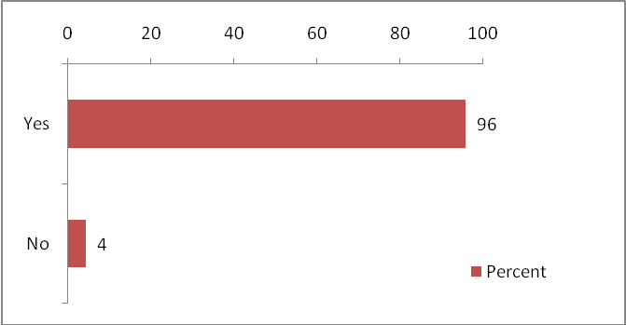

Q2. From the list of options below please tell us your preference.

- Cease all mobile library services, saving £150,000
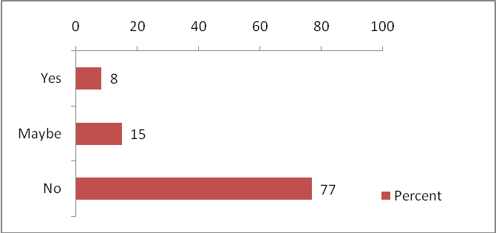

- Concentrate mobile services on those who are housebound or in residential care, saving £100,000
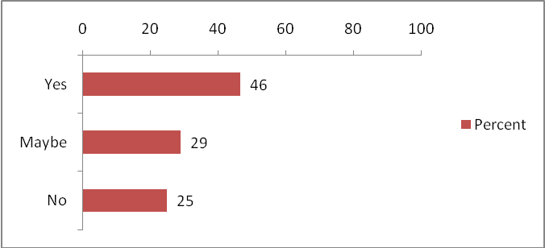

- As option (b) above but include those communities more than 2 miles from a library, saving £70,000
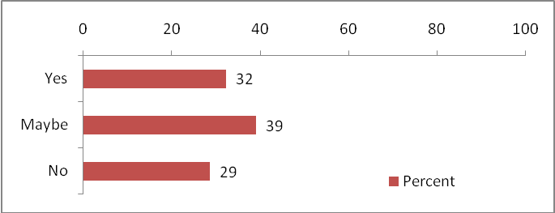

- Reduce opening hours at 6 large libraries from 45 hours to 37 hours, saving £20,000
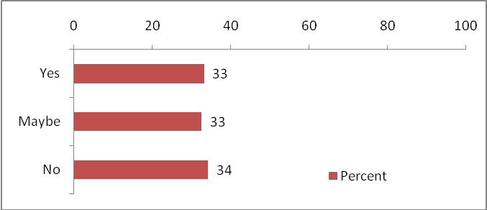

- Reduce opening hours at 5 medium size libraries to a standard of 25 hours per week, saving £20,000
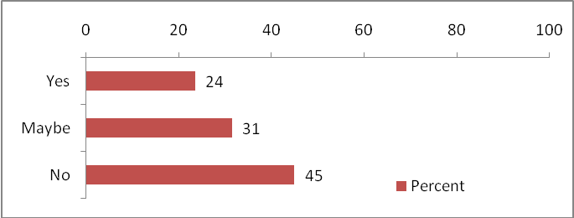

- Close some libraries, to save up to £150,000
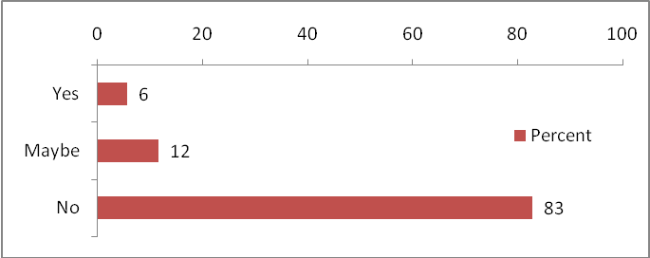
Q3a. Arising out of the recent national debate, other potential ways of providing library services have been suggested. In the short term these will not provide the necessary savings but they may offer opportunities in the medium to longer term. Please tell us which you think we should consider further.

- Share some or all service across Council boundaries
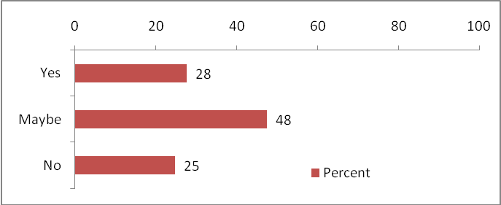

- Co-locate council services. For example, libraries with children's centres, youth centres, schools or customer services
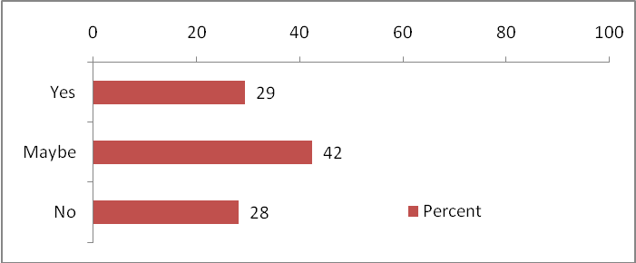

- New providers: outsource libraries to the private sector or a trust
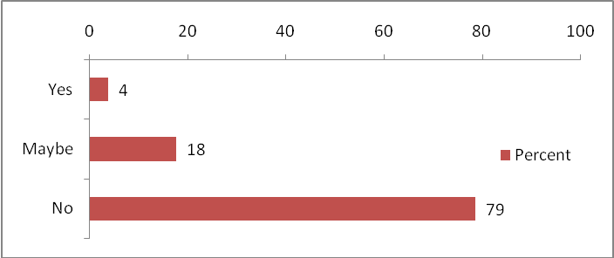

- Empower communities: transfer libraries to community or voluntary management

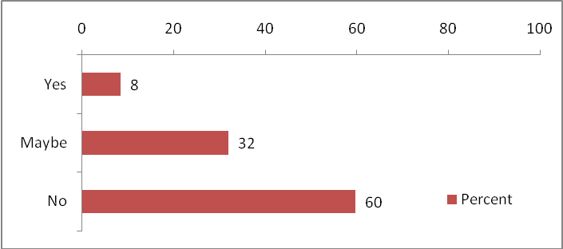

Q3b. Other than the option outlines in question 3a above can you suggest any alternative ways of delivering or funding the library service?

Respondent’s comments relating to this question were mainly associated with:

- Reviewing current charges already in place, implementing new charges such as the introduction of various library membership schemes
- Reduction in staff costs
- Smartening admin procedures
- Review opening hours
- Co-location of services
- Voluntary management
- Promote / hold more events, rent the space within libraries

