CALDERDALE MBC

WARDS AFFECTED: CALDER
9
CABINET

9 JANUARY 2012

TRANSFER OF LAND AT SANDY GATE, HEBDEN BRIDGE TO HEBDEN ROYD TOWN COUNCIL

REPORT OF THE DIRECTOR FOR COMMUNITIES

- ISSUE

1.1 To consider a request from Hebden Royd Town Council for the transfer of an area of land used for grazing at Sandy Gate, Hebden Bridge from Calderdale Council to Hebden Royd Town Council (see Appendix 1 and Appendix 2).

- NEED FOR A DECISION

2.1 Calderdale Council is under a legal duty contained within s123 of the Local Government Act 1972 to obtain best consideration when disposing of land and property assets. Furthermore, the Council’s Corporate Property Policy and Strategy requires that land and property assets should normally be sold or leased at full market value. This report allows Cabinet to consider whether the provisions contained within the General Consents Disposal Order 2003 should be exercised in order to facilitate transfer of the land at less than best consideration.

2.2 Hebden Royd Town Council has requested the transfer at nil consideration.

- RECOMMENDATION

3.1 It is recommended that Cabinet:

- Approve the transfer of the land at Appendix 1 on a 125 year lease at nil consideration to Hebden Royd Town Council, subject to the necessary procedures being followed and consents being obtained; and

- Delegate to the Director of Communities (in consultation with the Cabinet Member for Communities, the Head of Democratic and Partnership Services and the Director of Economy and Environment) authority to complete a transfer agreement with Hebden Royd Town Council which will permit the Town Council to enhance allotment provision within their area.
- BACKGROUND

4.1 The land at Sandy Gate is part of a plot currently let for grazing see Appendix 1. This plot was last let in 2008.

4.2 Cabinet approval was granted on 31st January 2011, minute number 151 for the transfer of the Council’s only allotment site in the area to Hebden Royd Town Council. Once this approved transfer is completed the town council will be responsible for the allotments waiting list within the area.

4.3 Hebden Royd Town Council has a proactive approach to allotment provision, actively working to secure land since July 2007 following a formal request from 6 residents. There is a high demand in the area and the Town Council identified the land at Sandy Gate as having potential to help fulfil this demand.

4.4 Following consultation with local residents, detailed proposals have been drawn up for the site and funding identified, see Appendices 3 and 4. The Town Council is also working with ‘Tree-responsibility’ who have submitted a funding bid to DEFRA for a community orchard and some woodland planting on the steeper areas of the site, these are shown on the plan in Appendix 5

4.5 The Localism Act actively encourages decentralisation and the transfer of services/assets to local communities. The Council has already transferred a number of assets to community groups following the adoption of a Calderdale Council policy on Community Management of Assets in April 2009, and has transferred the responsibility for allotment provision within the Hebden Royd area to the Town Council. The transfer of the land at Sandy Gate to Hebden Royd Town Council fits well into this agenda.

4.6 The property is currently allocated Greenbelt on the UDP. Whilst it is difficult to put a current open market value on the land it is considered by Land and Property Services that at some time in the future, the site will be regarded as suitable for residential development and that the value will increase significantly over time.

- OPTIONS CONSIDERED

5.1 Option 1 - Transfer the land to Hebden Royd Town Council on a 25 year lease at nil consideration with the certainty that the Council could recover possession on notice (say 12/18 months) after this period. The allotments would be designated as temporary. This option would give the Council the flexibility to take advantage of any future increase in land value. This option is being considered due to the predicted future value of the land concerned (see financial implications below) but would not fit with other recent land transfers for the purposes of allotment provision and may impact on the future viability of the site due to limiting funding opportunities. However, community use of the land for allotments and an orchard would be secured for the term of the lease with an option for extending the lease after that period.

5.2 Option 2 - Transfer the land to Hebden Royd Town Council on a 125 year lease at nil consideration. This is the recommended option. This would meet the Council’s objectives as described in 5.1 but would not enable the Council to take advantage in future years of any increasing land values. This option fits within the Council’s wider agenda of empowering local communities, reflects the fact that allotment provision should rest with first tier authorities, and would help to meet the high demand for allotments in the area. It would, however, safeguard community use of the land in the long term.

However, any transfer of more than 7 years is classed as a disposal and the under value is the loss of capital receipt. The under value in this case is £95,000.

However, a 125 year lease would ensure community use of the land in the long term and would be in line with other transfers of land for use as allotments across the Borough. Members need to be satisfied that the potential under value of up to £195,000 is outweighed by the positive aspects of a transfer, such as the way in which it should help create more potential for long term investment in allotments within the Hebden Royd area, where there is a demonstrable demand for such facilities and few alternative sites available.

5.3 In the case of both the above options the leases need to be contracted out of the Landlord and Tenant Acts and contain clauses that would enable CMBC to terminate the lease and take the land back if for example it ceased to be used for the permitted purpose or was not maintained. Although this particular case is a transfer to a Parish Council and the risk may be low there needs to be consistency in all transfers.

5.4 Option 3 - Grant a 5 year lease in line with other self managed allotment sites in Calderdale. This would mean that Calderdale Council would retain responsibility for non-routine maintenance and the infrastructure of the site. It may also constrain the ability of the Town Council to attract external funding.

5.5 Option 4 - Dispose of the site on the open market in order to generate a capital receipt.

5.6 Option 5 - Do nothing and continue to manage the site as it is now. This would restrict the ability of the Town Council to comply with Allotment Law and would signal apparent unwillingness on the part of the Council to devolve power to local communities.

- CONSULTATION

6.1 Hebden Royd Town Council have consulted with local residents as detailed in Appendix 4.

6.2 Since the land is held under the Open Space Act 1906 notices are being placed in the local press to advise on the proposed 25 year lease.

- FINANCIAL IMPLICATIONS

7.1 The potential income from the grazing licence is £100 per annum. If it is transferred at nil consideration then this potential source of income will be lost.

7.2 If the site was let at a market rate then it is estimated that the income to the Council would be £500.

7.3 Land and Property Services have put figures of £95k and £195k on the land value depending on whether we look at a 30 year or a 20 year deferment and, whilst it is unlikely that these figures would be achieved on the open market today, there is little doubt that this is a significant factor and that the value will increase significantly over time. There would also be no significant undervalue if the 25 year term is adopted (because the site is unlikely to be developed before then) but that there is an undervalue of at least £95k if the 125 year lease is adopted.

7.4 The proposal will also split the land currently owned by Calderdale MBC, which will reduce the value of the remainder to be retained by the Council. This would be more significant if the Council chooses to go for a 125 year lease.

- CORPORATE IMPLICATIONS

8.1 The bid was assessed using the Community Asset Management Framework, by a working group of officers from Communities (Neighbourhoods & Community Engagement and Safer, Cleaner, Greener), Economy and Environment (Land and Property), Finance and Legal Services.

- CONCLUSION

8.1 Transferring the land at Sandy Gate to Hebden Royd Town Council at nil value will enable the Town Council to comply with allotment law and better manage allotment provision to suit the needs of the local community.

8.2 A 125 year lease would ensure community use of the land in the long term. In particular through helping to create more potential for long term investment in allotments within the Hebden Royd area, where there is a demonstrable demand for such facilities and few alternative sites available.
Robin Tuddenham
Director for Communities
Date: 31 July 2026
FOR FURTHER INFORMATION ON THIS REPORT CONTACT:
Andrew Pitts, Acting Head of Neighbourhoods and Community Engagement Tel 01422 393264 Email Andrew.pitts@calderdale.gov.uk
DOCUMENTS USED IN PREPARATION OF THIS REPORT: Service files
DOCUMENTS ARE AVAILABLE FOR INSPECTION AT: Northgate House, Halifax
The land in question is shaded. The double line shows the boundary of the whole plot currently used for grazing. Appendix 1
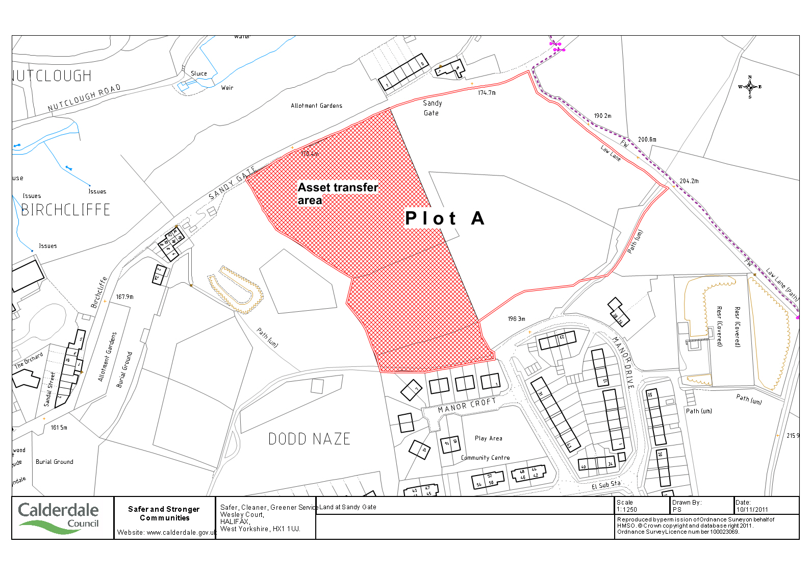

Appendix 2
The land looking from Sandy Gate

