CALDERDALE MBC

WARDS AFFECTED: LUDDENDENFOOT
8
CABINET

9 JANUARY 2012

TRANSFER OF LAND AT REDACRE, MYTHOLMROYD TO REDACRE GROWING PROJECT LTD

REPORT OF THE DIRECTOR FOR COMMUNITIES

- ISSUE

1.1 To consider a request from the Redacre Growing Project Ltd for the transfer of an area of land which consists of a disused former depot area and a steeply sloping area of low quality woodland at Redacre, Mytholmroyd from Calderdale Council to the Redacre Growing Project Ltd (see Appendix 1).

- NEED FOR A DECISION

2.1 Calderdale Council is under a legal duty contained within s123 of the Local Government Act 1972 to obtain best consideration when disposing of land and property assets. Furthermore, the Council’s Corporate Property Policy and Strategy requires that land and property assets should normally be sold or leased at full market value. This report allows Cabinet to consider whether the provisions contained within the General Consents Disposal Order 2003 should be exercised in order to facilitate transfer of the land at less than best consideration.

2.2 Redacre Growing Project Ltd has requested the transfer at nil consideration.

- RECOMMENDATION

3.1 It is recommended that Cabinet:

- Approve the transfer of the land at Appendix 1 on a 125 year lease at nil consideration to the Redacre Growing Project Ltd, subject to the necessary procedures being followed and consents being obtained.

- Delegate to the Director of Communities (in consultation with the Cabinet Member for Communities, the Head of Democratic and Partnership Services) authority to complete a transfer agreement with the Redacre Growing Project Ltd.

- BACKGROUND

  - Redacre Growing Group has worked for a number of years to develop allotments on a site at Redacre, Mytholmroyd. The project is complex due to the required land being held by three different owners. This is show on the plan in Appendix 1. The group has raised funds to purchase Plot A from Yorkshire Water in 2010 and in June 2011 completed the acquisition of Plot B from the Rochdale Canal. The Council granted an annual lease in December 2010 for access over Plot C so that work could commence on Plot A.

  - Planning approval was granted on 4th November 2010 for “Change of use of former depot to 40 no allotments, including provision of ancillary sheds, pathways and car parking area.” (Application number 10/01045/FUL). The plan submitted with the planning application (Appendix 3) included part of Plot C.

  - The group requires Plot C to allow access to their adjoining land and for car parking. The group plan to manage the woodland for wildlife and in the longer term plan to keep chickens in this area.

4.4 Cabinet approval was granted on 31st January 2011, minute number 151 for the transfer of the Council’s only allotment site in the area to Hebden Royd Town Council. Once this approved transfer is complete the town council will be responsible for the allotments waiting list within the area. Hebden Royd Town Council has provided support and funding to the Redacre Growing Group

4.5 The Localism Act actively encourages decentralisation and the transfer of services/assets to local communities. The Council has already transferred a number of assets to community groups following the adoption of a Calderdale Council policy on Community Management of Assets in April 2009, and the transfer of the Redacre site to Redacre Growing Group fits well into this agenda.

4.6 The group have decided not to express an interest in the empty building adjacent to the site which was associated with the former depot. This building will now be sold.

- OPTIONS CONSIDERED

5.1 Option 1 - Transfer the land to the Redacre Growing Group on a long term lease (125 years) at nil consideration. This is the recommended option as it fits within the Council’s wider agenda of empowering local communities, and will put to good use an area of land which at present has no particular function. The lease needs to be contracted out of the Landlord and Tenant Acts and contain clauses that would enable CMBC to terminate the lease and take the land back if for example it ceased to be used for the permitted purpose or was not maintained.

5.2 Option 2 - Grant a short term lease. This would mean that Calderdale Council would retain responsibility for non-routine maintenance and the infrastructure of the site. It may also constrain the ability of the group to attract external funding.

5.3 Option 3 - Dispose of the site on the open market in order to generate a capital receipt.

5.4 Option 4 - Do nothing and continue to manage the site as it is now. This would restrict any enhancement of the facility and would signal apparent unwillingness on the part of the Council to devolve power to local communities.

- CONSULTATION

6.1 Ward members and Hebden Royd Town Council support the transfer.

- FINANCIAL IMPLICATIONS

7.2 During the last 4 years it is estimated that £500pa has been spent clearing flytipping from the site.

7.3 If the site was let at a market rate then the income to the Council would be £55

7.4 The property is allocated Greenbelt on the UDP and there is no likelihood of any alternative use being permitted in the near future. On this basis, the open market valuation is £4,500

- CORPORATE IMPLICATIONS

8.1 The bid was assessed using the Community Asset Management Framework, by a working group of officers from Communities (Neighbourhoods & Community Engagement and Safer, Cleaner, Greener), Economy and Environment (Land and Property), Finance and Legal Services.

- CONCLUSION

8.1 The land at Redacre is currently a liability for the Council and has no real community use. Transferring this property to The Redacre Growing Project at nil value will enable the group to enhance the allotment facilities they are currently managing to the benefit of the local community. However, Members need to be satisfied that the undervalue of £4,500 is outweighed by the positive aspects of a transfer, such as the way in which it should help enhance allotments within the Hebden Royd area, where there is a demonstrable demand for such facilities.
Robin Tuddenham
Director for Communities
Ref:
Date: 29 July 2026

FOR FURTHER INFORMATION ON THIS REPORT CONTACT:
Andrew Pitts, Acting Head of Neighbourhoods and Community Engagement Tel 01422 393264
Email Andrew.pitts@calderdale.gov.uk

DOCUMENTS USED IN PREPARATION OF THIS REPORT: Service files

DOCUMENTS ARE AVAILABLE FOR INSPECTION AT: Northgate House, Halifax
Appendix 1
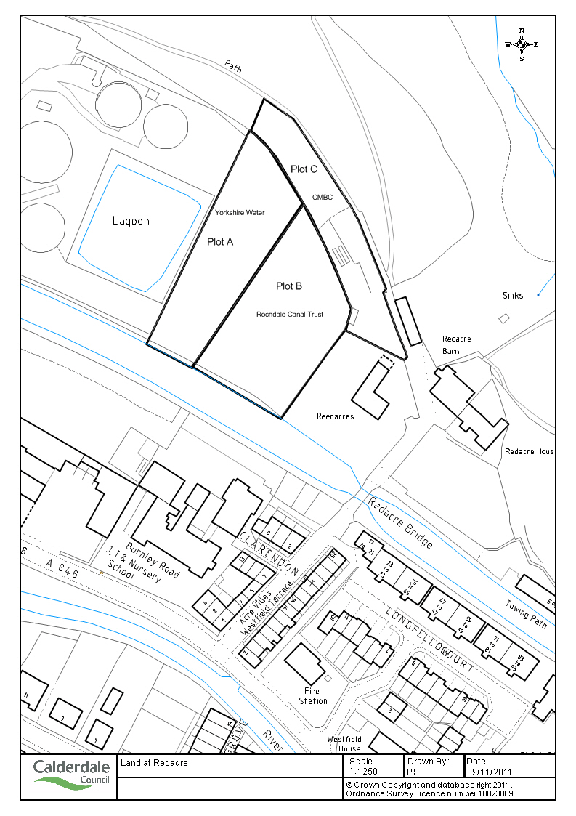

Appendix 3

