Everyone different everyone matters






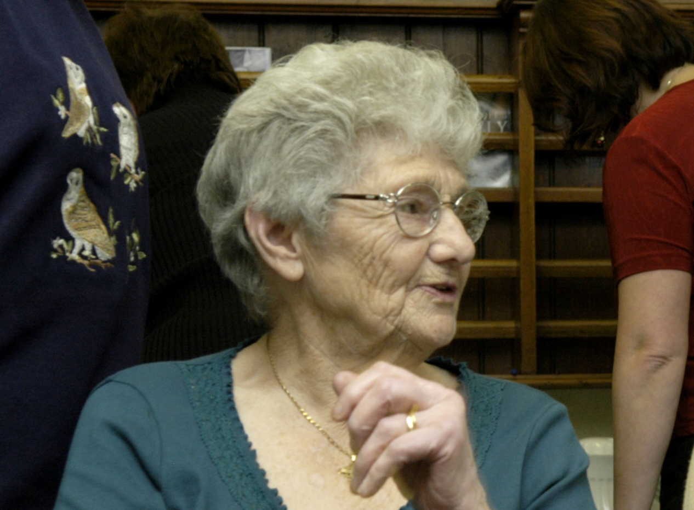


Equality & Community Cohesion Impact Assessment (EIA)
VgVov.uk
www.calderdale.gov.uk
Library Management System

Safer and Stronger Communities
December 2011
Equality Impact Assessment (EIA)

PART A : Initial Assessment to determine relevance if a full Impact Assessment is required

Directorate: Safer and Stronger Communities  Service Area: Cultural Services  Service / Policy / Function or Procedure to be assessed: Library Management System  Is this: New / Proposed , Existing or Changing | Date commenced: 31/10/’11  Date completed:  Lead Officer: Ian Horne

What are the aims and objectives / purpose of this?
The aim of this proposal is that by replacing the current out of date Library Management System (LMS), a more user friendly and interactive IT system can be implemented to enhance customer experience, and better integrate with other Council systems to identify and reach the wider demographic spectrum of users and potential users. The current (Dynix) system is reaching end of life with no development for some years, and supplier support minimal, forcing authorities still using the system to migrate elsewhere.

Please indicate its relevance to equality by selecting YES / NO / NOT SURE in each box below:
Is this relevant to: | Age | Disability | Gender | Race | Religion & belief | Gender Reassign-ment | Pregnancy and Maternity | Sexual orientation
Eliminating unlawful discrimination, victimisation and harassment | Yes | Yes | No | Yes | No | Yes | No | No
Advancing equality of opportunity | Yes | Yes | Yes | Yes | Yes | Yes | Yes | Yes
Fostering good community relations | Yes | Yes | Yes | Yes | Yes | Yes | Yes | Yes

If NOT RELEVANT, the Impact Assessment is now complete - please send a copy to your Directorate Equality Champion & to the Cohesion and Equality Team.

If RELEVANT, a full Impact Assessment needs to be undertaken (PART B).

Level of priority (if new/proposed policy/service): High Medium Low

PART B : Full Impact Assessment

Who benefits and how do they benefit? | - Customers and potential customers by having enhanced web based front end access to the libraries’ on line presence.  - Customers and potential customers having facility to comment and feedback via web 2.0 capabilities.  - Those who do not use English as first language as options to display, for example, library on-line catalogue in a range of different languages will be sought.  - The Library service by being able to identify and reach out to a greater and more diverse cross section within its’ catchment  - Improved recording and retrieval of borrower characteristics in Management Information will allow staff to identify gaps in service provision and target services more effectively.
What outcomes are sought and for whom? | - A greater interaction with all citizens  - Inclusivity for those who may find language a barrier to accessibility of the service  - Better opportunities to target sections of the public and market those areas which may have previously been omitted.  - Improved recording and retrieval of borrower characteristics in Management Information will allow staff to identify gaps in service provision and target services more effectively.  - Increased detail available when searching by both staff and customers will allow material relevant to each equalities group to be found more easily
Are there any associated policies/functions/services or procedures? | No, this covers the whole of the Library service
How will this service be delivered (e.g. direct service delivery, outsourced etc.)? | Will be delivered directly through the Library service
If external partners are involved in delivering the service, who are they?+
How is the service publicised and how do people access and/or request it? | The Library service as a whole is publicised on many levels, and replacement of the current Library Management system will allow greater publicity to be generated via a much enhanced web front end and to target groups.

What evidence/data already exists about the service and its users? (In terms of its impact on the ‘equality strands’, i.e. ethnicity, gender, disability, age, religion/belief, sexual orientation etc)

Evidence |  | Details
Research:  Any local, regional or national research available to help inform this EIA? |  | Census Data, Borrower data, Library Surveys,
Consultation:  Has there been any consultation with, or input from, service users, staff or other stakeholders?  If so, with whom, how were they consulted and what did they say? |  | Consultation on Library services has been conducted on a number of levels in the past 18 months.  - The Public Library User Survey (PLUS) covering all aspects of the Library service  - Consultation via Focus Groups and surveys targeted at minority groups in relation to King Cross Library development  - Facilities Review (to a lesser extent)
Monitoring:  What equality monitoring information/data is currently gathered. Are there any significant gaps?  What is the profile of current users/beneficiaries, and staff compared to the local demographic profile? |  | Currently age, gender and ethnicity are gathered as part of the library enrolment process, The current Library Management System does not integrate with other systems used, e.g. Mosaic, making it difficult to compare membership trends with wider demographic trends, the new LMS will address this issue.
Quality Assurance:  Any complaints, compliments, satisfaction surveys or customer feedback to help inform the EIA? |  | None
If information/data gaps are uncovered from the above assessment, what are they and how will you address them?
Barriers:  What are the potential or known barriers for the different ‘equality strands’ set out below?  Consider:  - Where you provide your service, e.g. the facilities/premises;  - Who provides it, e.g. are staff trained and representative of the local population/users?  - How it is provided, e.g. do people come to you or do you go to them? Do any rules or requirements prevent certain people accessing the service?  - When it is provided, e.g. opening hours?  - What is provided, e.g. does the service meet everyone’s needs? How do you know?  * Some barriers are justified, e.g. for health or safety reasons, or might actually be designed to promote equality, e.g. single sex swimming/exercise sessions, or cannot be removed without excessive cost. If you believe any of the barriers identified to be justified then please indicate which they are and why. |  |  | Solutions:  What can be done to minimise or remove these barriers to make sure everyone has equal access to the service? Consider:  - Other arrangements that can be made to ensure people’s diverse needs are met;  - How your actions might help to promote good relations between communities;  - How you might prevent any unintentional future discrimination.
Age | Potential barriers to older people using ICT facilities may include lack of familiarity and knowledge of the use of the system  Access to certain parts of the on-line catalogue may not be in appropriate format for younger users |  | Continue to deliver a program of IT taster sessions, building in awareness of the library management system  Provide ICT training for library staff to meet the specific support needs of older people.  Require that the new Library Management System is able to deploy the whole, or a sub set of the on-line catalogue in a more appropriate format.
Disability | People who are visually impaired or with physical disabilities may require adaptive technology in order to make full use of ICT facilities |  | Extend the range of adaptive and assistive technology centred in the Access for All Facility in the Central Library and further devolve to branch libraries to meet the needs of the disabled, and assist in making the on-line facilities of the library system more accessible.  Provide ICT training for library staff to meet the specific support needs of those with a disability
Gender | Non identified at this stage
Race | Our user profile now includes newer communities from Eastern Europe; a barrier may be in terms of language |  | Develop on-line services to be inclusive in providing a range of language options  Provide ICT training for library staff to meet the specific support needs of those whose first language may not be English
Religion or belief | Non identified at this stage
Gender Re-assignment | Recorded gender reference may not be accurate if a person is planning / going through or has undergone gender reassignment |  | Raise awareness of this with staff to ensure that where a library member informs the library that their record needs to be updated to reflect that their gender is different from birth that this can be accommodated easily.
Pregnancy and Maternity | Non identified at this stage
Sexual orientation | Non identified at this stage

NOTE: Anyone who does not have email will not be able to benefit from the improvements available to those who choose to be contacted by email.

If posts are affected or deleted, please list how this may affect how the Council ensures that its workforce is reflective of the community we serve. (Please note that if these numbers are so small it is important the individuals are not identified).

Employee Characteristic | No Negative  Impact | Negative Impact/barriers – please state what this may be | Solutions: are there any ways in which you could mitigate the impact
Age | X
Disability | X
Gender | X
Gender reassignment | X
Pregnancy & maternity |  | Staff currently on maternity leave may not be aware of proposed changes to the system | Ensure staff receive training on their return to work
Marriage and Civil Partnership | X
Race | X
Religion or belief | X
Sexual Orientation | X

Further Consultation:
Having established the barriers and potential solutions, do you need to consult with users/beneficiaries or others to ensure your response is appropriate?
YES X NO

If YES, how will this be done?
By better identifying individuals and groups who may be excluded, or feel excluded, by a lack of knowledge regarding the service, and how to access it.

If NO, how can you be sure you know enough?

If a new/proposed policy: Will the policy be adopted? Yes X No

If an existing policy: Are changes necessary? Yes No

If a changing policy: Are the changes necessary? Yes No

Monitoring:
If you have answered ‘Yes’ above, how you are going to ensure the solutions you have identified are effective?

Initially the intention will be to establish a baseline based on known demographic data and generate profiles from the enhanced data provided by a new management system. It will then be possible to measure success, or otherwise, in terms of reaching those groups or individuals previously not being engaged.

PART C : Equality Action Plan

Barriers identified | Solutions identified | Action required | Resource implications | Timescale | Lead Officer
There may be barriers to older people using ICT facilities including familiarity and knowledge of the use of the system | Provide ICT training for library staff to meet the specific support needs of older people | Continued development of staff training programs, and IT taster sessions for library users. | Release of staff from regular duties to undergo training/briefing | On-going | ICT, Information and Access Manager
Access to certain parts of the on-line catalogue may not be in appropriate format for younger users | Require that the new Library Management System is able to deploy the whole, or a sub set of the on-line catalogue in a more appropriate format. | Designate as a requirement within the system specification and deploy once new system is implemented | Possible additional charge to that of base system, to be factored into the selection process | Concurrent with implementation of new system | ICT, Information and Access Manager
People who are visually impaired or with physical disabilities may require adaptive technology in order to make full use of ICT facilities | Extend the range of adaptive and assistive technology centred in the Access for All Facility in the Central Library and further devolve to branch libraries to meet the needs of the disabled, and assist in making the on-line facilities of the library system more accessible.  Provide ICT training for library staff to meet the specific support needs of those with a disability | Accessibility features to be included in the in the system specification to allow the on-line facilities to be usable by all.  Continued development of training and induction programmes. | Accessibility functions to be included in specification, adoption of enhancing the current range and spread of functionality will have on-going budget implications  Release of staff from regular duties to undergo training/briefing | Accessibility functions within Library system will be concurrent with implantation, general accessibility service provisions on-going.  On-going | ICT, Information and Access Manager
Our user profile now includes newer communities from Eastern Europe; a barrier may be in terms of language | Develop on-line services to be inclusive in providing a range of language options  Provide ICT training for library staff to meet the specific support needs of those whose first language may not be English | A desirable requirement within the system specification to develop on-line services to be inclusive in providing a range of language options  Continued development of training and induction programmes. | None – cost should be included in software maintenance charge from system suppliers  Release of staff from regular duties to undergo training/briefing | Some language options to be available concurrent with the implementation of Library Management system, others to be on-going. | ICT, Information and Access Manager
Recorded gender reference may not be accurate if a person is planning / going through or has undergone gender reassignment | Raise level of awareness of staff to ensure that where a library member informs the library that their record needs to be updated to reflect that their gender is different from birth that this can be accommodated easily and sensitively | Ensure recording and retention of user detail in line with Data Protection requirements to be included in system specification  Continued development of training and induction programmes. | None, expected to be part of core system functionality.  Release of staff from regular duties to undergo training/briefing | Concurrent with implementation of new system | ICT, Information and Access Manager

PART D : Summary for Publication

Directorate:  Service Area:  Service / Policy / Function or Procedure to be assessed:  Is this: New / Proposed Existing Changing | Date commenced:  Date completed:  Lead Officer:

What are the aims and objectives / purpose of this?

Adverse effects Found Not Found

Outcome Policy amended Consultation undertaken

Involvement: Please indicate who carried out the Equality Impact Assessment and how other stakeholders were involved.

Summary of Outcome: Were barriers identified, and have plans been put in place to minimise these?

Will the new policy be adopted? Yes No

Equality Action Plan
(Insert Equality Action Plan here, or, if no further action is required as a result of the EIA, please explain why.)

PART C : Equality Action Plan

Barriers identified | Solutions identified | Action required | Resource implications | Timescale | Lead Officer

Signed off by Head of Service: Date:
Agreed by DMT: Date:
Lead Officer:
Contact: Tel: e-mail address:

