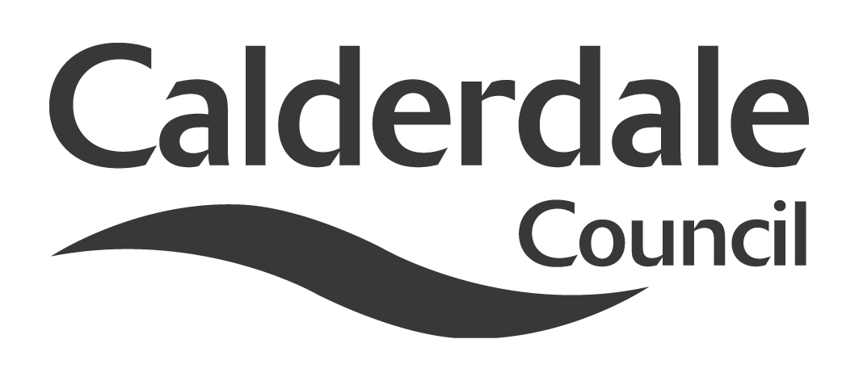
5

Report to Scrutiny Panel
Name of Scrutiny Panel | Safer and Stronger Communities
Meeting Date | 1st December 2011
Subject | Central Library Service Provision
Wards Affected | All
Report of | Scrutiny Support Officer
Type of Item  (please tick✓ ) | Review existing policy
Type of Item  (please tick✓ ) | Development of new policy
Type of Item  (please tick✓ ) | Performance management (inc. financial)
Type of Item  (please tick✓ ) | Briefing (inc. potential areas for scrutiny)
Type of Item  (please tick✓ ) | Statutory consultation
Type of Item  (please tick✓ ) | Council request
Type of Item  (please tick✓ ) | Cabinet request
Type of Item  (please tick✓ ) | Member request for scrutiny (CCFA) | √

Why is it coming here?
Request of the Chair of Safer & Stronger Communities Scrutiny Panel

What are the key points?
The Cabinet has announced proposals to relocate the Halifax Central Library to a new site adjacent to the Square Church, the Industrial Museum and the Piece Hall. Concern has been raised about the impact this may have on the accessibility of library services to residents of Calderdale.

Possible courses of action
Scrutiny may wish to make recommendations to Cabinet or full Council.

Contact Officer
Steve Barnbrook, Scrutiny Support Officer 01422 393252
steve.barnbrook@calderdale.gov.uk

Should this report be exempt?
No

Report to Scrutiny Panel
- Background

On 31st October 2011 Cabinet considered the issue of Northgate house and the Central Library. The following is the outcome of that discussion and the proposal to Council:

Northgate House / Halifax Central Library and Archive
Cabinet proposals to Council

Key messages:

- Northgate House and the Halifax Central Library and Archive buildings are expensive to maintain and are not fit for purpose for our customers. It is more cost effective to sell the site and build a new library. To refurbish Northgate House would cost up to £15 million, and to refurbish Halifax Central Library and Archive would cost up to £6m.
- The Council listened to the views of local people in the library consultation in 2009 and is proposing to build a new central library: within walking distance of the bus and train stations; retaining the archive in Halifax; and accessible for all. The new purpose built building would provide our customers with a state-of-the-art modern library of an appropriate size.
- We know from our experience with King Cross and Hebden Bridge libraries that more people use new facilities. 600 libraries are due to close across the UK in the next 2 years – we want to invest in our central library.
- Visitor numbers using our archive have been falling – by keeping it in Halifax in a state-of-the-art library we will reinvigorate people’s interest.
- Businesses want to invest in Calderdale and local people want better shops and leisure facilities. We want to seize the opportunity to safeguard Halifax’s economic future, bring jobs and visitors and join Halifax’s exciting developments together.
- The new central library and archive supports the Piece Hall redevelopment and creates a vibrant cultural quarter with Square Chapel and Orange Box.
What are we doing?
Cabinet has resolved to recommend to Council on the 7th December that we:
- Build a brand new central library and archive next to the Square Spire, adjoining the Piece Hall.
- Sell the Northgate House / Halifax Central Library and Archive site to make way for an exciting new non-food retail development.
- Sell the Heath site to locate Council services together and help pay for the new library.

Why are we doing it?

For a better town centre

- Halifax needs more retail space in the future. The recent Strategic Retail Needs Assessment update in 2010 identified the need for at least a quarter of a million more square feet of comparison retail space (e.g. footwear, clothing, recreational goods) in Halifax by 2026.
- For years, people have shopped in nearby towns and cities which have offered more choice. The Council wants to reduce this leakage of consumer spending outside the town.
- Bringing bigger and better shops to the town centre is long overdue. Under the proposals, a redeveloped Northgate site could provide larger retailer stores to meet the needs of retailers currently not located in the town centre. People have already told us that they want to see a more vibrant town with better shops and leisure facilities.
- Redevelopment of the Northgate site presents a marvellous opportunity for development of a sought after retail site, to build on the back of the shortly to be opened Broad Street Plaza development which will offer new restaurants, hotel and cinema for the town.
- This development will ensure that the whole of Halifax becomes an attractive destination for shoppers. More people shopping in Halifax town centre is good for all retailers and businesses, and will give greater choice for residents..
- This proposal would:
- Represent a major investment in the town’s future.
- Attract more shoppers to the town centre by offering a range of exciting shops.
- Provide a much-needed boost to the local economy by increasing footfall and creating hundreds of new jobs.
- Provide a natural link between The Piece Hall, Woolshops, bus station and Broad Street Plaza development.
For a better Central Library and Archive:
- Because we’ve built two new libraries recently, we know that new libraries attract more users. While other councils are closing libraries, we’re reaffirming our commitment by investing in a new central library and archive for the future.
- The proposed new purpose-built library and archive will enhance the cultural quarter, based around the Piece Hall and the Square Chapel.
- The location, adjoining the Piece Hall and with a link between the two buildings, will help to increase footfall in the new library while also increasing library use.
- The current library and archive, which would require significant investment to bring it up to an acceptable standard, would close at the time the new library and archive has been completed, so there is no significant disruption to customers.
- The proposed new library and archive would give better access for older people and people with disabilities
- The archive would be purpose-built, in order to make the best of the material stored there. It could become a genuine learning resource, opening up the archive for more use by schools, students and visitors.
- The proposed new library and archive is on a better site than that which was proposed for Broad Street Plaza because:
- It is closer to the town centre and people will not need to cross a busy main road to get to it
- It will be an integral part of the proposed Piece Hall development, creating a cultural quarter
- It will be nearer to the town’s railway station and walkable from the bus station and will have access directly from the refurbished Piece Hall
For better Council services for the public:
- The Council is already looking at ways it can work more efficiently. This option would mean that it could:
- Make full use of the buildings it already owns and rents, and staff working smarter such as hot desking and working from home
- Save money by selling of Northgate, which has become increasingly expensive and difficult to manage
- Support the new Customer First facility proposed in the new Broad Street Plaza – where customers can access a full range of Council services in one place.

When will this happen?
Further work will now be undertaken to establish timescales for the proposal. If the Council decides to go ahead, then initial indications are that the new central library and archive could be open in 2015:
- By Spring 2012 – assessment for office accommodation; study for site near Piece Hall for the new library and archive
- By Autumn 2012 – begin work on office accommodation for relocating staff; submit planning consent for new library; begin marketing of existing Northgate and Heath sites
- By Spring 2013 – relocate staff to alternative premises to allow vacation of Northgate House and Heath sites. The Halifax Central Library and Archive will remain open to the public until the new library opens.
- Summer 2013 – construction begins on new library
- Spring 2015 – new library opens
How is this being paid for?
- The sale of the Northgate House / Halifax Central Library and Archive site will contribute to the total cost of the new library. If we kept the site, we would have to spend up to £15 million to refurbish Northgate House and up to £6 million to refurbish Halifax Central Library.
- The cost of running the ageing Northgate site is around £½m a year. Costs will be mitigated in the future if the Council disposes of the building and relocates staff and looks at different ways of working. Services for Northgate House and Central Library and Archive are shared and to sell Northgate and retain the library would cost around £830,000.
- With better use of existing resources, and better ways of working, the Council will be in a position to sell the site at Heath, which is situated within an area of significant demand for residential and food retail use. This will also contribute to the cost of the proposed new central library and archive.

- Main issues for Scrutiny

The purpose of this scrutiny item is not to consider issues around Northgate House, building designs, retail opportunities etc. It is to consider what impact a proposed relocation of Central Library to a new site will have on the accessibility of Library services to residents of Calderdale, particularly those with mobility problems. An Equality Impact Assessment is being prepared as the proposals are developed prior to full Council on December 7th, although it is not available at the time of writing.

There has been concern expressed by individuals and a number of organisations, including Halifax Civic Trust, about the proposals and the impact they may have.

There is legislation and guidance on what the council should consider in developing its proposals.

Equality and Diversity Act 2010

Public Sector Equality duty

The Public Sector Equality duty came into force on 5 April 2011. This is a key measure in the Equality Act, designed to ensure that all public bodies contribute to tackling discrimination and promoting equality of opportunity.

General Equality Duty

The Equality Duty has three aims. It requires public bodies to have due regard to the need to:
• eliminate unlawful discrimination, harassment, victimisation and any other conduct prohibited by the Act;

• advance equality of opportunity between people who share a protected characteristic and people who do not share it; and
• foster good relations between people who share a protected characteristic and people who do not share it.
The protected characteristics covered by the Equality duty are:

- Age
- Disability
- Gender
- Gender reassignment
- Marriage and civil partnership (Employment issues only)
- Pregnancy and maternity
- Race
- Religion or belief
- Sexual orientation
To comply with this duty it is necessary for the organisation to understand the potential effects of its activities on different people.
The Equality Duty will be one of a number of factors that need to be considered. The weight given to the Equality Duty, compared to the other factors, will depend on how much that function affects discrimination, equality of opportunity and good relations and the extent of any disadvantage that needs to be addressed.

- Consultation

The scrutiny panel will welcome submissions relating to the particular issue outlined in this report.

- Conclusions

The relocation proposals have generated a high level of public interest. It is important that regard is given to the views of the public in the development of these proposals. The accessibility of any new facility should be a priority for the council.

- Documents available for inspection at

Town Hall, Crossley Street, Halifax HX1 1UJ

