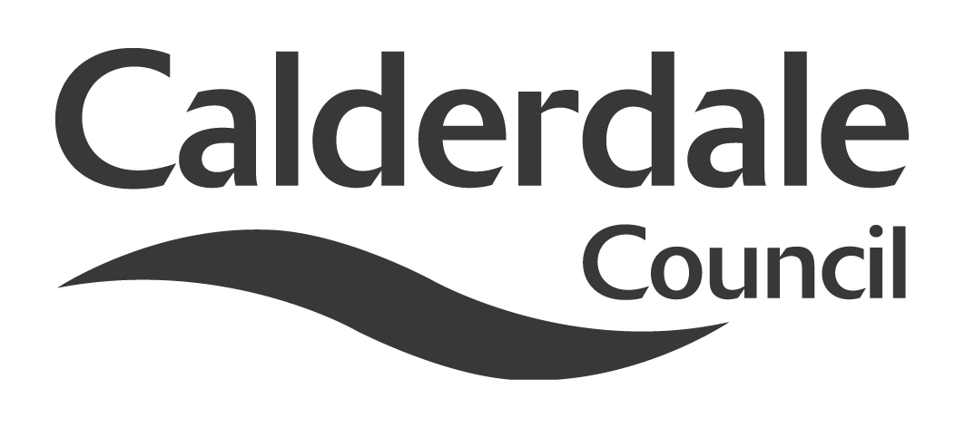
7

Report to Scrutiny Panel
Name of Scrutiny Panel | Economy and Environment Scrutiny Panel
Meeting Date | 13 April 2011
Subject | Carbon Reduction in Calderdale
Wards Affected | All
Report of | Scrutiny Support Officer
Type of Item  (please tick✓ ) | Review existing policy
Type of Item  (please tick✓ ) | Development of new policy | √
Type of Item  (please tick✓ ) | Performance management (inc. financial)
Type of Item  (please tick✓ ) | Briefing (inc. potential areas for scrutiny)
Type of Item  (please tick✓ ) | Statutory consultation
Type of Item  (please tick✓ ) | Council request
Type of Item  (please tick✓ ) | Cabinet request
Type of Item  (please tick✓ ) | Member request for scrutiny (CCFA)

Why is it coming here?
Ongoing detailed review by the panel

What are the key points?
Review of progress to date and policy context

Possible courses of action
Agree recommendations or identify further information required

Contact Officer
Steve Barnbrook, Scrutiny Support Officer 01422 393252 steve.barnbrook@calderdale.gov.uk

Should this report be exempt?
No

Report to Scrutiny Panel
- Background

At its meeting of 13th October 2010, the panel agreed to Terms of Reference for a detailed review of Carbon Reduction in Calderdale.

The objectives of the review were agreed within the Terms of Reference as follows:

- To assess the progress made by the Council towards its 10:10 objectives
- To assess whether 10:10 is the best, or should be the only, means that the Council uses to work toward Carbon Reduction
- To explore other initiatives such as the Covenant of Mayors
- To examine the impact on the Council of the Carbon Reduction Commitment Energy Efficiency Scheme (CRCEES) and the opportunities it may offer
- To look at how the Council might influence carbon reduction behaviour in Calderdale, including public, private and third sector and also domestic users
- To look at the potential for energy generation both within the Council and across Calderdale to both reduce carbon emissions and as a means of income generation, utilising feed-in tariffs and potential renewable heat incentives
- To explore how the Council might work with partners, and in partnerships, to deliver some of the identified objectives

Members of the panel have visited the Alternative Technology Centre in Hebden Bridge and The National Trust Gibson’s Mill buildings at Hardcastle Crags, and attended a meeting of the Calderdale Forward Climate Change sub-group.

Some members also attended a seminar hosted by Barnsley Council on “Planning for low carbon living”.

The panel have taken evidence from a variety of sources both in person, including Professor Andy Gouldson from Leeds University, and members of the Climate Change sub-group, and in report form.

They made two interim recommendations in December, which have both been acted upon. The first was the purchase of Vantage Point software. This is now in place and awaiting database refinement. The second was that solar photovoltaic panels be considered as an alternative energy generation source in the refurbishment schemes of three schools. Business cases are now being developed for these.

In March, the panel received a presentation from officers on opportunities to enter into partnership with an external provider to install solar photovoltaic cells on council roofspace and share in the financial benefits this may afford. Whilst recognising the merits of such a proposal, the panel felt that the possibility of the council financing the scheme through prudential borrowing and therefore maximising income opportunities for the benefit of the borough should also be investigated further and made recommendation to cabinet accordingly.

The panel has recognised from an early stage that a carbon strategy for Calderdale would comprise of both the reduction of carbon by reducing our energy requirements through such measures as improved energy efficiency (such as insulation), and also the generation of energy by low carbon methods (e.g. solar, wind). They have also recognised that strategies must be developed both for “internal” council operations (crucially ensuring that school buildings are included in this consideration) and also for how Calderdale Council can help influence carbon reduction throughout the borough.

- Main issues for Scrutiny

Since this detailed review began in October there have been significant developments both nationally and locally.

Nationally, there has been the ongoing progress through Parliament of the Energy Bill. There has also been a major change to the Carbon Reduction Commitment Energy Efficiency Scheme (CRCEES), a review of Feed-in Tariffs (include a fast-track review of large scale solar photovoltaic tariffs) and the announcement of the Renewable Heat Incentive.

Locally, there has been the commencement of work on an energy strategy, the approval of invest-to-save funds to help meet our 10:10 commitment, the exploration of solar photovoltaic schemes for council buildings and a domestic energy efficiency programme pilot scheme in Hebden Bridge, in addition to various other activities including those of some of our local and regional partners.

Carbon reduction and mitigation continues to play an increasing role in policy-making and decision-making at all levels.

The Scrutiny panel need to assess whether the evidence gathered to date has enable them to fulfil the objectives of the review as outlined in part one above, or whether further work is necessary.

For example:

- Has the invest-to-save scheme gone far enough to address the requirements of the 10:10 commitment?
- Have other initiatives been suitably explored, or have they been overtaken by developments?
- Have the changes to the CRCEES caused a need to change focus?
- Have the panel received enough evidence on how the Council might influence the carbon behaviour of others in Calderdale?
- Have sufficient methods of renewable energy creation been explored?
- Has sufficient evidence been taken on partnership working?

- Further action and timescales

To be determined by the panel.

- Conclusions

If the panel are satisfied that the evidence received to date is sufficient, they will be in a position to make recommendations to Cabinet, Full Council and/or partners. A final report including the full evidence base, final recommendations and executive summary can then be produced. The panel may wish to consider how this report could be publicised.

If the panel feel that more evidence is needed then this can be identified and a timetable for completion agreed.

- Appendices

Appendix 1 gives information on the policy context for carbon reduction
Appendix 2 shows the current work being done by Calderdale Council.
Appendix 3 is a flier regarding community renewable energy workshops

- Background documents

United Nations Framework Convention on Climate Change
Kyoto Protocol
European Renewable Energy Directive
The Climate Change Act 2008
The UK National Renewable Energy Action Plan
The Energy Bill
Leeds City Region - Green Infrastructure Strategy

- Documents available for inspection at

Westgate House, Westgate, Halifax, HX1 1PS

