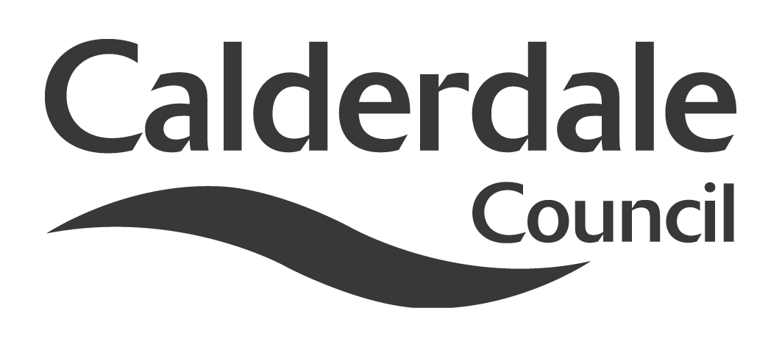
5

Report to Scrutiny Panel
Name of Scrutiny Panel | Economy and Environment Scrutiny Panel
Meeting Date | 02 March 2011
Subject | Carbon Reduction in Calderdale
Wards Affected | All
Report of | Scrutiny Support Officer
Type of Item  (please tick✓ ) | Review existing policy | √
Type of Item  (please tick✓ ) | Development of new policy | √
Type of Item  (please tick✓ ) | Performance management (inc. financial)
Type of Item  (please tick✓ ) | Briefing (inc. potential areas for scrutiny)
Type of Item  (please tick✓ ) | Statutory consultation
Type of Item  (please tick✓ ) | Council request
Type of Item  (please tick✓ ) | Cabinet request
Type of Item  (please tick✓ ) | Member request for scrutiny (CCFA)

Why is it coming here?
Members are involved in a detailed review of Carbon Reduction in Calderdale

What are the key points?
There have been a number of developments both locally and nationally which members will wish to consider as part of their policy formulation on this subject.

Possible courses of action
The panel may wish to make further interim recommendations on carbon reduction strategies, or may wish to formulate final recommendations and the structure of a detailed review report.

Contact Officer
Steve Barnbrook, Scrutiny Support Officer steve.barnbrook@calderdale.gov.uk
01422 393252

Should this report be exempt?
No

Report to Scrutiny Panel
- Background

At its meeting of 13th October 2010, the panel agreed to Terms of Reference for a detailed review of Carbon Reduction in Calderdale.

The objectives of the review were agreed within the Terms of Reference as follows:

- To assess the progress made by the Council towards its 10:10 objectives
- To assess whether 10:10 is the best, or should be the only, means that the Council uses to work toward Carbon Reduction
- To explore other initiatives such as the Covenant of Mayors
- To examine the impact on the Council of the Carbon Reduction Commitment Energy Efficiency Scheme (CRCEES) and the opportunities it may offer
- To look at how the Council might influence carbon reduction behaviour in Calderdale, including public, private and third sector and also domestic users
- To look at the potential for energy generation both within the Council and across Calderdale to both reduce carbon emissions and as a means of income generation, utilising feed-in tariffs and potential renewable heat incentives
- To explore how the Council might work with partners, and in partnerships, to deliver some of the identifies objectives

Since then members of the panel have visited the Alternative Technology Centre in Hebden Bridge and The National Trust Gibson’s Mill buildings at Hardcastle Crags, and attended a meeting of the Calderdale Forward Climate Change sub-group.

The panel have taken evidence from a variety of sources both in person, including Professor Andy Gouldson from Leeds University, and members of the Climate Change sub-group, and in report form.

They have made two interim recommendations, which have both been acted upon. The first was the purchase of Vantage Point software. This is now in place and awaiting database refinement. The second was that solar photovoltaic panels be considered as an alternative energy generation source in the refurbishment schemes of three schools. Business cases are now being developed for these.

The panel has also recognised from an early stage that a carbon strategy for Calderdale would comprise of both the reduction of carbon by reducing our energy requirements through such measures as improved energy efficiency (such as insulation), and also the generation of energy by low carbon methods (e.g. solar, wind). They have also recognised that strategies must be developed both for “internal” council operations (crucially ensuring that school buildings are included in this consideration) and also for how Calderdale Council can help influence carbon reduction throughout the borough.

- Main issues for Scrutiny

There have been a number of developments nationally, regionally and locally since the December scrutiny panel meeting, when the carbon review was last on the agenda. These are outlined below.

National Developments

Feed-in Tariffs

On 7th February the Government announced the First Review of Feed-in Tariffs. This had been anticipated but has been brought forward for completion by the end of 2011, with tariffs unchanged until April 2012.

The Department for Energy and Climate Change (DECC) has indicated that it has a number of concerns around take-up levels of some low-carbon electricity generation technologies, particularly large scale solar PV and farm-based anaerobic digestion.

Large scale solar PV is classed as having an output over 50kW. A rough rule of thumb on this figure is that it would represent an array of solar panels above approximately 400m². DECC are concerned that there are far more of these projects under the Feed-in Tariff scheme (FITs) than they had anticipated, and that, if left unchecked, they could take a disproportionate amount of available funding or even break the cap on total funding. DECC’s response to this is that they will “fast-track consideration of large scale solar photovoltaic projects (over 50kW) with a view to making any resulting changes to tariffs as soon as practical, subject to consultation and Parliamentary scrutiny as required by the Energy Act 2008” (DECC First review of Feed-in Tariffs: Broad terms of reference).

DECC will also undertake a short study into the take-up of FITs for farm-based Anaerobic Digestion plants, as only two such projects have been accredited so far. DECC are looking again at the tariff rates to see if they are sufficient to make such schemes worthwhile.

Green Deal

The Green Deal will enable private firms to offer consumers energy efficiency improvements to their homes, community spaces and businesses at no upfront cost, and recoup payments through a charge in instalments on the householders’ energy bills.

The legislation to enable this to happen (confusingly, this is also called the Energy Bill at the moment!) began its passage through Parliament in the House of Lords on 8th December 2010, and is currently scheduled to have its Report Stage in that House on 2nd March.

According to the Government’s summary of its proposals, there are a number of things which must be included as prerequisites for all Green Deal plans. The most important one is the so-called “golden rule”. This states that:

“The expected financial savings must be equal to or greater than the costs attached to the energy bill”

Regional Developments

Calderdale is currently working alongside other authorities to develop a Leeds City Region Domestic Energy Efficiency Programme (DEEP), which is seeking to build upon some of the national Green Deal proposals as outlined above.

At the heart of the Government’s proposals is the “Green Deal plan”, an innovative financing mechanism which allows consumers to pay back through their energy bills. This means consumers can see the Green Deal charge alongside the reductions in energy use which generate savings on their bill. It also means that if they move out and cease to be the bill-payer at that property, the financial obligation doesn’t move with them but moves to the next bill payer.

The role of the Green Deal provider is to offer a Green Deal plan to customers, which enables them to finance work recommended by an accredited adviser and undertaken by an accredited installer. These functions might be done in-house by the provider, or shared amongst other organisations, but the customer’s contractual relationship is with the provider.

The LCR DEEP aims to deliver independent whole house energy surveys and enable customers to access impartial energy advice. The project aims to support customers who wish to take up carbon saving measures through easy routes to accredited companies able to deliver the measures. The accredited companies could be through an approved framework led by LCR appointed energy companies or non LCR appointed but appropriately accredited companies operating in the market. The LCR DEEP needs to place its self within the Green Deal Framework and deliver a programme in line with the new energy company obligation from autumn 2012.

Leeds City Region is currently participating as a Local Carbon Framework Pilot benefitting from DECC funding and has submitted a Round 1 Regional Growth Fund Bid to support the creation and retention of green jobs and deliver the first three years of a LCR DEEP.

Local Developments

The Environmental Team have produced an update report on their activities. This is attached as Appendix 1. As mentioned in the report, the team are currently putting together a report to Cabinet on the potential of large-scale photovoltaic schemes across council buildings. This has the possibility of being a major development in the carbon reduction progression for Calderdale, although much depends on the timescale and outcome of the Government’s review of Feed-In Tariffs as mentioned above. It is anticipated that more information will be available by the time of the panel meeting.

Officers from the private sector housing team are also in discussions with prospective partners and progressing local DEEP pilot projects in the Hebden Bridge area.

- Conclusions

Over the course of this review members have not only made recommendations but have demonstrably influenced the approach of the council toward carbon reduction.

Members now need to decide, in the light of ongoing local, regional and national developments, whether to gather further evidence or to move toward a final report and recommendations.

- Appendices

Update report from the Environmental Management Team

- Background documents

The Energy Bill [HL]
The Green Deal: A Summary of the Government’s Proposals (DECC)

- Documents available for inspection at

Westgate House, Westgate, Halifax HX1 1PS

