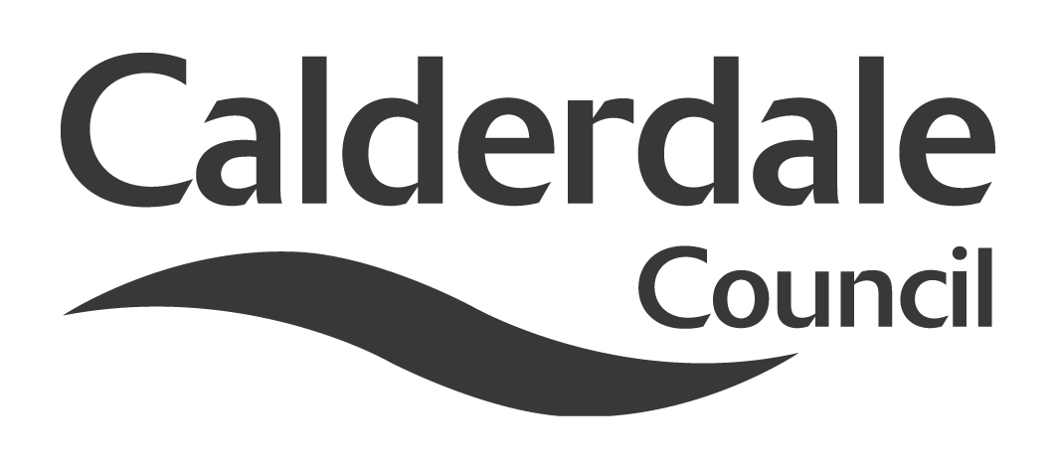
5

Report to Scrutiny Panel
Name of Scrutiny Panel | USE OF RESOURCES
Meeting Date | 24th February 2011
Subject | Review of Democratic & Partnership Services
Wards Affected | All
Report of | Ian Hughes – Head of Democratic & Partnership Services
Type of Item  (please tick✓ ) | Review existing policy
Type of Item  (please tick✓ ) | Development of new policy
Type of Item  (please tick✓ ) | Performance management (inc. financial) | X
Type of Item  (please tick✓ ) | Briefing (inc. potential areas for scrutiny)
Type of Item  (please tick✓ ) | Statutory consultation
Type of Item  (please tick✓ ) | Council request
Type of Item  (please tick✓ ) | Cabinet request
Type of Item  (please tick✓ ) | Member request for scrutiny (CCFA)

Why is it coming here?
To provide the Panel with an update on the Review of Democratic & Partnership Services

What are the key points?
The development of an Improvement Programme, in phases, for Democratic & Partnership Services

Possible courses of action
For comments and noting by the Panel and for the timetabling of further updates

Contact Officer
Ian Hughes – Head of Democratic & Partnership Services

Should this report be exempt?
No

Report to Scrutiny Panel
- Background

1.1 Following the review of Legal, Democratic and Electoral Services by Reach Consulting (Cumbria) Ltd in June 2010 and subsequent reports to this Panel and to Cabinet; work commenced on taking forward the recommendations made in the Reach Consulting report in relation to Democratic Services.

1.2 The Council’s Process Improvement Team was engaged by the Head of Democratic and Partnership Services in December 2010, following the conclusion of the call-in procedure of the Cabinet’s decision reached on 25 October 2010. The Process Improvement Team was asked to build on the Reach Consulting review and advise on the process required for the preparation of phase 1 of the review concentrating on Democratic Services.

1.3 The analysis work undertaken by the Process Improvement Team has led to a clear understanding of how Democratic Services has changed to meet ever increasing demand from Members and other customers across all Directorates of the Council. This has led to a section that not only supports Members but carries out a variety of other support functions such as management of buildings, provision of reception facilities, porter functions, general administration functions, operation of a post room and management of a document management system for Legal Services. An opportunity therefore now exists to ensure that that support is appropriate given the current financial challenges being faced by the Council. An opportunity also exists to take advantage of other ongoing reviews and initiatives from across the Council and recent innovations in technology to provide support functions in as efficient a way as possible.

1.4 It is therefore proposed to undertake a programme of improvement activity within Democratic Services. Phase 1 of that programme will focus on a range of administrative and support processes consisting of:

- Buildings management
- Print production
- Postal process and document scanning
- Document management for Legal Services
- General administration functions.

Phase 2 of the activity will look at how Members are supported and will focus on the work of:

- Committee administration
- Scrutiny support
- Members’ services
- Mayoralty.

1.5 The project will build on the work of Reach Consulting and the Process Improvement Team and it will also utilise approaches adopted by the Council-wide reviews of administration/support and asset/facilities management. It will look, where appropriate, to streamline processes and to eliminate any inefficient or unnecessary activity should this be found.

1.6 A project team utilising existing resources from across the Council will be established to undertake the detailed work required to implement any proposed new processes in order to deliver the required changes and yield efficiencies. It is expected that that project team will require input from:

- Democratic Services
- Business Change and Performance Management
- Finance
- Human Resources
- Corporate Communications
- Internal Audit
- Legal Services.

1.7 In addition to the work undertaken by the project team it is recognised that key stakeholders within the project will be:

- Cabinet
- All Members
- Cabinet Portfolio holder for Performance and Resources
- Business and Governance Committee
- Use of Resources Scrutiny Panel
- Senior Management Team
- Head of Democratic and Partnership Services
- Staff within Democratic and Partnership Services.

- Main issues for Scrutiny

To consider and comment upon the progress of the review of Democratic and Partnership Services as detailed in this update report.

- Consultation

3.1 Consultation with all stakeholders will be vital to the progress of the review and improvement programme with particular emphasis being placed upon work that will be necessary with Members to ensure that any proposed changes impact positively on the support currently provided to them leading to an improvement in the delivery of that support together with efficiencies in the processes undertaken and managed by Democratic Services.

3.2 The project will adopt a number of communication principles in that communications will be:

- Timely – to ensure the right people know the right things at the right time
- Tailored – to meet the needs and preferences of identified stakeholders
- Open and honest – for transparency of decision making
- Two-way communication with staff and/or staff representative groups will be consulted and their views taken into account when defining proposals.

- Further action and timescales

4.1 It is proposed that a project board will be established to oversee governance of the project. It will be responsible for ensuring that:

- The project delivers the required outcomes for the Council within the agreed timescale – proposed to be by 31 March 2012
- The approach adopted complies with Council policies
- All stakeholders are consulted at the required points within the project
- Risk is effectively managed and delivery plans are robust
- Change to the scope of the project is effectively controlled.

In order to deliver the project the following inputs will be required:

- Support of Members at all levels, Chief Executive, Heads of Service, Senior officers, front line managers/staff, unions and Democratic Services staff
- Data and analysis of staffing structures and costs from the Directorate Finance Manager will be required to establish the scope of the review and also to establish a benchmark against which potential savings can be evaluated. Finance colleagues will then be required to help realise the actual savings
- Process improvement skills will be required to help design and implement new ways of working
- Corporate communications will be required to help to design the communication plan and assist in the delivery of communication at all levels
- Audit input will be required to ensure any new processes meet required control standards

4.2 The project will deliver the following outputs:

- A detailed analysis of Democratic Services detailing current costs and numbers of staff involved in each function
- A proposed process and structure for the section dealt with in a report for the Portfolio holder, Cabinet, this Scrutiny Panel and SMT
- Implemented structure, if agreed, together with the realisation of savings and implementation of any new processes.

4.3 It is also proposed that, in line with the recommendation approved by Cabinet in October 2010 a review of Legal Services is commenced in June 2011. Ahead of that review, recruitment will have been completed into the vacant Legal Assistant posts within Legal Services. That recruitment has been timed to coincide with the conclusion of the budget process as it is possible that some of those vacant Legal Assistant posts could be filled by internal redeployment from staff identified as being at risk across other Directorates of the Council. Any posts not filled through that procedure will be advertised externally with a view to all posts being recruited to by the start of the new Municipal Year.

- Options appraisal

The options for Democratic and Partnership Services were fully considered both in the Reach Consulting (Cumbria) Limited report and in the subsequent report both to this Panel and to Cabinet in October 2010.

- Conclusions

Members are asked to note the progress of the review and to consider timetabling an update report to be provided to this Panel.

- Appendices

None.

- Background documents

Report of Reach Consulting (Cumbria) Limited
Cabinet report dated 25 October 2010

- Documents available for inspection at

Democratic and Partnership Services, Westgate House, Westgate, Halifax, HX1 1PS.

