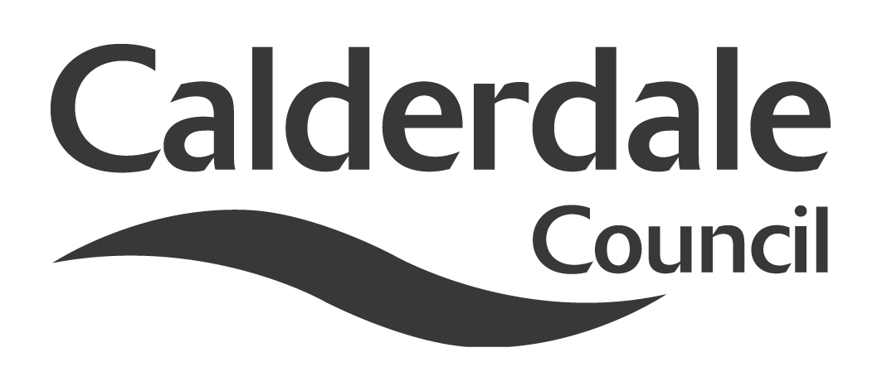
6

Report to Scrutiny Panel
Name of Scrutiny Panel | Safer & Stronger Communities Scrutiny Panel
Meeting Date | 20th January 2011
Subject | The Localism Bill
Wards Affected | All
Report of | Scrutiny Support Officer
Type of Item  (please tick✓ ) | Review existing policy
Type of Item  (please tick✓ ) | Development of new policy
Type of Item  (please tick✓ ) | Performance management (inc. financial)
Type of Item  (please tick✓ ) | Briefing (inc. potential areas for scrutiny) | √
Type of Item  (please tick✓ ) | Statutory consultation
Type of Item  (please tick✓ ) | Council request
Type of Item  (please tick✓ ) | Cabinet request
Type of Item  (please tick✓ ) | Member request for scrutiny (CCFA)

Why is it coming here?
Members wished to be appraised of the key points of this major piece of legislation.

What are the key points?
The Localism Bill is currently working its way through Parliament. It contains over 200 clauses covering areas such as Housing, Planning, Local Democracy and Community Empowerment. Many of the proposals will have an impact on areas covered by the remit of this scrutiny panel, both inside and outside the council.

Possible courses of action
Members may wish to consider the potential impacts of the Bill and make recommendations to Cabinet and/or partners as appropriate.

Contact Officer
Steve Barnbrook, Scrutiny Support Officer 01422 393252
steve.barnbrook@calderdale.gov.uk

Should this report be exempt?
No

Report to Scrutiny Panel
- Background

The Localism Bill had its First Reading in the House of Commons on 13th December 2010. The Second Reading is set for 17th January 2011 (i.e. before this panel meeting).

- Main issues for Scrutiny

There are a large number of proposals set out in this Bill. This paper seeks to examine those which have a bearing on the sphere of safer and stronger communities.

Consequently, areas such as housing and local authority structures have not been covered.

Equally, it is not the purpose of this paper to explore the philosophy behind the Bill, or make linkages with other areas of Government activity such as the Comprehensive Spending Review or the Big Society.

The following are themes within the Bill with relevance to Safer and Stronger Communities:

General Power of Competence: Local authorities, including certain parish councils, will have “all the same powers that an individual generally has, which will enable them to do anything apart from that which is specifically prohibited”. The government said this would mean that local councils have new freedoms to run services “free from Whitehall diktat”, and more freedom to innovate and work together with others to drive down costs. It said councils could use the power to “set up banks, develop property, run new services and own assets”. There will, however, be certain restrictions, qualifications and limitations on the power, and it may be that a number of legal test cases arise. Indeed, the whole premise of clarification of the power arose from a court case (Court of Appeal, 9th June 2009 – London Authorities Mutual Limited).

Right to veto excessive council tax rises: The public will be given the power to approve or veto excessive council tax rises. Where any local authority – including police and fire authorities, and larger parishes – sets an increase above a ceiling set by the Secretary of State and approved by the House of Commons, a referendum of all registered electors in their area will be triggered.

Community Right to Challenge: Voluntary and community groups, social enterprises, parish councils and local authority employees delivering a service will have the right to challenge a local authority, by expressing an interest in running any service for which they are responsible. A local authority will be required to consider and respond to this challenge. The challenge could lead to a procurement exercise in which the challenging organisations – and other interested parties – could take part

Community Right to Buy: local authorities will be required to maintain a list of public or private assets of community value and put it forward for consideration by communities. As and when listed assets come up for disposal (either the freehold or a long leasehold), communities will be given the chance to develop a bid and raise the capital to buy the asset

Local Referendums: local people, councillors and councils will have the power to instigate a local referendum on any local issue. The results will be non-binding, but local authorities and other public bodies will be required to take the outcome into account in their decision-making

Predetermination: The Localism Bill will make it clear that the normal activities of a councillor – such as campaigning, talking with constituents, expressing views on local matters and seeking to gain support for those views – “should not lead to an unjust accusation of having a closed mind on an issue that can lead to a legal challenge”. This will have particular relevance in planning matters.

Bin Taxes: sections 71 to 75 of, and Schedule 5 to, the Climate Change Act 2008 will be repealed so that so-called 'bin tax' schemes – allowing councils to charge residents for household rubbish collections or fine families for having a full bin – cannot be introduced

Community Infrastructure Levy: there will be three changes to the CIL, which allows local authorities to set charges which developers must pay when bringing forward new development in order to contribute to new infrastructure. These are provisions to: make regulations requiring some of the funds to be passed to neighbourhoods where the development has taken place; make clear that funds can be spent on the ongoing costs of infrastructure, as well as the initial costs of new infrastructure; give councils greater control over setting charging levels (independent examiners will still consider whether the charging schedule is unreasonable, but it will be for the authority to decide how to make it reasonable)

Neighbourhood Planning: communities will have a new right for communities to shape their local areas. Neighbourhood plans will enable communities to permit development – in full or in outline – without the need for planning applications

Community Right to Build: local communities will have the power to take forward development in their area without the need to apply for planning permission, subject to meeting certain safeguards and securing 50% support of the community through a referendum

Duty to cooperate: local authorities and public bodies will have a duty cooperate with each other

Pre-application consultation: Prospective developers will be required to consult local communities before submitting planning applications for very large developments. Developers will then be required to have regard to any opinions raised during this consultation when deciding whether to make any changes before submitting their planning applications

- Consultation

Many aspects of the Bill require in themselves a large degree of consultation.

- Further action and timescales

The Bill still has a number of stages to pass through before it becomes law, and amendments are possible along the way. Actions may be determined as the bill approaches Royal Assent.

- Options appraisal

Not Applicable

- Conclusions

This is a major piece of legislation which, when passed, will present a number of challenges and opportunities to local authorities, partners and the people of Calderdale. It is important that members are fully aware of the impacts of the legislation and are therefore in a position to respond and plan accordingly.

- Appendices

None

- Background documents

Localism Bill 2010-11 as introduced to Parliament December 2010
Explanatory notes to the Bill December 2010

- Documents available for inspection at

Westgate House, Westgate, Halifax HX1 1PS

