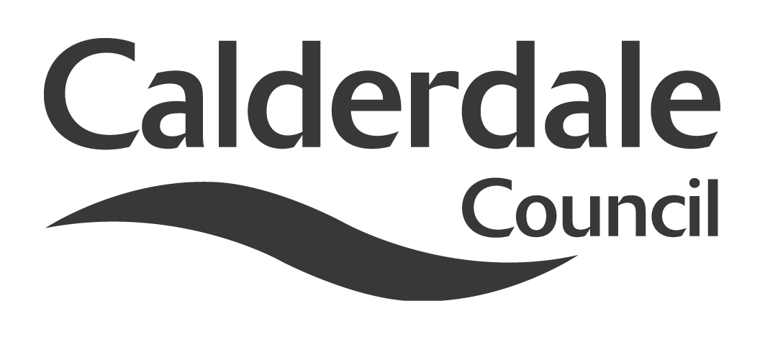
5

Report to Scrutiny Panel

Name of Scrutiny Panel | Safer and Stronger Communities
Meeting Date | 20th January 2011
Subject | Todmorden Town Hall
Wards Affected | Todmorden
Report of | DIrector of Safer and Stronger Communities
Type of Item  (please tick ✓) | Review existing policy
Type of Item  (please tick ✓) | Development of new policy
Type of Item  (please tick ✓) | Performance management (inc. financial)
Type of Item  (please tick ✓) | Briefing (inc. potential areas for scrutiny) | √
Type of Item  (please tick ✓) | Statutory consultation
Type of Item  (please tick ✓) | Council request
Type of Item  (please tick ✓) | Cabinet request
Type of Item  (please tick ✓) | Member request for scrutiny (CCFA)

Why is it coming here?
- In response to the Panel requesting briefing information

- To obtain the Panel’s views on the proposed development plan

What are the key points?
- A prudent and realistic financial approach that could lever in substantial capital investment from Heritage Lottery Fund at a potential rate of £9 for every £1 Council contribution.

- A business and activity plan that accords with the aims and objectives of the Town and Borough Councils and satisfies the aspirations of the local community.

Possible courses of action
- Making recommendations to the Town Hall Development Group, with particular regard to:

  - links to other priorities within the Council;
  - fundraising options ;
  - associated risks;
  - project governance;
  - future support from Scrutiny

- Lending support to the project and its aims as it seeks external funding

Contact Officer
Gary Borrows – Head of Cultural Services

Tel: 01422 392600

Email: gary.borrows@caldedale.gov.uk

Should this report be exempt?
No

Report to Scrutiny Panel
- Background

1.2 Todmorden Town Hall is one of six public halls managed by Cultural Services. In the past 4 years major improvements have been carried out to three of them: Clay House, Brighouse Civic Hall and Shelf Village Hall. However, the complexity and cost of restoring Todmorden Town Hall is significantly higher because it is a grade 1 listed building.

1.3 Thus in 2008 a Development Group was formed as part of the Todmorden Town Centre Renaissance Board. The Group’s remit has a special focus on development options for the Town Hall and so its members were drawn widely from local organisations. It is advised by a representative of English Heritage and officers of the Council. Councillor Olwen Jennings is the current chair of the Group.

1.4 In the past two years the Group has made considerable progress towards its aims by:

- completing initial designs studies;
- commissioning a conservation statement for the Hall;
- holding a national architectural competition;
- selecting and appointing architects to complete a feasibility study.

In the course of this work three full public consultations were held.

1.5 The works will preserve the outstanding heritage of the Hall but will also transform the facilities to support existing uses and attract new audiences and activities. From a premises perspective this will be achieved through more flexible room arrangements, full lift access to all areas, improved audiovisual and data services and new or upgraded facilities throughout.

1.6 The feasibility report contains full details of the proposals but in brief improvements include:
- the installation of 3 new lifts,
- an extension to the main hall balcony with new toilets and bar beneath;
- a “reheat” kitchen suitable for catering functions;
- transformation of the current (inaccessible) caretaker’s flat into a room for civic ceremonies;
- new areas for commercial hire or rental;
- the installation of heritage learning space;
- full repairs and renovations internally and externally to the stonework, electrical systems and mechanical services.
- decorative works to restore and protect the historic aspects of the building.

1.7 The business plan identifies four main audiences.

1.8 Civic

The Hall will continue to host all the civic functions and meetings of the Town Council. The central chamber is retained for larger meetings together with a suite of rooms that vary in size for committee use. A new mayor’s parlour will be created above the formal staircase, affording spectacular views across the town. The oval shaped room will also be available for marriage ceremonies and other formal gatherings.

1.9 Community

All the current community use will be supported, including dancing, choral/orchestral concerts and exhibitions, for example. Beyond this, there will be scope for having local and tourism information services around a reception area. The balcony too can be used as a seated audiovisual area showing continuous presentations to visitors. A central aim of the project is to broaden the range of activity to help bring sustainability and thus areas have been designed to serve multiple purposes.

1.10 Heritage

The major apartments of the Hall are not normally available for viewing without special arrangement so visitors have very limited opportunity to access the town’s principal architectural attraction. Educational visits are similarly constrained and there is a lost opportunity for schoolchildren to learn about the rich and abundant heritage of the town. The proposal will redress this by providing much greater representation of this heritage through standing and temporary exhibitions, workshops and installing ICT facilities for local groups to create a digital archive and for class visits to connect to school learning networks.

1.11 Commercial

The proposal focuses on two markets: conferences and celebrations (especially weddings, renewal of vows etc.). Works to the main hall are planned in order to create acoustics that satisfy both music and speech. Digital projection facilities to a screen on the main stage will be fitted and there is the option to upgrade these for digital broadcasts. The excellent rail connections from Todmorden to Manchester and Leeds open up the market for day conferences. The same ICT facilities for heritage use will also serve as a business centre during conference. Committee rooms will provide break out space and the upgraded kitchen will comfortably meet catering expectations.

Wedding bookings are already taken at the Hall but the improved decorations and facilities will enhance the grandeur of the building and consequently its attraction as a venue. Moreover the flexible accommodation will cater for small and larger scale events.

- Main issues for Scrutiny

- Do these proposals promise a sustainable future for the Hall?
- Is the business plan realistic and deliverable?
- Will the heritage and essential character of the Hall be preserved?
- To date have the community had adequate opportunity to shape the Hall’s future and is there scope in the future for local people to participate.
- Are the proposals inclusive of all sections of the community?
- In terms of activity are there any community, educational, commercial or other opportunities that could be considered or followed up?
- Is the development budget realistic and what are the prospects for further fundraising?

- Consultation

3.1 To date there have been three phases of public consultation. First, the community was consulted on the overall vision for the project, including what elements were essential and desirable. Discussion around this was stimulated by a range of design ideas; for example, the blending of other council services with the existing uses. Outcomes from this phase established that civic functions and community activities were an essential to the Hall’s future. Also the development of the heritage aspect was emphasised. These ideas shaped the design brief that was used as the basis for the architectural competition.

3.2 The second phase involved the public in that competition and the selection of architects to undertake the feasibility study. In order to narrow the15 entries down to a shortlist of 3, all the 15 design schemes were put on public display for 2 weeks at the Town Hall itself and at the library. The public feedback was reported to the Development Group before a decision was made. In the event, the successful practice, Camillin Denny, also ranked as number 2 in the public consultation results.

3.3 A third phase of consultation was undertaken by Camillin Denny as part of the feasibility study. This was extensive and full details of this are documented in the final feasibility report.

3.4 Notwithstanding this consultation strategy, it should be noted that the Development Group itself represents wide sections of the local community and members will regularly report back to their respective organisations.

3.5 English Heritage has also been represented on the Group throughout and has provided support and guidance in the development of the proposals. Equally, council officers from Building Design; the Fire, Safety and Access team; and the Conservation team have participated widely in the process. The Heritage Lottery Fund was consulted at regular intervals of course, even before the project outline was submitted to them last summer.

3.6 The Development Group also feeds back to the Town Centre Renaissance Board so that plans for the Hall accord with the direction of the wider town development.

- Further action and timescales

4.1 In December 2010 Cabinet allocated £400k funding as match funding and this has opened the way to a Heritage Lottery Fund (HLF) bid. The eventual overall project cost is likely to exceed £5m and for this level of HLF bid, the application must follow a two stage process. A first stage bid for development funding is in preparation with a provisional submission date of 16 February 2011. The outcome of this first stage application would be known in late May 2011. If successful, a subsequent second stage bid for the full amount will follow.

4.2 Although the £400k Council contribution by itself can lever in as much as £4m HLF funding to the project, any funds raised from other external sources can also be counted as match funding up to a maximum HLF grant of £5m. Consequently the Development Group is examining a range of fund raising options, initially for £100k to maximise the grant but also for works and activities not eligible for HLF funding.

4.3 In the event of an unsuccessful bid the £400k allocated by Cabinet would be returned to central funds. However, it is recognised that there are essential external stonework repairs to be carried out. Officers would request that the Council give consideration to reallocating some monies towards these. These repairs are included in the proposals and would of course be undertaken as part of a successful bid.

- Options appraisal

5.1 Given the low level of the Council’s capital reserve it is clear that the financial viability of this project has always rested heavily on a successful Heritage Lottery Fund (HLF) grant. Recently HLF raised their potential contribution to eligible schemes upwards to 90%. This means that the £400k Cabinet allocation may leverage up to £4m of grant. The feasibility study forecasts capital costs at between £4.5m and £5.5m. The Development Group accepts that further external fundraising will be needed and has discussed options. However the prospects for this fundraising will be greatly improved by an award of stage 1 funding from HLF.

5.2 At this time it is considered that this current set of proposals represents the only realistic option that will deliver the vision for the Hall and also respect its grade 1 listed status.

- Conclusions

6.1 This is a scheme that has developed and matured over the past 2 years and has secured widespread support due to the extensive consultation that has been carried out. This has been achieved on a modest budget of £35k that was used mainly for the feasibility study and the commissioning of an earlier detailed conservation study and statement. Apart from advertising costs and some small administrative expenses the architectural competition was carried through at no cost to the Council. Architectural practices were advised that their design submissions must carry no fee and it is testament to the quality and architectural standing of the Hall that so many practices were still prepared to proceed on this basis. Their designs will be retained as part of the project archive.

6.2 Notwithstanding the attractiveness, creativity and range of the designs for the Hall, the full business proposals must still deliver a mix of activities that satisfy the community’s aspirations. The Development group welcomes the Scrutiny Panel’s comment and observations on the progress so far.

- Appendices

7.1 Selected illustrations and designs from the feasibility and conservation studies will be available for the meeting.

- Background documents
- Todmorden Town Hall Outline Development Brief
- Todmorden Town Hall Conservation Statement (Architectural History Practice ( 2008
- Todmorden Town Hall Fire Safety and Access Statement
- Feasibility study carried out by Camillin Denny (Architects) 2009 - available on CD
- Documents available for inspection at

By hyperlink to web site or from:

Cultural Services, Westgate House, Halifax.

