# ONS Create a custom dataset

Link: <https://www.ons.gov.uk/datasets/create>

The Create a custom dataset (also called Flexible table builder) can be found on the [Census - Office for National Statistics (ons.gov.uk)](https://www.ons.gov.uk/census) under Census 2021 data.

Note the data selected in this builder may be affected by Statistical disclosure rules (SDR). This mean some results will only be available at higher levels of area. For more information, see [Protecting personal data in Census 2021 results - Office for National Statistics (ons.gov.uk)](https://www.ons.gov.uk/peoplepopulationandcommunity/populationandmigration/populationestimates/methodologies/protectingpersonaldataincensus2021results)

1. Click on the [ONS Census webpage](https://www.ons.gov.uk/census). Select population type (select one type only). ‘Continue’
2. Change the ‘Area type’ by clicking on ‘Change’. This is the level you want the data to be displayed at. Only one option can be selected. ‘Continue’
3. Change the ‘Coverage’ by clicking on ‘Change’. This is the geography the data should cover. For either ‘Search for [Area type selected in the previous step] by name’ or ‘Select all [Area type selected in the previous step] within a larger area’, search for a name and click on ‘Add’ to include. More than one can be added at this point. ‘Continue’
4. Click on ‘Add a variable’ and select ‘Search for a variable’ or ‘’Browse for a variable’.
5. If ‘Search for a variable’ is selected, enter keywords related to the variable being searched. Click on ‘Search’. All possible variables matching the keywords entered will be displayed.
6. If ‘Browse for a variable’ is selected, a list of all variables available is displayed.
7. For each variable, click on the > to the left of the variable name to see an explanation of the dataset. Click on ‘Add’ to include the variable. You can select more than one variable.
8. Whilst including variables, keep an eye on the Notes banner at the top of the page. This will display how many records are available and will indicate if your selection is being affected by the SDR, it will say how many of possible records will show data.

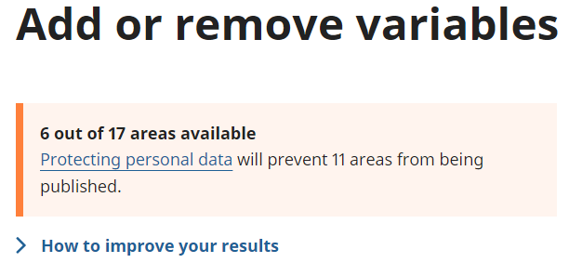

1. Once the selection is complete, click on ‘Continue’. If the Notes banner shows some records will not be published, click on the option ‘How to improve your results’ for suggestions on how the results can be improved. Options suggested can include:
   1. Change the level of Area type (note if you use this option, the Coverage may change to ‘England and Wales’
   2. Change the categories selected in the variables selected.
   3. Remove variables from the query.
2. Once the query is ready to run, click on ‘Get the data’
3. The next page give the different options available to download the data. If the download has more than 1 million rows, XLSX is not available because Excel cannot contain any more rows.
4. At the bottom of the page is a link to the dataset which can be used to return to this query.