Guidelines for Lifting and Lowering

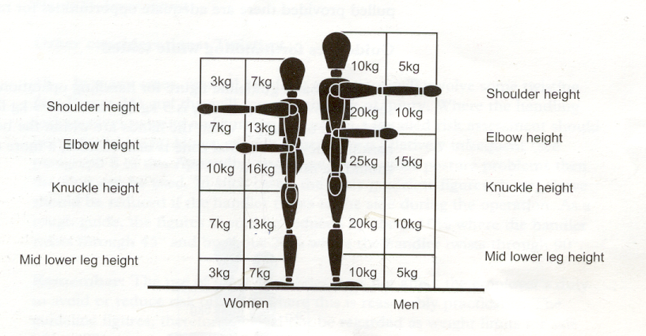
The guidelines assume that the load is easy to grasp with both hands and that the operation takes place in reasonable working conditions with the handler in a stable body position. The basic guideline figures for identifying when manual lifting and lowering may not need a detailed assessment are set out in the diagram below. If the handler’s hands enter more than one box zone during the operation, the smallest weight applies. However, the transition from one box to another is not abrupt; an intermediate figure may be chosen where the handler’s hands are close to a boundary.
The drawing and guideline weights shown are based on a fit and healthy male & female
Where lifting or lowering with the hands beyond the box zones is unavoidable, a more detailed assessment should always be made.

These basic guideline figures for lifting and lowering are for relatively infrequent operations – up to approximately 30 operations per hour. The figures will have to be reduced if the operation is repeated more often. As a rough guide, the figures should be reduced by 30% where the operation is repeated once or twice per minute, by 50% where the operation is repeated around five to eight times per minute and by 80% where the operation is repeated more than about twelve times per minute.

Even if the above conditions are satisfied , a more detailed assessment should be made where;
- the worker does not control the pace of work;
- pauses for rest are inadequate or there are no change in activity which provides an opportunity to use different muscles;
- the handler must support the load for any length of time.

