CALDERDALE MBC Agenda item 11

WARDS AFFECTED: ALL

USE OF RESOURCES SCRUTINY PANEL – 11th February 2015

STATISTICS AND INFORMATION TO SUPPORT THE 2014 ANNUAL SAFETY REPORT TO CABINET

Report of the Health and Safety Manager – Martin Allingham

Introduction

This report supplements the Annual Safety Report prepared for Cabinet on the 15th of December 2014 (See Appendix A). The Report to Cabinet summarises accident data and other measurable safety performance information. The information below, which is provided in full, will allow Members to scrutinise, in detail, this summarised information provided to Cabinet Members and allow members of scrutiny to examine clearly the work undertaken by the Corporate Health and Safety Team.

In general the accident statistics and performance information in this report indicate that Health and Safety is being well managed at all levels of management across the Council.
Please see detailed contents of annual safety report below:-

Contents

1. Health and Safety Management………………………………….Page 2
2. Safety Improvements in 2014……………………………………..Page 5/31
3. Self Auditing…………………………………………………………Page 5
4. Health and Safety Training………………………………………...Page 8
5. Incident Reporting…………………………………………………..Page 13
6. Benchmarking Figures……………………………………………..Page 21
7. Fire Safety Management…………………………………………..Page 22
8. Claims Experience………………………………………………….Page 25
(NB: All accident statistics provided for period April 2013 to March 2014)

Appendix A - Annual Safety Report prepared for Cabinet. (Pages 28)
Appendix B – Work Programme 2015 (Page 36)

1 Health and Safety Management
1.1 The Health and Safety Managers assessment is that the safety systems, policies and safety management structure within the Council, which have been improved over the last 12 years are adequate and do provide protection to the Council’s employees, the public, resources and individual officers.
1.2 The Council’s Corporate Health and Safety Team continue to provide an extensive Service to all Directorates to ensure delivery of the Council’s general Statutory Health and Safety requirements.
1.3 The Corporate Health and Safety Team consists of one manager, two Safety Advisers and an Apprentice Technical Safety Co-ordinator.
In summary the service provided by the corporate team includes:-
TABLE 1
Service – Protecting persons, assets, resources and reputation. | Statutory Requirement | Work completed 2013-14
Provision of competent advice to managers and staff on all aspects of risk assessment and safety management | Management of Health and Safety at work Regulations 1999 –(Regulation 7) | Large number of contacts with managers and staff.  E.g. Number of work e-mails handled by H&S Manager in last 6 months. *This does not include SPAM and emails to other members of the team.  - Received – 3981 (JULY- DEC 2014)Sent – 2152 (JULY - DEC 2014)
Writing and reviewing of the Council’s Safety Policy (and safety guidance, information, notices, news letters, safety alerts etc) | Health and Safety at Work Act 1974 – Section 2 | Revised CMBC H&S Policy and Arrangements and revised Drug and Alcohol Testing Policy revised. All approved at Cabinet.
Provision of safety information, safety alerts, news letter including the upkeep of the health and safety site on the intranet for all staff | Health and Safety at Work Act 1974 – Section 2 (c) | All library guidance documents reviewed. (110 plus).  New/revised guidance issued. News letters published and six safety alerts issued.
Consultation with employees including attendance at Safety Committees and Chairing the Safety Compliance Group. | Safety Reps and Safety Committee Regulations 1977 | Attended all Directorate Safety Committee meetings. Management of the Safety Compliance Group.
Health and safety training programme and e-learning provision | Health and Safety at Work Act 1974 – Section 2 (c) | See training statistics and information below for detail.
Accident/incident procedures, monitoring and investigation and liaison with the HSE. | Reporting of Diseases and Dangerous Occurrences Regulations 2013 (rev) | See stats below – All reports received are read, filed and acted upon. All serious accidents are investigated in detail and reports produced for Insurance. All actions taken are recorded.
Management of Incident Register | Health and Safety at Work Act 1974 – Section 2 | Reviewing information, advice to managers, writing to aggressors and advice to staff re precautions when visiting potentially violent persons.
Provision of information and investigation work to support the insurance section | Common Law | Regular meetings taken place sharing information and investigation work
Accident prevention programme – including management of several health and safety corporate data bases, including the audit system (which is used by all managers), the violent incident database, accident database, e-learning database. Safety inspections, and monitoring of safety standards collected through database information. | Management of Health and Safety at work Regulations 1999 –(Regulation 5) | Including:  (Summary of planned work programme for 2015 produced and issued to Chief Executive and Director of Communities and Service Support)
Monitoring of the safety standards of all the council’s contractors and external event organisers. | Health and Safety at Work Act 1974 – Section 3 | Monitoring SITA, AMEY, care providers and construction contractors. Work on the CHAS database.
Health and Safety Inspections | Management of Health and Safety at Work Regulations 1999 | Numerous safety inspections as listed in work programme 2014.
Fire Safety – advice, monitoring and written guidance. | Fire Safety Regulatory Reform Order 2005 | Fire safety aspects concerns are often picked up in health and safety inspections.
Partnership work SWYMT | Management of Health and Safety at work Regulations 1999 | Policy, accident investigation, advice
Supporting Emergency Planning Manager | Civil Contingencies Act 2004 | The health and Safety Section are the on call emergency planning officers out of hours.
Research/sharing of good practice and updates. Liaison and work with HSE, Yorkshire Regional Safety Officers Group LGA National Panel etc Detail below | N/A | Updating Officers on HSE Intervention plans, sharing best practice, developing policies with Yorkshire Councils etc

There are three other dedicated/related health and safety posts within the Council who provide extremely valuable additional health and safety services for their Directorates. These post holders do not provide all the services above and are not managed by the Corporate Health and Safety Manager but do support the work of the Corporate Health and Safety Team and work closely to ensure the best service for the Council. The Health and Safety Manager monitors these officers to ensure all advice given meets the Corporate Safety Policy, to ensure standards are maintained and there is no duplication of work or inconsistency.

These post holders are:-

Schools Safety Adviser – This post holder does many of the tasks outlined in Table 1 but all in Children and Young People’s Service and primarily in schools. Under Directorate Policy all health and safety advice to schools is a traded service and all schools (including Academy, Voluntary Aided, and Foundation) buy back this service. This post holder also provides an emergency planning function, specialist fire safety advice for schools, specialised training programme for schools, approves all school educational visits and supports the work of the Access and Capital Team which he is part of. Approximately forty percent of his work is acting as a consultant to the Academy, Foundation and Voluntary Aided sector and this work is all self funded. This post holder also has a contract to provide safety services to Airedale Academy in Castleford.

Community Services Safety Officer – This post holder does many of the tasks outlined in Table 1 above but all within Community Services. He provides specialist engineering and technical support to Community Services. He has an additional role as Shay Stadium Ground Safety Officer on match days operating under a grounds safety certificate and now represents Calderdale on the Armed Forces Community Covenant.

The Building Control Manager who is highly qualified on fire safety management provides valuable specialist support on fire safety as he has some budget allocated to providing an advisory service to Directorates on Fire Safety and Access Issues. He provides technical fire safety support for managers and all the health and safety advisers. Originally there was a post holder dedicated to this work but that was lost in the cuts. Information on fire safety below has been provided by the Building Control Manager in consultation with the Health and Safety manager (See section 7).

Other Additional Support - In addition to these post holders there are a number of staff who attend the Safety Compliance Group who support the work of the Corporate Health and Safety Team.

Representation on Regional and National Groups - Calderdale is very well represented at all levels. The Health and Safety Manager is the Chair of the Yorkshire Regional Safety Officers Group and represents Yorkshire at a national level attending the LGA panel with the HSE policy development officer for local government and other UK safety bodies. The School Safety Adviser who is an ex West Yorkshire Fire Officer is the chair of the national IOSH Fire Risk Management Group and speaks nationally (and in Hong Kong this year) on fire safety. He was invited to a dinner at the House of Lords representing IOSH this summer as part of this work. He also attends the Yorkshire Regional Education Group and the Outdoor Education Advisers Panel. The Community Safety Officer also Chair’s the Yorkshire Regional Hand Arm Vibration Group which shares info on compliance with this specialist legislation requirement. He also Chair’s the Kirklees and Calderdale Occupational Health and Safety Group which provides advice and support to the private sector. In addition he also sits on the IOSH National Panel on behalf of IOSH to assess new members. The Building Control Manager is also the Chair of the Regional Local Authority Building Control LABC and Chair of the Safety Advisory Group for Safety at Sports Grounds at the Shay Stadium.

Safety improvements in 2013/14

See cabinet report Appendix A – Section 5.3/5.4.

3 Self Auditing

3.1 During 2014 a total of 356 Managers, Head Teachers, contractors and external care providers were identified as responsible persons for completing a health and safety assessment for their area. All Heads of Service now have access to this system and can monitor their manager’s performance. The Safety Advisers audit 10% of the database by visiting managers on site and ensuring inspection on site matches managers inputted information. All non compliance will be followed up as it was last year. See Table 2 (b) below.

3.2 The system allows for action lists, provides safety guidance and generally helps the manager ensure all their basic safety management systems are in place and they are complying with Health and Safety Regulations and best practice.

3.3 The system has been improved significantly and the corporate safety team continues to audit all our major contract providers and external care providers.

3.4 The range of risks that are presented to staff, the public and its contractors through Calderdale Council’s activities are wide ranging and many are very significant. Every significant risk is identified in the self auditing process and managers are required to confirm they have these areas well managed. This is generally successful and demonstrated by the fact that the accident statistics generally reflect injuries in the “lower risk” areas e.g. slips and falls and manual handling etc.

The following examples in table 2 (a) below are significant areas of risk that are covered in the audit and are generally well managed.

Table 2 (a) - (NOTE: These are in no particular order)

Falls from height | Machinery accidents | Employee being attacked/lone working
Fire/smoke inhalation | Electrocution | Chemical accident
Gas explosion/leak | Catering/food poisoning | Exposure to asbestos
Legionella management | Anaphylactic shock - pupils | Failure to manage hot water for vulnerable clients
Confined space incident/lack of oxygen etc | Supervising vulnerable clients eg manual handling, violence | Failure of lifting machinery
Contractor management | Collapse of CMBC structure, e.g. wall/building | Control of medicines
Educational visits | Work experience | Minibus safety
Driving at work, reversing accidents, | Risks associated with water eg swimming pools, lakes, reservoirs we manage. | Exposure to tobacco smoke.

AUDIT PERFORMANCE BY MANAGERS

TABLE 2 (b) - Summary of Performance: - At Dec 2014

Directorate /Audit Group | Number of employees who were required to complete an on line Self Assessment H&S Audit | Performance | % Completed
Directors | 5 | 4 | 80%
Heads of Service - “Leading on Health and Safety” | 13 | 12 | 100%
Chief Executives | 19 | 19 | 100%
Communities | 81 | 80 | 99%
Economy & Environment | 28 | 28 | 100%
Adult Health and Social Care | 38 | 38 | 100%
Children and Young People’s Services (CMBC Schools) | 52 | 45 | 86.5%
Children and Young People’s Services  (Non Schools) | 59 | 51 | 86.4%
External Care Provider | 59 | 56 | 95%
Contractor (SITA and AMEY) | 2 | 2 | 100%
TOTAL COMPLIANT | 356 | 333 | 93.5%

*Heads of Service are following up on any areas showing non-compliance.

4 Health and Safety Training

4.1 Health and safety training is a statutory requirement because the competency of staff is a key issue.

4.2 This has been a year for consolidation in health and safety competence of staff through good training provision.

4.3 The Corporate Health and Safety Advisers have continued to work to provide a comprehensive list of core health and safety training courses which have been well attended by all Services (See table 3a below).

The team has consolidated on the IOSH accredited training for managers. This is the only course with a charge of £60 per manager for 4 day course. This is due to the fact that we have to pay IOSH for each manager’s pack and accreditation certificate. The training is nationally recognised. Externally, CMBC would pay anything between £500 and £700 per manager for this training.

In this reporting period we ran 2 IOSH courses where a total of 18 CMBC employees attended and successfully completed the course achieving the nationally recognised IOSH Managing Safely Certificate. By running these courses “in house” the Council has saved a substantial amount in training costs based on an average course fee of £500.

Under HR One we are now selling any IOSH Working/Managing Safely places not taken internally to the private sector and have made a gross profit of £2850 in this financial period. We also had over 13 of our staff on each course so our resources are not being compromised.

We have also started delivering all H&S awareness training for AH&SC including a small number from the private sector who are invoiced for the training by workforce development.

4.4 A substantial amount of work has been done by the Community Safety Officer on briefing employees in critical health and safety roles on the new alcohol and drugs policy and the dangers of the effects of alcohol on the morning after.

4.5 The Corporate H&S Section trainers have delivered a wide variety of essential safety related training in this period. The Calderdale One
course list and total numbers attending are listed below in Table 3 (a). The directorate breakdown is listed below in table 3 (b).

TABLE 3(a) – Calderdale One Training
Course Name | Number of staff completing course
Asbestos Awareness | 65
Practical Manual Handling in the Workplace | 18
Fire Warden and Fire Safety Awareness | 35
Working Well | 74
EVAC+CHAIR Training | 7
Introduction to Health and Safety | 17
Site Contact Training | 81
Health and Safety Briefings for Social Workers | 113
Alcohol & Drugs Policy Implementation | 24
Alcohol and Drugs awareness for employees (TS*)
IOSH Working Safely | 70
IOSH Managing Safely | 18
TOTAL: | 522
TOTAL NUMBER OF H&S INDUCTION RECORDS RETURNED IN THIS PERIOD: | 189

TS* - Delivered by Communities Health and Safety Officer

TABLE 3(b) – Attending safety courses (Directorate Breakdown)

CMBC Directorates | Employees attending Calderdale One Health and safety-related training courses
Adult Health and Social Care | 47
Chief Executive’s Office | 51
Children & Young People’s Services | 158
Economy & Environment | 138
Communities | 128
TOTAL: | 522
Total for the previous year 2012-2013 (for comparison) = 403 | Increase of 119 staff attending safety courses from the previous year.

4.5 E-Learning - There is a reduction in the number of people who have access the online health and safety training modules in 2013/14 from 505 users in the previous year to 313 users in the current period. A total of 990 safety courses were completed by users which have also decreased from 1499 in the previous period. (See table 4a and 4b).

The training courses per employee are costing less that £2 per employee. This is proving to be a very cost effective method of delivering basic training to staff across the Council in all Directorates.

4.6 E-Learning - The responsibility for the E Learning programme management now lies with Emma Glynn in Workforce development who acts as a central administrator of the system. Lee Broadbent and Julie Greenwood act as additional administrators, providing staff with access details on request.

TABLE 4a – Online Health and Safety Training Modules – (number of courses completed under each safety module)

Available Safety Module | Number of completed course
An Introduction to Health & Safety at Work | 195
An Introduction to Managing Health & Safety at Work | 49
Asbestos Awareness | 13
DSE and Work Station Health & Safety | 134
Fire Safety, Prevention & Evacuation | 161
Safe Manual Handling | 119
Avoiding Slips, Trips and Falls | 62
Managing & Handling Stress at Work | 47
Effective Hand hygiene | 30
RSI – What is it and How to Avoid it | 31
Staying Safe with Noise | 9
Staying Safe with Electricity | 20
Staying Safe with Hazardous Substance | 18
Staying Safe with Vehicles | 15
Staying Safe in Confined Spaces | 16
Protecting the Environment at Work and Home | 10
Introduction to risk assessment | 40
Preventing bullying in the workplace | 17
Test yourself on the highway code | 0
Handling Violence and Aggression | 1
Lone Working | 2
Personal Safety in other peoples homes | 1
TOTAL: | 990

Table 4b - E Learning figures (Directorate Breakdown) 2013/14:
Directorate | Courses Completed | Users
AH&SC (Personal Safety) | 4 | 1
Communities | 126 | 31
Chief Executive’s Office | 40 | 19
C&YPS | 620 | 188
AH&SC | 122 | 54
Economy & Environment | 78 | 20
TOTALS: | 990 | 313
 | Number of E-learning Safety Modules Completed by CMBC Staff – for comparison
 | 2012/13 | 2013/14
TOTALS: | 1499 | 990
 | Number of CMBC Staff Completing E-learning Safety Modules – for comparison
 | 2012/13 | 2013/14
TOTALS: | 505 | 313

4.7 Health and Safety training for Schools

The School safety adviser offers the following health and safety training schedule under a traded service agreement.

TABLE 4c – C&YPS Training Prospectus for schools 2014
Course  Spring 2014 | Date | Duration | Venue | Cost
CIEH Fire Safety Principles Level 2 Award | 8 Jan 2014 | 1 Day | Heath A | £90 each
CIEH Workplace Health & Safety | 22 Jan 2014 | 1 Day | Heath A | £90 each
Paediatric First Aid (2 day) | 30 & 31 Jan 2014 | 2 Days | Hfl.Mill | £120 each
Educational Visits | 11 Feb 2014 | ½ Day | Heath L | £50 each
Emergency Management/Planning In Schools | 18 Feb 2014 | ½ Day | Heath A | £50 each
Identifying & Managing Stress | 20 Feb 2014 | ½ Day | Heath B | £50 each
Safety Essentials for Premises Manager | 19 March 2014 | 1 Day | Heath L | £80 each
Outdoor Education Group Leader | 2 April 2014 | 1 to 5pm | J. Farm | £30 each
The following courses can be held in your school/establishment at a mutually convenient time and date
Introduction To Health & Safety - up to 20 staff | Contact H & S Team | 1 hour | School | £100 per session
Asbestos Awareness - up to 20 staff | Contact H & S Team | 1 hour | School | £100 per session
Working at Height - up to 20 staff | Contact H & S Team | 1 hour | School | £100 per session
Fire Awareness - up to 20 staff | Contact H & S Team | 1 hour | School | £100 per session
Manual Handling Theory - up to 20 staff | Contact H & S Team | 1 hour | School | £100 per session
Risk Assessment - up to 20 staff | Contact H & S Team | 1 hour | School | £100 per session

Course  Summer 2014 | Date | Duration | Venue | Cost
Educational Visits | 29 Apr 2014 | ½ Day | Heath A | £50 each
Outdoor Education Group Leader | 21 May 2014 | 1 to 5pm | J. Farm | £30 each
Safety Essentials for Premises Manager | 13 May 2014 | 1 Day | Heath A | £80 each
Emergency Management/Planning In Schools | 14 May 2014 | ½ Day | Heath L | £50 each
Paediatric First Aid (2 day) | 20 & 21 May 2014 | 2 Days | Hfl.Mill | £120 each
CIEH Workplace Health & Safety | 22 May 2014 | 1 Day | Heath L | £90 each
CIEH Fire Safety Principles Level 2 Award | 5 June 2014 | 1 Day | Heath L | £90 each
Identifying & Managing Stress | 10 June 2014 | ½ Day | Heath A | £50 each
The following courses can be held in your school/establishment at a mutually convenient time and date
Introduction To Health & Safety - up to 20 staff | Contact H & S Team | 1 hour | School | £100 per session
Asbestos Awareness - up to 20 staff | Contact H & S Team | 1 hour | School | £100 per session
Working at Height - up to 20 staff | Contact H & S Team | 1 hour | School | £100 per session
Fire Awareness - up to 20 staff | Contact H & S Team | 1 hour | School | £100 per session
Manual Handling Theory - up to 20 staff | Contact H & S Team | 1 hour | School | £100 per session
Risk Assessment - up to 20 staff | Contact H & S Team | 1 hour | School | £100 per session

5 Incident Reporting

5.1 HSE Reportable Accidents - Last years annual safety report reported that there were 11 reportable incidents reported to the HSE (including major injuries and incidents resulting in over 3 days off work). This year, as can be seen from the information below, there has been an increase to 15 reportable accidents to the HSE. This increase is a concern but it is considered this is due to the changes in the accident reporting procedure which has made it even easier for manager’s and schools to report accidents. These accidents reported to the HSE have all been investigated by the Health and Safety Team. The summary is provided in Table 5 below. The most significant accidents were:
    - The fall from a ladder in a school. The caretaker had used a ladder unsuitable for the task.
    - A school crossing patrol lady was hit by a car whilst in the road. Police investigated.
    - Vice spun off work bench and injured her foot (School teacher).
    - Injured himself with Stanley Knife cutting sign off.
All the other 11 accidents were slips, trips and falls where the injured party had been wholly or substantially responsible for the accident.

None of the above accidents caused a HSE inspector to contact the Council for further information. This indicates they could not see any breach of legislation or they considered the injuries were not significant to warrant further action. In addition, it is clear that none of the injured person submitted a complaint as this always results in contact.

Information has been included in the Tables 5 (a-c) below. Table 5(a) shows the F2508 summary, Table 5(b) Causation, Table 5(c) by directorate and Graph 5(d) shows the comparison figures over the previous years.

5.2 All Employees – There has also been an increase in minor injuries for all employees reported to the Health and Safety Section. This has increased from 43 to 67 this year. Two tables have been included to show the numbers by Causation 6(a) and by Directorate 6(b). See Table 6. The main concern is that the number of slips, trips and falls has doubled from 11 in 2013 to 23 in 2014. This is also reflected in the F2508 statistics. More work is needed on slip prevention for 2015. See Appendix B - Work Programme 2015.

5.3 Members of the Public - Last year there were 30 reportable incidents involving members of the public who were injured on our premises. This year this figure has risen by 5 to 35. See Table 7.

5.4 Pupils - The number of reports of pupils injured for this year is 52 which is an increase of 41 from last year’s reports which numbered 11. This looks like a significant concern but the Health and Safety Manager and Schools Safety Adviser believe this is due to the improved accident reporting procedure (phone only). Clearly there has been significant under-reporting from CMBC schools in previous years. The main incident groups reported were falls from ‘trim trail’ play equipment and slips, trips and falls and running into stationary objects throughout the school. See Table 8.

5.5 CMBC Statistics in context - Overall in this reporting year there were no deaths to any employee; contractor or member of the public from the Council’s numerous activities. During the period we employed 4229 staff and thousands of members of the public visited or attended CMBC premises. No critical or very serious injuries, such as a loss of an eye, finger or limb or significant burn etc were recorded within this period. A combined total of 289 incidents (Near misses, non-reportables, Academy incidents and incidents to employees, members of the public and CMBC schools) were recorded by the Health and Safety Team within this period including incidents to employees, pupils and members of the public as well as those that were deemed as either near miss incidents or non-reportable incidents. 97 officer hours were used to record these accidents (taking into account that each accident takes approximately 20 minutes to record and report to the relevant people). This does not account for further accident investigation hours.

5.6 Violence & Aggression reports – The statistics for this year indicate that the number of reports of violence & aggression towards employees has decreased from 172, as stated in last year’s report, to 145 in this period. Three tables have been included to show the Types of incident (pie chart) 9(a), numbers by Directorate 9(b) and by Physical only, Verbal only and Both Physical & Verbal Abuse 9(c).

5.7 All significant reports of Violence and Aggression towards staff are checked and followed up by the Corporate Health and Safety Team, with competent advice given as necessary.

5.8 Table 10 shows benchmarking against other Yorkshire Council’s. Unfortunately, CMBC is no longer the top performer, but remains in the top quartile.
 | Major/Over 7 day | Type of incident | Inside/Outside | Summary
AL | Major Injury | Slipped, Tripped or Fell | Outside | Injured person fell over his own feet whilst delivering books and consequently broke his arm as he fell.
DG | Over 7 Day Lost Time Injury | Fell from Height | Inside | Fell 5-6 feet from a ladder whilst inspecting a blind which wasn’t working correctly.
FR | Over 7 Day Lost Time Injury | Hit by Moving, Flying or Falling Object | Outside | Was struck from behind by a vehicle whilst undertaking he school crossing duties.
HS | Major Injury | Slipped, Tripped or Fell | Inside | Injured person slipped on the wet floors that she was cleaning consequently breaking her wrist
KT | Major Injury | Hit by Moving, Flying or Falling Object | Inside | Vice spun off during a D&T lesson striking the injured person on the ankle, consequently breaking it as a result.
LH | Major Injury | Slipped, Tripped or Fell | Inside | Slipped on an area of wet floor consequently breaking her wrist.
LB | Over 7 Day Lost Time Injury | Slipped, Tripped or Fell | Inside | Tripped over her child causing soft tissue damage to her knee as a result.
LF | Over 7 Day Lost Time Injury | Hit Something Fixed or Stationary | Inside | Stubbed her toe on a chair leg causing a fracture.
MD | Major Injury | Slipped, Tripped or Fell | Outside | Twisted left ankle as a result of falling down an incline in the car park. Resulted in broken foot and tendon damage.
ML | Over 7 Day Lost Time Injury | Slipped, Tripped or Fell | Outside | Pushed by a child in the playground causing her to fall and break her left wrist.
ND | Over 7 Day Lost Time Injury | Injured whilst Handling, Lifting or Carrying | Outside | Cut hand with Stanley Knife whilst trying to cut down a sign outside.
SL | Major Injury | Slipped, Tripped or Fell | Outside | Fell on mud breaking his ankle whilst undertaking a site inspection.
SL | Major Injury | Slipped, Tripped or Fell | Outside | Fell over on the footpath causing her to break both her arms.
SK | Major Injury | Slipped, Tripped or Fell | Outside | Fell over flowerbed resulting in a broken wrist.
SK | Major Injury | Slipped, Tripped or Fell | Outside | Walking to the car after carrying out a telecare assessment, the injured person went over on her foot on an uneven surface resulting in a broken ankle.
TABLE 5(a) – F2508 Summary Information
Table 5(b) - HSE Reportables (F2508) - EMPLOYEES

By Causation = TOTAL 15 – Increase of 4 from 11 in the previous year

Table 5(c) - By Directorate

Table 5(d) - HSE Reportable (F2508) by Years – for comparison

Table 6(a) - ALL EMPLOYEE ACCIDENTS

By Causation = TOTAL 67 –up 24 from 43 in the previous year

Table 6(b) – All Employee Accidents by Directorate = TOTAL 67 – Up 24 from 43 in the previous year

Table 7 - PUBLIC ACCIDENTS

By Causation = TOTAL 35 – Up 5 from 30 in the previous year

Table 8 - PUPIL ACCIDENTS

By Causation = TOTAL 52 – Up 41 from 11 in the previous year

Table 9 - VIOLENCE & AGGRESSION

Table 9(a) - By Type - TOTAL 145 –Down 27 from 172 in the previous year

Table 9(b) - Violence & Aggression by Directorate

Directorate | Numbers of Violence & Aggression Reports to H&S
Children and Young People’s Services | 70
Safer & Stronger/ Communities | 34
Adult Health and Social Care | 26
Economy & Environment | 14
Chief Executive’s Office | 1
TOTAL | 145

Table 9(c) – Violence & Aggression by Type for comparison with last year

 | 2012/13 | 2013/14
Both Physical & Verbal | 59 | 41
Physical Abuse only | 36 | 51
Verbal Abuse only | 69 | 43
Blank /other (including racial and electronic aggression towards CMBC staff.) | 8 | 10
TOTAL | 172 | 145

Table 10 - BENCHMARKING
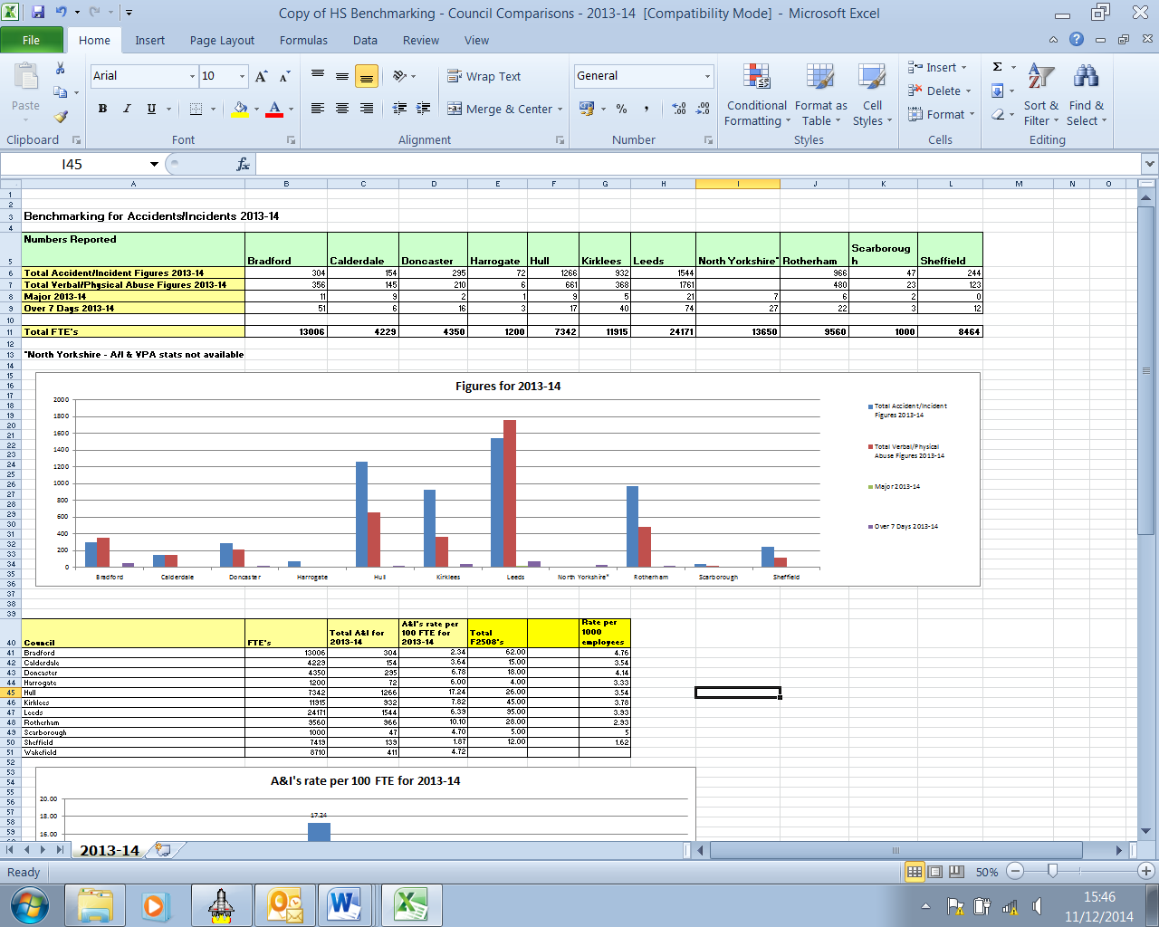
Table 10(a)
Table 10(b)
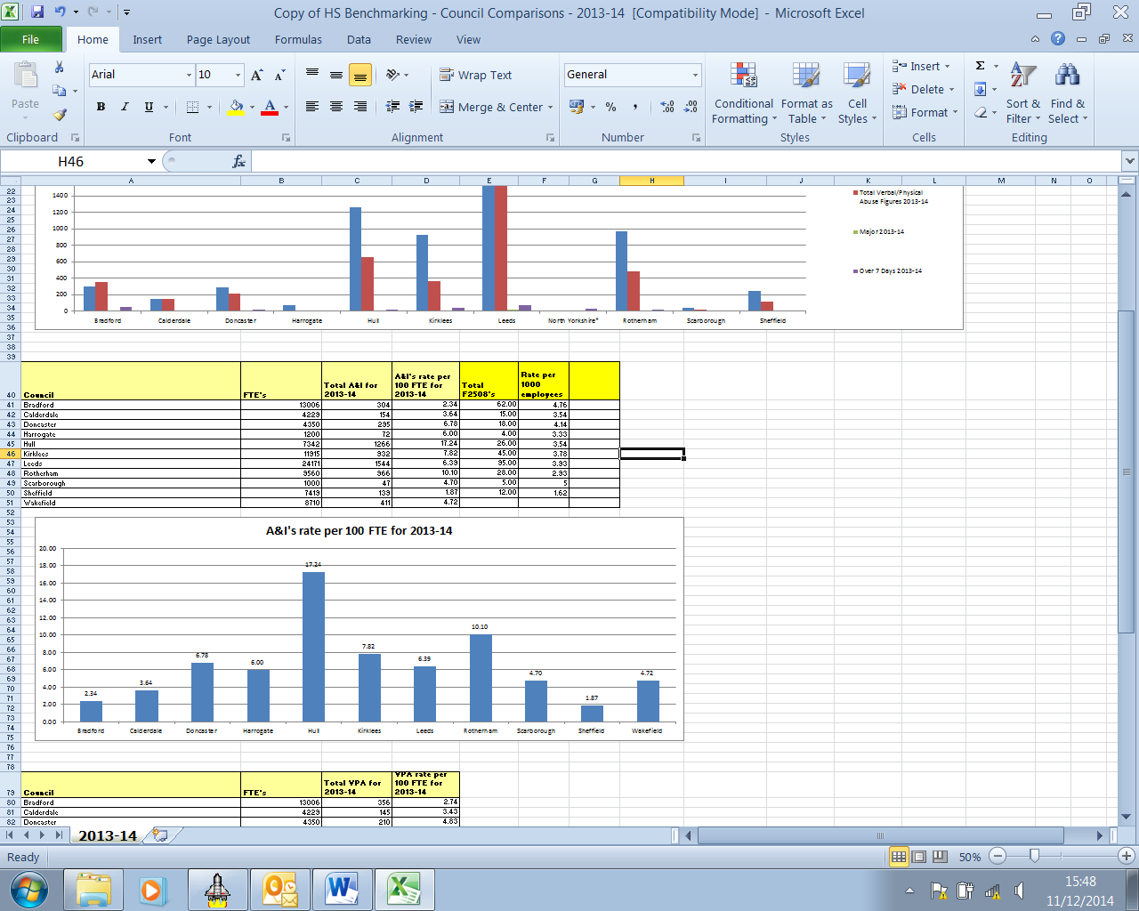
Table 10(c)

Table 10(d)
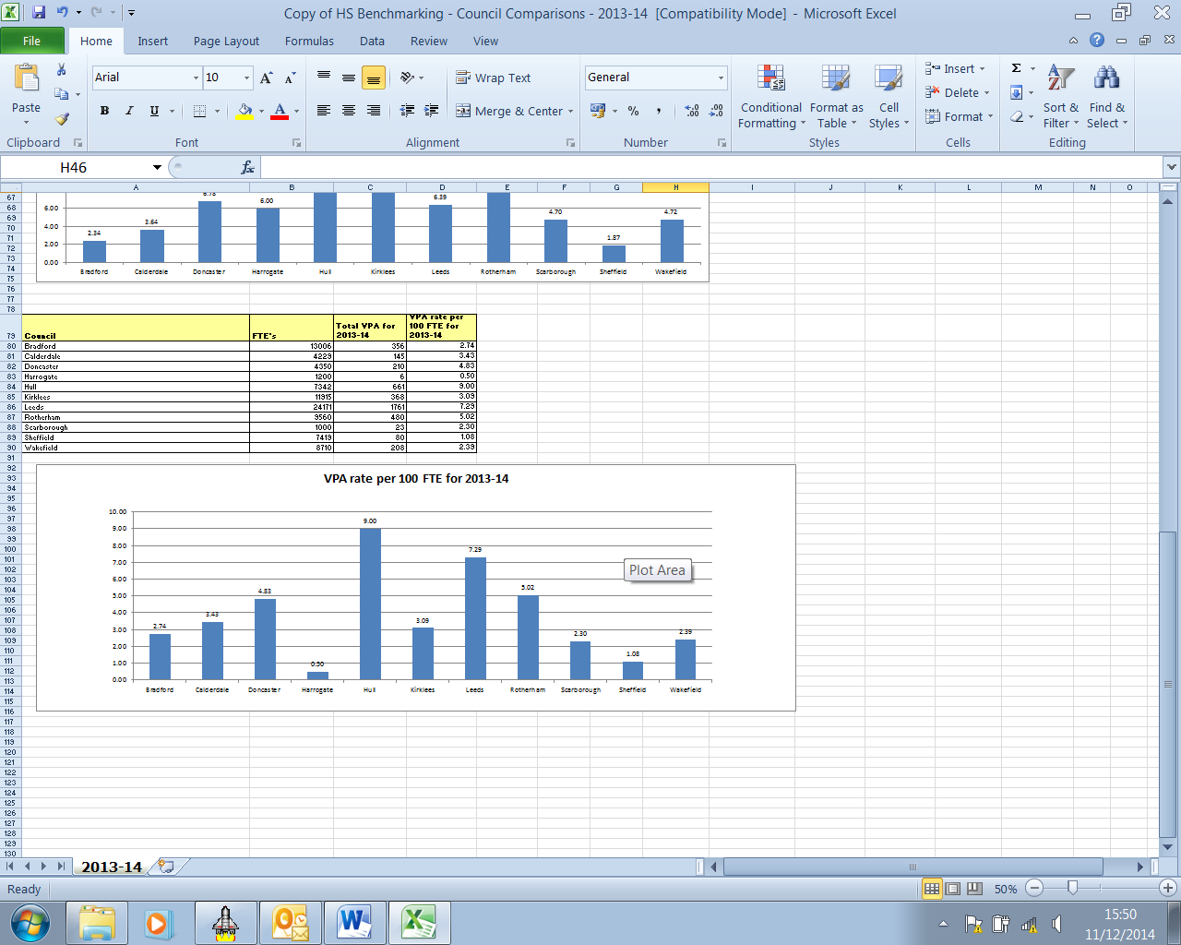
Table 10(e)

7 Fire safety in Calderdale

The authority remains committed to ensuring the safety and welfare of all staff, service users and customers against the threats of fire in our premises.
The risk of fire is recognised as a constant hazard, placing people, services and assets in jeopardy if not managed appropriately.

7.1 Documentation

The Authority has in place a Fire Safety Policy Statement adopted by Cabinet, that commits to safeguarding all people who use Council premises and includes arrangements to ensure that the duties and obligations imposed upon the Council, under the Regulatory Reform (Fire Safety) Order 2005 are met.

The Authority has published a suite of risk assessment documents, together with three volumes of fire registers and other guidance documents to support relevant staff in their management of fire safety within the work place.
It is essential that a suitable and sufficient fire safety risk assessment is in place for all our premises and that the regular checks and tests required by the Fire Register are undertaken and recorded.

7.2 Fire safety initiatives

The corporate Health and Safety Team, together with members of Building Control continue to visit Council premises and provide advice and guidance regarding fire safety.
Fire safety initiatives include an enforcement protocol between Calderdale MBC and West Yorkshire Fire and Rescue Service regarding ‘Fire safety in Schools’ and systems of work by the Corporate Asset and Facilities Management (CAFM) Team to maintain the safe use of Calderdale premises.
In addition, discussions have been initiated between the authority and West Yorkshire Fire and Rescue Service regarding the provision of an enforcement protocol or memorandum of understanding relating to the whole of the Corporate estate.

7.3 Training

The Building Control Service continues to provide Fire Warden training to Calderdale staff via regular Calderdale One courses, and Service specific, bespoke fire safety training continues to be provided across the authority.
Whilst both the corporate Health and Safety Team and Building Control continue to provide training regarding the use of generic fire evacuation aids.

Also, the corporate Health and Safety Team and Building Control continue to support the CAFM Team with their training programme for Site Contact staff, incorporating fire safety training.

7.4 Fire incidents

Despite the authority’s commitment to fire safety, there remain a number of incidences of fire occurring within or about Council premises. All these incidents were investigated. Please see the summary details below:

TABLE 11 - Reported Fire Events

Date | Location | Cause | Affect | Injuries
13.05.13 | Garage to yard to rear of Elland Council Offices | Malicious fire setting | Fire damage to lock up garage | No injuries
29.07.13 | La Munch Bunch (Princess Buildings)  Market Street Halifax | Electrical fire | Fire damage to electrical equipment and decoration | No injuries
22.08.13 | Battinson Road Depot, Battinson Road Halifax | Accidental fire attributed to welding sparks | Damage to ventilation filters (H&S Manager on site!) | No injuries
04.10.13 | Little Stars Day Nursery  Parkinson Lane Community Primary School  Parkinson Lane  HALIFAX  HX1 3XL | Dirty oven causing smoke | Smoke about the premises | No injuries

Date | Location | Cause | Affect | Injuries
10.02.14 | Ryeburn House | Accidental chip pan fire | Fire damage to flat | No injuries
08.03.14 | Shibden Hall accessible WC adjacent to the museum village | Malicious fire setting | Fire and smoke damage to toilet block | No injuries
May 2014 | Rippenden Sports pavilion | Malicious fire setting | Fire and smoke damage | No injuries
Tuesday 13th May 2014 | Hebden Vale Centre - Smoking Shelter | Possible carelessly discarded cigarette | Fire and smoke damage, requiring minor repairs | No injuries
Monday 14th July 2014 | Higgins Close Day Care Centre | Accidental fire in gas fired tumble drier | Minor smoke damage | Smoke inhalation
Friday 15th August 2014 | Todmordon Community College | Accidental fire to temporary negative pressure extract duct to Contractors asbestos removal accommodation sited within the basement | Minor smoke damage | No injuries

7.5 Conclusion

Fire safety management remains a priority to maintain the safety and welfare of staff, service users and customers, to meet our legislative duties, maintain our physical assets, preserve business continuity, protect the environment and maintain our corporate reputation.

The above noted regular incidences of fire within our own premises illustrate the importance of managing fire safety, ensuring staff are trained and that we all remain vigilance to the risks of fire occurring to prevent the opportunities for injury to staff, customers and stakeholders.

8 Claims Experience 2013/14

Information provided by Helen Branford, Insurance Manager. All the insurance information is provided in four year periods as claims can be received for up to 3 years from the accident.

8.1 Table 12(a) below shows the numbers of claims is 83 from employees occurring in the last four complete financial years (2010 – 2014). The total for the four years previously (2009 – 2013) was 103 which shows a positive 20% reduction in claims. This is interesting because the recent accident statistics indicate an increase in accident rate which normally would be reflected in more claims. This information does suggest the increased accident rate is down to better accident reporting procedures alone.

8.2 Tables 12(b) & 12(c) show the number of claims received from members of the public in the last four complete financial years. The number of claims from the public remains fairly static with a small reduction in the total with the majority of claims still coming from highways.

8.3 The cost of these claims and the associated insurance costs on the Councils resources are obviously substantial. (Detail held by Insurance Manager). Personal injury claims may take several years to settle so it is difficult to accurately compare amounts paid out year on year.

8.4 Obviously reduction in accidents needs to be a priority to reduce the number of claims. In addition good safety management and safety training must continue.

8.5 Good records for health and safety training, documented risk assessments, policies and procedures and maintenance of systems is essential to adequately defend claims.

TABLE 12(a)
TABLE 12(b)

TABLE 12(c)

END

FOR FURTHER INFORMATION ON THIS REPORT CONTACT:-
Martin Allingham – Telephone (01422) 393080

DOCUMENTS ARE AVAILABLE FOR INSPECTION AT:
Health & Safety Section, Westgate House, Halifax

APPENDIX A - ANNUAL SAFETY REPORT

CALDERDALE MBC

WARDS AFFECTED: ALL

CABINET – DATE 15th DECEMBER 2014

2014 ANNUAL HEALTH & SAFETY REPORT FOR CALDERDALE MBC

Report of the Health and Safety Manager

1. ISSUE

The Councils compliance with Health and Safety Legislation is mandatory and Statutory Health and Safety requirements must be maintained as a minimum.

This report is produced in accordance with the Council’s Safety Policy and best practice recommended by the HSE in the document “Leading on Health and Safety at Work” (INDG417).

2 NEED FOR A DECISION

This report is brought to Cabinet so that Members are able to satisfy themselves that the Council’s safety arrangements are adequate.

3. RECOMMENDATIONS

It is recommended that Cabinet:-

3.1 Approve the Councils Health and Safety Policy Statement. This has been reviewed in accordance with best practice recommended by HSE. No changes are recommended this year – See Appendix 1 (page 9).

3.2 Approve the revisions to the Council’s “Alcohol and Drugs Misuse Policy” appendix 2 (page 13) including the recommendation to make the policy applicable to all staff.

3.3 Agree that safety work on the four buildings identified in the report are prioritised. This ongoing work and detailed requirements on these buildings will be the subject of a report to be taken to the Capital Programme Working Party and CAFM Board as a priority detailing additional proposals for remedial action which will reduce these risks.

3.4 Agree that further reports to Cabinet need to be produced by the Director of Economy and Environment to identify how safety matters identified in the corporate buildings estate will be managed.
4. BACKGROUND

4.1 This is the twelfth annual safety report for Cabinet providing members with the opportunity to assess the Council’s health and safety performance for 2013 -2014 and assure itself that the Council’s huge range of operational activities do not present a significant risk to the community of Calderdale or its employees or contractors. Members are informed within the report about positive health and safety management and also about where there may be concerns.
5 HEALTH AND SAFTEY MANAGEMENT
5.1 Safety Performance in 2013/14 - The Corporate Health and Safety Team provide key statutory and beneficial health and safety functions to support all Directorates across the Council. These include advice, inspection, audit, training, policy development, accident investigation, safety information, safety alerts, emergency planning, HSE liaison and management of the incident register.
A summary of Health and Safety performance and main concerns for 2013/14 are highlighted below to allow Members of the Cabinet to assess performance. However, as in previous years, a report containing detailed statistics and additional information covering all aspects of safety management above during 2013/14 will be provided to the Use and Resources Scrutiny Committee early in 2015.
  - Minor Concerns:
5.2.1 The number of reported accidents to employees has risen to 67 from a total of 43 last year. The number of more serious accidents, which have to be reported to the HSE under the RIDDOR regulations, has also increased from 11 to 15, but these figures should be treated with caution. The Corporate Health and Safety Team have changed the CMBC accident reporting procedure in order to gain a greater standard of information, which is helping us fight insurance claims more effectively. The team now take the reports via telephone as soon as the incident occurs rather than relying on managers to submit forms. This has been a far easier method for reporting accidents and has resulted in a significantly higher number of incidents reported over the 2013-14 financial year than in previous years. This increase in reporting is in all probability due to under reporting in previous years rather than a significant increase in incidents
5.2.2 The number of accidents reported involving members of the public being injured on Council property has increased slightly from 30 to 35. These incidents, as in previous years, are mainly slips, trips and falls, and although this is a concern it is believed that it is due to the improved reporting procedures. All serious incidents are investigated by the Council Safety Team who have a slip prevention strategy and work very closely with the Insurance Section on this matter.
    - The number of staff completing the CMBC online health and safety training modules has decreased substantially from 505 to 313. A total of 990 online courses were completed in 2013-2014. Although this is a reduction from 1499 safety courses completed in the previous year by CMBC staff (a record all-time high), online training is still being well received by all directorates across the Council. (The total cost of online training is £2500 equating to just over £2 per course, which is an incredibly cost effective way of training CMBC employees and meeting statutory requirements)

  - Positive Health and Safety Performance 2013/14
5.3.1 Compliance by CMBC managers completing their self assessment audits on health and safety was close to 97%. (356 managers were audited). A total of 62 contractors employed by the Council including all our major contractors also undertook safety self audits, which were submitted back to the Health and Safety Manager for assessment, compliance was close to 95%. Compliance by Community and Voluntary Controlled Schools was 90%.
All contractors undertaking maintenance work for the council including those who do not complete a H&S self audit are CHAS compliant which is a nationally recognised safety scheme.
The CMBC on line H&S self audit service is offered to Academy, Foundation, Trust and VA schools as a tool to assist them with their own H&S management and 30% of these schools use the system.
All the self assessment submissions are monitored by the Health and Safety team, and any outstanding safety actions identified are recorded and followed up. Also 10% of outstanding actions are then checked for compliance on site with the managers.
    - The number of incidents of violence and aggression to staff reported to the health and safety team was 145, a reduction of 27 from 172 in 2013. Many interventions are put in place to reduce this violence and aggression such as training, CCTV, and lone working arrangements.
    - The number of staff attending training delivered by the Corporate Health and Safety Team through HR One (formerly Calderdale One) has increased from 406 to 522.
    - The new health and safety induction process, which was introduced in 2012/13, has become even more successful in the 2013/14 period with a total of 189 managers completing the induction for their employees and returning the completed Health and Safety induction documentation. Since the programme began, a total of 423 employees have received this initial briefing from their line manager, providing them with the basic Health and Safety information that they require for their job role. All these records are held on Vision as well as a central database.

  - Positive health and safety initiatives in 2013/14

5.4.1 The Health and Safety Team produced all the risk assessment documentation for crowd management for the Calderdale section for the Tour De France. The team also briefed all CMBC staff involved, Police and the contracted crowd management company on all safety requirements and procedures. The HSE thanked all the Yorkshire Regional Safety Officers who were involved in this event.
    - The Health and Safety Team are supporting the Councils “Core Values” and “thinking commercially” and have generated a gross income of £2850 over the last 12 months by providing IOSH accredited training to the private sector.
    - The new Customer First unit opened in November 2013. Staff safety was a key part of Customer first managers concerns and a great deal of work went into the project from design to staff training. The unit deals with approximately 14,000 visitors a month and there can often be times when all the advisers are busy and queuing and frustration is inevitable. Incredibly since opening there have only been 6 reports of violence and aggression in the unit of which none of these were physical. The Health and Safety Manager has assessed all the procedures and risk assessments put in place by management and credit must be given to all the managers and staff working in this unit. A model of excellence!
    - The Health and Safety Apprentice Technical Safety Co-ordinator has successfully passed the first modular examination in his National Diploma (degree equivalent level 6) delivered by NEBOSH (The National Examination Board for Occupational Safety and Health.) This NEBOSH Diploma is a highly regarded and recognised health & safety qualification throughout the country. There are many health & safety advisers employed within the industry who only have the lower General Certificate Qualification.

    - The Institute of Occupational Safety and Health (IOSH) Managing Safely and Working Safely training courses continue to be well received by staff and this reflects positively on the Council ensuring more of our staff have higher levels of competence and this is being seen in the quality of risk assessments in the workplace and safety procedures.

    - Collaboration between Calderdale’s Health and Safety Team, Leeds City Council and the Health and Safety Executive (HSE) proved a success this summer with the running of a joint regional event. The HSE National Local Government Division made a trip up from London to Leeds to launch their new advice, guidance and web page on “Sensible risk in Local Government”. This event was well attended and well received by Councillors, Heads of Service and Chief Executives from across Yorkshire. The HSE has written to Calderdale thanking us for our support at the event.

    - The Corporate Health and Safety Team, together with members of Building Control continue to visit Council premises and provide advice and guidance regarding fire safety.

Fire safety initiatives include an enforcement protocol between Calderdale MBC and West Yorkshire Fire and Rescue Service regarding ‘Fire safety in Schools’ and systems of work by the Corporate Asset and Facilities Management (CAFM) Team to maintain the safe use of Calderdale premises.

In addition, discussions have been initiated between the authority and West Yorkshire Fire and Rescue Service regarding the provision of an enforcement protocol or memorandum of understanding relating to the whole of the Corporate estate.

    - The new Ministry of Justice Reforms which came into force in April 2013 have reduced the amount of time councils have to act upon claims received. To date these new time frames have been met by the Council. This objective has been helped by the new accident reporting telephone arrangements which have been a success ensuring the Council and our Insurers having all the information required to handle claims successfully and speedily. This ensures that speculative claims can be dealt with efficiently by the insurance team.
    - There were no reportable accidents from Calderdale schools involved with educational visits. These visits are designed to take students of all ages out of their comfort zones and challenging them in a positive way. There were 3929 off site visits, of which 73 were overseas in 17 different countries along with 293 residential and 386 adventurous activities. This resulted in a grand total of 95,894 days of student involvement in school organised activities from September 2013 until August 2014. All the visits are risk assessed and monitored by the schools safety officer.
6 HEALTH AND SAFETY CONCERNS 2013/14
6.1 Health and Safety Policy
The Councils Health and Safety Policy Statement needs to be reviewed in accordance with best practice recommended by HSE. No changes are recommended this year – See Appendix 1.
6.2 CMBC Misuse of Alcohol and Drugs Policy
The introduction of the new Policy 12 months ago has proved to be effective in dealing with the problems that had been identified. However there have been a number of teething problems introducing the Policy and therefore the Policy needs amending accordingly, see detail summary of changes appendix 2. The main issues are the scope of the policy with the Unison believing it should apply to all staff and questions raised by managers that we have only focused on random alcohol testing and we should also include random drug testing. We can test for drugs using mouth swabs for a specific concern for one individual but if we wish as a Council to do random testing for drugs the testing process needs to be more involved. Safety staff will need to be trained for urine testing protocols or it may be more appropriate for an external company to be used which both have an additional cost. Unison, Unite and GMB have been consulted on the amendments.
6.3 Building maintenance issues impacting on health and safety standards
6.3.1 There are a number of Health and Safety concerns related to four high profile Council buildings. Although the risks presented by these hazards does not warrant immediate closure of any of the buildings, there are significant maintenance and repair issues impacting on safety. These four buildings have become more of a concern as result of evidence gathered in recent safety inspections and information provided from managers. Buildings are clearly being affected by the maintenance backlog, lack of resources and an estate with many buildings unfit for purpose. It has become clearer that a failure to invest and maintain these buildings adequately will eventually become unsustainable from a safety point of view.
The four buildings of immediate concern are:-
- The Borough Market
- Victoria Civic Theatre
- Halifax Pool
- Lower Edge Day Centre
6.3.2 Although the risk of serious injury or death is unlikely the risk of delaying essential maintenance has consequences. As the buildings deteriorate month on month the risks increase and the buildings are continuing to degrade. Injury is unlikely as temporary preventative maintenance measures are already being taken on these buildings by CAFM and regular monitoring is constantly being undertaken to mitigate the risks. This work needs to continue being a priority on these buildings.
7 TRADE UNION COMMENTS

“Unison fully supports the comments and recommendation in this annual safety report. Unison has always had a good relationship with the Council’s Health and Safety section and is fully supportive of the sections common sense approach to health and safety management.”

However, Unison has some serious concerns around the budget constraints being placed on CAFAM, which is leading to the potential for serious accidents to occur at a number of Council maintained buildings.
Two in particular that are a cause for concern are the Victoria Theatre and the Borough Market.

(Edward Ashman, Unison Branch Secretary)

8 FINANCIAL/OTHER CONSIDERATIONS

8.1 There are financial implications arising from the report if Members agree to the recommendation in 3.3. This will need further assessment but costs could be significant. Further reports should be produced by Economy and Environment for Cabinet on this matter where specific buildings are identified which require substantial repairs to ensure safety compliance.

8.2 There are some minor financial costs associated with extending the random drug testing of safety critical employees if the revised policy is agreed. This would be a one off cost of £600 (approx.) to train safety staff to do this in house or approximately £50 per test per employee if we use an external company.

9 CONCLUSION

Provided action is taken on areas of concern identified Members should be satisfied with the Councils Health and Safety performance and Health and Safety record.

MARTIN ALLINGHAM
HEALTH AND SAFETY MANAGER

MARTIN BLOWER
CORPORATE RISK MANAGER

2014

FOR FURTHER INFORMATION ON THIS REPORT CONTACT:-
Martin Allingham – Telephone (01422) 393080
DOCUMENTS ARE AVAILABLE FOR INSPECTION AT:
Health & Safety Section, Northgate House, Halifax, HX1 1UN

APPENDIX B – Work Programme 2015

SUMMARY OF WORK PROGRAMME – 2015 Health and Safety Team Meeting

SECTION 1 – H&S REVIEW DATE: DEC 2015

Work programme priority 1 – Essential
Work programme priority 2 – Very Important
Work programme priority 3 – Aspiration to achieve

 | Task | Detail | Lead | Priority | Start Date | Planned  end date | Notes
1 | Production of Annual Safety Report | Gather info and collate draft report  Meet with individual H of S re problem areas. Liaise with Directors etc as required  Negotiate with H of S or Directors re any contentious issues.  Meet Chief Exec  Take to SMT  Action any agreements  Meet portfolio holder  Agenda Setting Meeting  Take to Cabinet -  Prepare report for Scrutiny | MA  MA  MA  MA  MA  MA  MA  MA  MA  MA  MA  MA | 1 | June/July  August  September  October  Nov  Nov  Nov  Nov  Dec  Dec  Dec | Dec
2 | Management of H&S data base | Revise audit question sets and identify new managers/remove those left.  Review –  Primary  Secondary  Arrange Meetings with EOS –Archive all audits.  Making sure schools lists changed with new Academies in correct group.  Send out all Audits to managers  Send audits to Directors and H of S  Send out all schools audits | Team  WD  WD  JL  WD/MA  LB  MA  MA  WD | 1 | Feb  Feb  Feb  Feb  Feb  Feb  March/April  June/July  March |  | MA to coordinate
3 | Audit Follow Up- on line | E mail all managers with outstanding actions from 2014 data base.  Those ignoring forward to H of S | JL/WD  MA | 1 | Ongoing | JAN | .
4 | Health and Safety Inspection Programme | IN PRIORITY ORDER  -10% data base monitoring inspections of 2014 audits showing concern.  - Specific attention to “100% and NA managers”  Check/inspect/monitor all buildings/activities we have not visited in last three years – Listed below. Every inspection check CAFM EQC database re all statutory checks complete.  1 The Shay  2 ISCAL  3 Saville Close  4 Ferney Lee  5 Mixenden Activity Centre  6 Forrest Cottage  7 Brighouse Youth and Community Centre  8 Linden Brooke  9 Luddenden Youth Centre  10 Queens Road N Centre  11 Sowerby Bridge Community Centre  12 16 Pellon Network Centre  13 Bankfield Museum  14 Lyndhurst (SWYMT run)  15 Shibden Hall Museum  16 Halifax Central Library  17 Manor Heath Nurseries  18 Lock Hill Mill Depot  19 Cutting hedge Service  20 Youth Offending Team Hoover  21 Vulnerable Children’s Service  22 Public Parks Central Valley  23 Countryside service  24 Mental Health day care – (Denise Mountain)  Contracts  - SITA monitoring  - 5% Care Homes  - Amey Highways  - CDM jobs CAFM | JL/WD  JL/WD  ALL  ALL | 1  1  2  1  1  ALL REST 2  1  1  1  1 | JAN - DEC  JAN  JAN- DEC  MARCH  JAN - DEC | DEC
5 | Health and safety training programme | Training  IOSH Course for Executives  Deliver H&S Update Briefings for all managers in Town Hall –  Topics  - Legal update/ Cases in Court/HSE Priorities for 2015/Cancer Awareness  - Implementing alcohol and drug policy  - CDM Update  - New Accident reporting requirements  - Training Matrix  - Work at height  Advertise all courses via Safety Co-ordinators  Deliver all IOSH Managing Safely, refreshers and Working Safely Courses.  E-Learning MANAGE SYSTEM  -  -Promote and monitor e-learning programme as per Council Policy  NEW SAFETY INDUCTION PROCESS  WD and LEE follow up all new starters and keep records  MA deliver all inductions to H of S  WD deliver all inductions tier 3  Deliver all AH&SC Safety Inductions  New courses for 2015  Ladder Awareness  Manual handling | MA  MA  JL/WD  LB  ALL  WD  MA  WD  WD/JL  MA  MA | 2  1  1  1  1  1  1  1  1  2  2 | March  Jan/Feb  JAN - DEC |  | Agreed GL will arrange all schools H&S training for 2015. Need to see their programme.
6 | Incident/ Accident Investigation  Programme  (H & SC, R & D Corp’s) | Accident Investigation  Any deaths at work as per CMBC protocol.  ACC04 VA04 processing/assessing  Mgt follow up  Loop closing  Dealing with Insurance  Dealing with HSE  Review VA04 – Add security  Add additional q in prompt on supervision.  Develop lessons learnt | MA  ALL  ALL  JL/MA  MA/JL  WD  WD  JL | 1  1  1  1  1  1  1  1  2 | NA | NA
7 | 2015 Proposed Projects | Re deliver all Safety Pack Inductions to Children’s Social Work Teams  Sandpit review – manor heath  Voluntary Group Documentation with Sian Rogers  Occupational health Improvements re stress management. Work With Jackie Addison.  Drug testing training/monitoring  Cancer promotion HSE  Engineers risk assessment documentation  Review of Fire Risk Assessments  Slip and fall Prevention programme | MA  MA  MA  MA  JL/WD  ALL  MA  MA  JL | 2  1  1  1  1  2  2  1 | JAN - DEC  Already ongoing |  | Work with Mike Terry
8 | Managing Safety Compliance Group | Agenda’s (As per Safety Policy aims)  Minutes | MA  LB | 2 |  |  | N/A  Attend and disseminate information
9 | To provide competent advice. As per Safety Policy. | Ongoing:-  Telephone advice  E-mail advice  Visits requested by managers  Incident response and emergency support to managers. | ALL | 1 | Ongoing |  | Main part of works. (EG MA E Mails NOT SPAM running at 7000 received per annum )
10 | Safety News Letter | Collecting Articles  Consulting Safety Comp Group  Producing draft  Sending draft to all relevant parties  Put on intranet | ALL  MA  MA/JH  MA  WD | 2 | Editions  February  Summer  Winter | As per
11 | Management of Incident Register | Manage database  Administer database  Liaise with Link Officers  Review register – link Officers – MA to monitor  Coordinate link managers  Send out monthly information | MA  MA  MA  MA  MA | 1 | Ongoing | DEC
12 | Review of Guidance and Policies  (Substantial Work) | In priority order. Reviews required (unless it says NEW below).  Review all docs as required  Update intranet site | ALL  WD  ALL | 2  2  2 | Jan to Dec | Dec
13 | HSE/FIRE Liaison | Advising management on any significant enforcement changes and visits etc  Specific attention on fire risk assessment and fire register this year on all visits | MA  ALL | 1 | Ongoing |  | Liaison required with Mike terry on Fire RA documentation
14 | Budget Monitoring | Meetings with Finance as required | MA/LB | 2 | Ongoing |  | NA
15 | Loop Closing | Ensuring all inspections  Serious E –mail advice goes on system or are followed up. | ALL | 1 | monthly
16 | Net Working with Peers – Method for keeping Professional career Development without attending courses | Target appropriate meetings.  Attending Regional SO Meeting  Attending Calderdale and Kirklees meeting  IOSH Meetings Rogerthorpe  Checking standards, sharing good practice and benchmarking  Attending LGA/HSE National Panel | MA  JL/WD  All  MA | 2 | Quarterly  Quarterly |  | Attend where possible  WD and JL IOSH MEETINGS
17 | Professional career development -without attending courses | Ensure we are up to date as per HSE competency requirements. All to be achieved at minimal cost.  Attend appropriate regional safety groups on appropriate topics. All free.  Ensure Lee’s IOSH Diploma training continues following successful passing of first part of diploma. | MA/JL/WD  MA | 2 | Jan/Dec |  | Attendance will only be at seminars which are free or nominal cost and only when topics are legal updates or relevant to CMBC work.
18 | Slips Trips and falls Project | Continued Development of database. | JL WD | 3 | Ongoing |  | Swimming pool work on slips and falls to be passed to Tony Smallman.
19 | Celebrating Success | Arrange Awards for outstanding contribution to H&S. To take nominees to safety compliance group for vote/agreement. | MA | 3 |  |  | Missed last year.
20 | SAGE group  (Event Safety Group – Police/Fire/Ambulance) | Attend SAGE meetings  Assess event plans  TD Yorkshire  MA to update training where possible | MA  WD/MA  MA | 2  1 | Quarterly
21 | Briefing Chief Exec - | Briefing papers  Meetings as required | MA | 1 | As requested by CE
22 | Emergency Planning work | Additional work required to support EP Manager as H&S Team now delivering most of the out of hours response to emergency planning and some of the normal hours response.  Training, input into documents, on call, incidents as required.  Refresher training required. Attendance at partners exercises at minimum. | MA/JL/WD | 1 | As required by EP Manager
23 | Support | Support GL and TS when on leave, educational visits / out of hours  Monthly meetings with GL/TS/PT | ALL | 3 | As required
24 | Safety Committees | Attendance at relevant internal committees | ALL | 3 | Ongoing
25 | Quality Assurance Work | Updating QA documents –  Work wit Audit as required | MA | 2 | No date yet for 2015 |  | NA
26 | Safety Alerts | Continue with alerts as per 20124 | MA | 2 | Ongoing |  | NA

