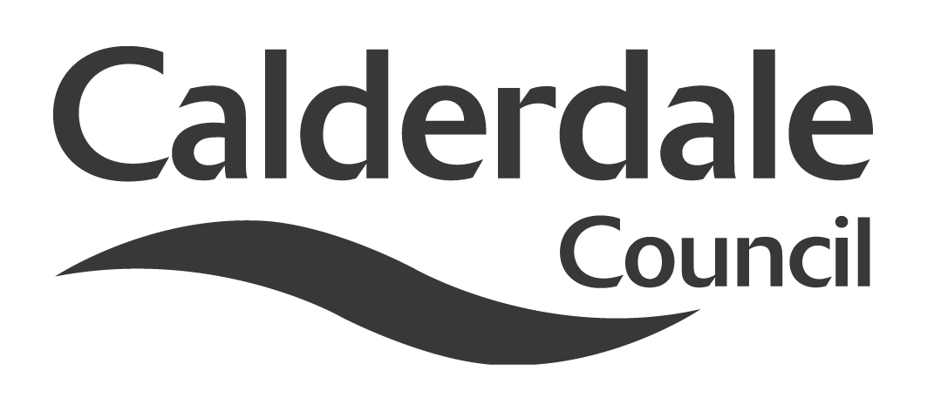
6

Report to Scrutiny Panel
Name of Scrutiny Panel | Economy and Environment
Meeting Date | Wednesday 28 September 2011
Subject | Fuel Poverty
Wards Affected | All
Report of | Director, Economy and Environment
Type of Item  (please tick✓ ) | Review existing policy
Type of Item  (please tick✓ ) | Development of new policy
Type of Item  (please tick✓ ) | Performance management (inc. financial)
Type of Item  (please tick✓ ) | Briefing (inc. potential areas for scrutiny) | ✓
Type of Item  (please tick✓ ) | Statutory consultation
Type of Item  (please tick✓ ) | Council request
Type of Item  (please tick✓ ) | Cabinet request
Type of Item  (please tick✓ ) | Member request for scrutiny (CCFA)

Why is it coming here?
A report has been requested by members about Fuel Poverty in Calderdale.

What are the key points?
- An update about recent and future work to reduce fuel poverty and carbon in Calderdale.
- A summary of the work to carry out the actions of the Calderdale Affordable Warmth Strategy.
- This report sets out the current definition of fuel poverty, and how it affects Calderdale residents. Fuel poverty has a direct correlation to ill-health, poor educational achievement and high mortality rates.
- Calderdale has a large proportion of old stone houses which remain largely un-insulated. They are inefficient in terms of energy use, carbon emissions and are expensive to heat.
- Increasing energy efficiency and promoting behavioural change are locally the most effective ways of preventing fuel poverty. Local generation of energy could assist in tackling fuel poverty.
- Reducing the amount spent on energy equates to more available income to be spent on local shops and services.

Possible courses of action
It is suggested that members:
- Note progress, and make observations on the report, and recommendations for future priorities

Contact Officers
Helen Rhodes, Private Sector Housing Manager, tel 01422 392485.
Richard Armitage, Housing Projects Manager, tel 01422 392474.

Should this report be exempt?
No
Report to Scrutiny Panel

- Background – The Issue of Fuel Poverty
  - Our home is the place that most of us spend the largest part of our lives, sleeping, cooking, eating, bathing, playing, studying and even working. The effects of living in poor housing are directly linked to ill health, poor educational achievement, impeded work opportunities and, high mortality rates. Where poor housing conditions and poverty combine the effects are magnified, and it is here that fuel poverty is found.
  - Fuel poverty occurs when a household would have to spend more than 10% of its income on all fuel use and to heat it to an acceptable level (21⁰C for the main living area and 18⁰C for all other occupied rooms). A household that would have to spend more than 20% of its income on fuel is said to be in severe fuel poverty.
  - The government has commissioned an independent review of fuel poverty, being led by Professor John Hills. An interim report is expected in November 2011, with the final report to be published in early 2012.
  - The 2008 Calderdale Private Sector Stock Condition Survey estimated that 24% of Calderdale households are suffering from fuel poverty, with the highest concentrations in Todmorden, Park and Town wards. Smaller pockets are dispersed throughout older parts of the borough. These areas of hidden fuel poverty can be masked by the statistics in more affluent areas. The levels will, unfortunately increase due to the recent rises in energy costs.
  - There are 35,000- 40,000 stone built properties in Calderdale, many with attic bedrooms, classed as hard to treat. The average energy efficiency rating (SAP) of privately owned units is 55, compared to 66 for social housing stock. As energy prices increase more people are expected to fall into the category of fuel poverty.
  - Old stone terraced houses are generally the cheapest homes available for private ownership and private rented. Because of this they are lived in by the households with the smallest incomes. They pay more for their energy bills than people in social housing or newer private housing. Therefore the issue of insulating hard to treat houses is an essential element of eradicating fuel poverty in Calderdale.
  - When heating and ventilation are inadequate, houses can become damp and attract condensation mould. Some of the poorest residents in Calderdale are living in unhealthy conditions like these.
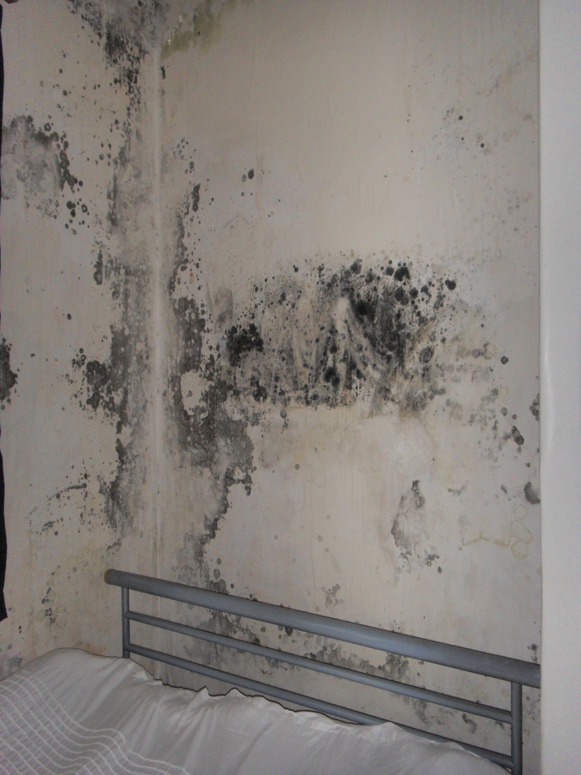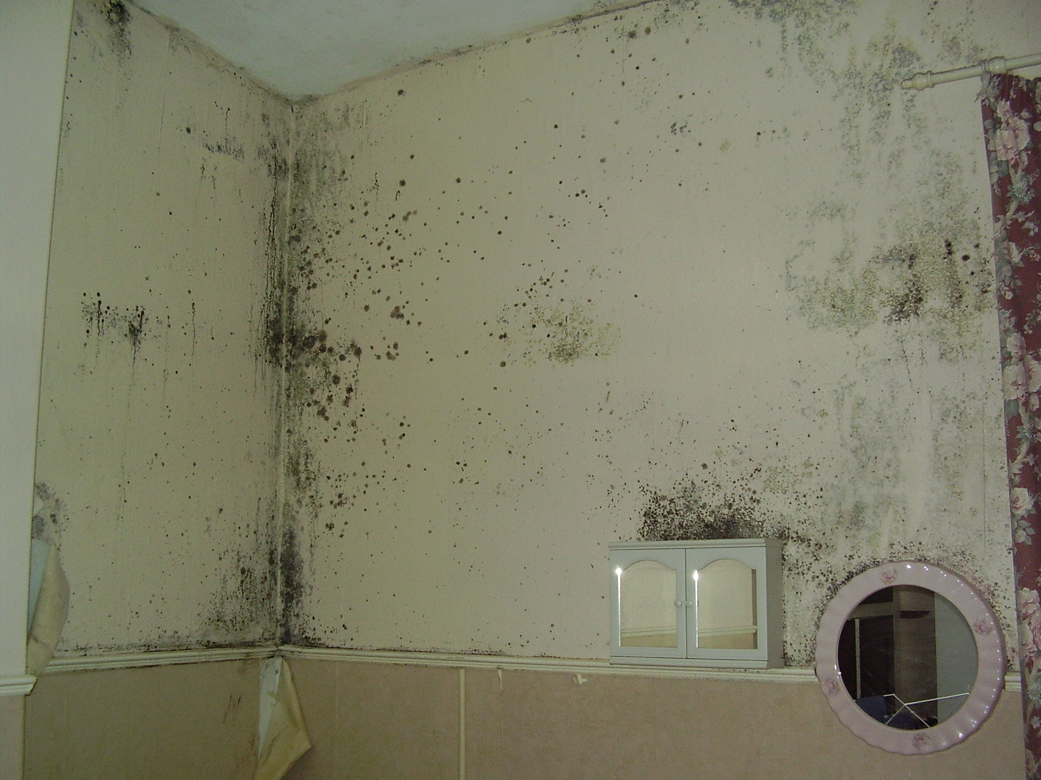
Bedroom in Holywell Green Briggate, Elland
  - Fuel poverty has been consistently rising since 2004 as a result of rising energy costs. Between 2007 and 2010, the total number of households in fuel poverty was estimated to have increased nationally from 3.250m to 4.389m. Source: Centre for Sustainable Energy & Consumer Focus research. The graph below estimates the position in 2010.

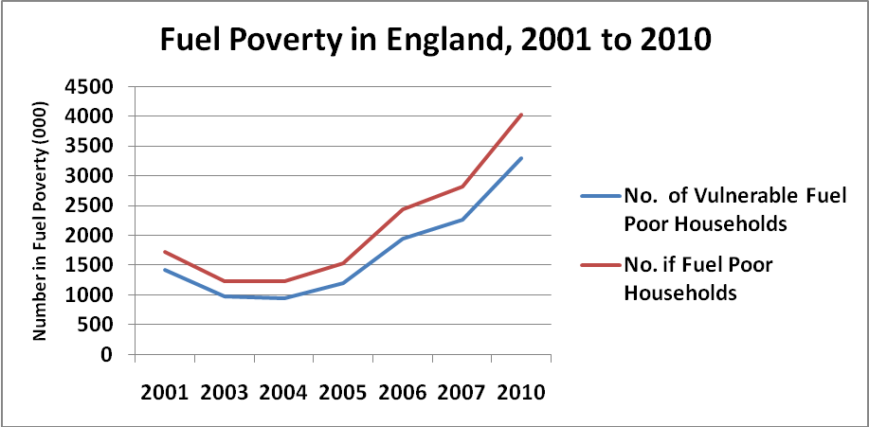

  - The map below shows concentrations of fuel poverty as a percentage of all private properties, with the number of output areas within that percentage range.
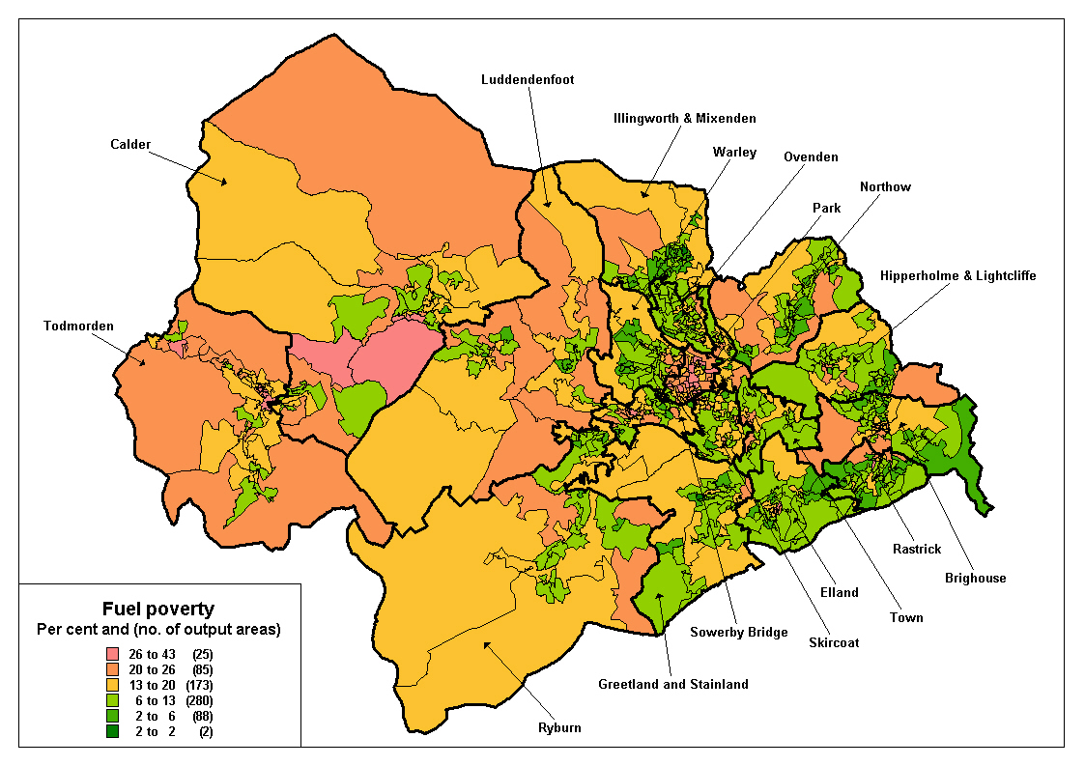
  - Analysis shows that £88 out of every household’s energy bill is levied by the energy companies to subsidise their carbon reduction work and funding regardless of the bill payer’s circumstances (source, National Energy Action).
- Background – The benefits of reducing Fuel Poverty
  - Health and Well Being
    - A safe, warm home prevents ill health and enables independent living. Relatively small investments are needed in order to prevent or postpone higher level interventions by Health and Social Care services.
    - Extended periods of colder weather can thicken the blood and slow respiration, increasing the likelihood of clots, strokes and falls particularly in older people. In the very worst cases, longer term chronic cardiovascular and pulmonary conditions can occur such as bronchitis and pneumonia. Health issues directly affected by a cold living environment are excess winter deaths, respiratory diseases, falls and other accidents, as well as independence.
    - Research carried out by the Chartered Institute of Environmental Health (CIEH) has found that excess winter deaths that occur as result of the seasonal colder weather are3 times higher in the coldest 25% of the housing stock, compared to the warmest 25%.
    - Other Research by the CIEH and the Buildings Research Establishment (BRE) in 2008 found that for every £1 spent improving energy efficiency where residents are likely to require treatment due to excess cold saves the NHS £34.19 over 10 years, per 100,000 homes.
    - A model for estimating the cost of hazards in the home has been developed by the Building Research Establishment and the Chartered Institute of Environmental Health based on data from the English House Condition Survey and the cost of hospital and health treatment. Based on the total private housing stock in Calderdale of 85,000, the model predicts that 250 incidents occur every year because of ‘excess cold’. These range from high risk incidents such as a regular occurrence of severe pneumonia to lower risk ones such as re-occurring chest infections and heavy colds.
    - The model estimates that the cost to the NHS for treating the illnesses / conditions that arise because of the incidents is £4.3M a year. The same model estimates that removing the cost of removing these hazards from the coldest homes, and preventing the ill health, is around £1.2M.
    - Educational achievement is also linked to housing standards; a warm home free from damp is a pre-requisite for the healthy physical and mental development of young children and effective home study.
    - A longer term view on this work at local and national level is essential. Marmot’s report for Friends of the Earth on the impacts of cold homes on fuel poverty sets out a compelling case for this for three reasons:
        - The health burden
        - Inequity
        - Mitigation
    - This work needs to be linked to the changes in public health provision, and future development through the Strategic Needs Assessment document and new Health and Well Being Board.

Case study
Mr A of Halifax was diagnosed with terminal lung cancer in October 2009, with an estimated life expectancy of 6 months. A referral was made to Calderdale Disabled Advice Resource Team (DART) for assistance by a specialist nurse.

DART visited the patient in his home and supported him with financial advice on his sick pay and a range of successful applications for benefits, employment support allowance, higher level DLA, pension credit, full council tax benefit and a disabled parking permit over time. Noticing the coldness and only sources of heating being a gas fire and portable heater, the DART caseworker referred the case to the Council’s Housing Energy Action Team (HEAT) in October 2009.

A new gas heating system and insulation were installed bringing an immediate improvement to Mr A’s quality of life and thermal comfort of the property. In the winter of 2008/9 he had been hospitalised 5 times due to severe chest infections. Following the heating work and despite his low immunity he only had one chest infection during winter 2009/10, saving upwards of £25,000 in healthcare costs and lived on for a further 5 months past his life expectancy.

  - Environment
    - Around 32% of the Borough’s carbon dioxide emissions are generated by residential housing, largely from water and space heating. By encouraging the take up of insulation measures and behavioural change, energy consumption can be significantly reduced, contributing to the overall carbon reduction target.
    - Different measures and their associated estimated carbon savings are set out below. This information was sourced from the Energy Saving Trust and is based on an uninsulated 3 bedroom semi detached property.
Type of Measure | Approximate fuel bill saving (£/year) | Annual Carbon Saving (kg/year) | Lifetime Carbon Saving (kg/30 years)
Cavity Wall Insulation | 110 | 560 | 16,800
Loft insulation (0 – 270mm) | 145 | 730 | 21,900
Loft insulation top up (50-270mm) | 40 | 210 | 6,300
Internal dry lining | 365 | 1800 | 54,000
External cladding | 385 | 1900 | 57,000

    - There is general recognition that effective insulation is a pre-requisite before any microgeneration / renewable heating technologies are considered. Insulation reduces the energy load of the house and means that smaller, lower cost systems could be suitable.
  - Economy
    - Developing the local supply chains in the energy efficiency sector and building capacity for the Green Deal provide good opportunities for the local economy. Building on existing relationships with good local contractors can help them to maintain and expand the number of jobs available to Calderdale residents.
    - By reducing expenditure on energy we can maximise other disposable household income making it available to be spent in the local area (shops, restaurants etc). Investment in local energy generation could create new jobs and safeguard existing jobs in the construction and microgeneration industries.

- Background - Effective methods for tackling fuel poverty
In order to bring people out of fuel poverty, it is important to understand its causes. The Affordable Warmth Strategy sets out an action plan to influence the factors which cause fuel poverty.
In general terms are:
- The price of heating fuel
- Household income and expenditure
- The energy use in the house, behaviour and energy efficiency
  - The price of fuel has been rising and is likely to continue to do so in the foreseeable future. DECC suggests £300 will be added to every household’s annual fuel bill by 2020 to fund the work needed to improve the country’s energy infrastructure and other carbon saving work. Other predictions forecast that average household energy bills could increase from the current £1300 (dual fuel for a 3 bed semi) could increase to as much as £2500 (source, Ofgem) or even as high as £4000 (source, uSwitch.com).
  - There are ways of mitigating against energy price increases:
    - Local generation of energy through community and microgeneration schemes
    - Energy price comparison and choice of the most efficient tariff
  - Household income can be influenced by good quality benefits advice, budgeting skills, good employment levels. Domestic energy use can be influenced by promoting insulation and efficient heating as well as promoting behavioural change around energy use.
  - Behaviour change is a long term ambition; there are some quick wins to be gained from the distribution of real time electricity monitors followed up with advice about how to affect the rate of energy consumption. Education about the effect of choosing more efficient appliances and the use of stand-by also reduce consumption.
  - It is likely that the majority of the borough’s housing will remain for the next 50-100 years and beyond. Once insulation has been installed, it requires virtually no maintenance and has an estimated lifespan of 40 years. The most effective gains are from loft and cavity wall insulation. Other gains are to be made from draught-proofing, double glazing, underfloor insulation etc.
  - Different properties need different solutions, depending on their construction type and specific requirements. Based on a 3 bedroom semi-detached property, the following chart shows the effectiveness of different insulation measures in terms of savings in fuel costs and reduced carbon emissions.
  - Members will note the much better carbon and fuel bill savings through dry lining or external cladding systems. However, these measures cost significantly more than standard fibre measures. Even though they generate savings of up to £400 per year, it could take over 25 years to recover the cost of the initial investment, based on today’s energy prices.
  - Pound for pound, cavity products and loft insulation continue to prove better value than solid wall insulation solutions. Their lower production and installation costs mean that the costs of the investment can be recovered within a 12 – 18 month period through energy bill savings.
- Calderdale Affordable Warmth Partnership
  - The work to implement the Calderdale Affordable Warmth Strategy is coordinated by the Calderdale Affordable Warmth Partnership. It includes representatives from the following organisations:
Age Concern
Alternative Technology Centre, Hebden Bridge
Calderdale Council
Citizens’ Advice Bureau
Energy Saving Trust Advice Centre
Energy Help
NHS South & West Yorkshire NHS Trust - Chair since July 2005
Pennine Housing 2000
Pension Service
Smartmove
Warm Front
West Yorkshire Fire and Rescue Service
  - A report against the strategy’s action plan has been discussed at Adult Health and Social Care Scrutiny Panel (with invitations to all other Sctrutiny Chairs) each 6 months since 2008.
  - A copy of the reviewed action plan is attached in Appendix 1 for information.
  - Work is underway to review the strategy and set out an action plan for the next 18 months. This will fit well with the ending of the Carbon Emissions Reduction Target (CERT) and Community Energy Savings Programme (CESP) funding streams at the end of 2012.
  - A new action plan will then be required once more detail on the Green Deal and new Energy Company Obligation is known in 2012.

- Reducing and Eradicating Fuel Poverty
  - Eradication of fuel poverty is an aspirational goal, simply because the price of energy and household incomes are largely beyond the authority’s control.
  - Good work has been carried out over previous years to understand the housing stock and to make improvements to energy efficiency by providing free and discounted loft and cavity wall fibre insulation, as well as promoting national schemes such as WarmFront.
  - Over the last 10 years more than 7500 households have benefited directly from energy efficiency measures provided by the Council. These include; 3044 had loft insulation only, 1025 had cavity wall insulation only, 1580 properties had both loft and cavity wall insulation installed at the same time. Building Control records show that at least 8693 properties had cavity wall insulation installed since the work became notifiable. This will not include work that has not been reported by some installers to Building Control.
  - The Energy Saving Trust estimates that there are 4000 lofts still uninsulated in the Borough and a further 2000 cavity walls suitable for fibre fill.
  - In Calderdale there are approximately 35,000 to 40,000 privately owned stone houses which do not have a cavity wall suitable for blown fibre fill and many have an attic room. The recent Calderdale Hard to Treat pilot project found that insulation solutions are available but they are more expensive, sometimes disruptive and do not attract the subsidies from current schemes.
  - Some of the key findings of the ‘Hard to Treat’ project are set out below:
  - Low income households have higher levels of disrepair. Remedial work was required for 16 of the 43 properties on the pilot before insulation could be installed.
  - Around 20% of the older stone houses surveyed had cavities suitable for fill with either expanded polystyrene beads (EPS) or polyurethane foam (PUR).
  - National policy makers (DECC and Ofgem) along with the energy companies currently assume that properties built before 1920 are constructed with solid walls.
  - Attic bedroom insulation is effective and popular, 21 properties out of the 43 assisted took up attic room dry lining on the pilot project.
  - Better information and awareness raising is needed to make people aware of the alternative products suitable for random stone cavities, and reverse the general misconception that nothing can be done for stone homes.
  - The greater level of disruption with the work, the lower the rate of take up. All forms of cavity insulation are easier and cheaper to install compared to solid wall insulation. Internal dry lining had little demand because of the disruption to radiators / plumbing, skirting board and decorations. Higher costs and loss of floor space are other barriers.
  - External cladding systems are an alternative for solid wall properties. However, there is significant alteration to the external appearance of the building and it is expensive.

- Work planned to reduce fuel poverty

  - Safe & Warm Homes Project 2011-2014

    - Work is about to start on a project that will offer a package of energy efficiency and home safety measures to private owners and tenants in Calderdale, funded with £500,000 from the Performance Reward Grant. The project will make homes warmer and safer, reducing the risks of accidents and harms associated with cold properties and trips and falls in the home.

    - The target is to assist 2,500 vulnerable privately owned households during this period with one or more of the following measures:
  - Loft and cavity wall fibre insulation
  - Insulation for stone properties and those with attic rooms
  - Efficient heating systems
  - Free energy saving gadgets
  - Stair rails & key safes

    - Wider work is being done to increase awareness of how householders can help themselves by publishing practical information on the Council’ webpage on insulating stone houses, simple insulation methods, energy efficiency advice, changing suppliers, tariffs and payment options. An article in the last Calderdale Call on insulating stone houses generated a good response.

    - Staff have received training to become energy advisors and are now able to produce Energy Performance Certificates for individual householders or private landlords.

    - Additional funding will be brought into the project from energy companies to provide free and discounted loft and cavity wall insulation through the energy companies’ Community Energy Savings Programme (CESP) and the Carbon Emission Reduction Target funds (CERT) initially. Following the end of these programmes there are other funding opportunities through the Green Deal, Feed in Tariffs, Energy Company obligation, renewable heat incentive.

  - Leeds City Region Domestic Energy Efficiency Programme (LCR DEEP)

    - LCR DEEP offers an innovative approach to energy efficiency that will:
- Deliver quality ‘whole house’ surveys and impartial advice to householders on how their energy efficiency ratings could be improved.
- Make subsidies more accessible, allowing customers to make informed choices.
- Support small and large businesses in the local low carbon economy, encouraging, innovation and competition within the domestic energy sector.
- Be flexible to respond to changing subsidies in future years.

    - £145,000 funding was approved by DECC in late November 2011 for a pilot programme to look at the practicalities of the scheme. £110,000 was targeted at The Upper Valley of Calderdale, the project completed in March 2011.

    - The immediate priority will be to maximise the potential to attract CERT and CESP money into Calderdale with further work proposed for hard to treat housing in the more deprived areas. Some pump-prime money needed to achieve this has been allocated from the Safe & Warm Homes project.

    - Although the bid for Regional Growth Fund (RGF) round 1 was unsuccessful, the bid recently submitted for RGF round 2 is being strongly supported by DECC. Timescales for the decision are unclear. It will hopefully be made by the early part of 2012.

  - The Green Deal

    - The Green Deal is a national initiative to allow people to have energy efficiency measures worth up to £6500 carried out to their homes at no up front cost. This can be supplemented with up to a further £3500 for vulnerable households through the proposed Energy Company Obligation. Both are expected to start at the end of 2012.

    - The Green Deal works on the premise that the saving in a household’s energy bills will be sufficient to repay the cost of the measures, plus interest, over a period of up to 25 years. The Golden Rule of the Green Deal is based around the financial savings that will be generated from the saving in energy bills to fund the work and leave the household financially better off.

    - In its present format, it is unlikely that it will benefit fuel poor households who are unlikely to be heating their homes to the recommended levels. Although any measures will help improve the thermal comfort of their homes, the work may not generate the reduction in bills to cover the cost of the measures.

    - DECC will be consulting on the Green Deal this autumn. The authority’s Housing Energy Action Team will be coordinating Calderdale’s response.

    - Work is also being done to develop a submission for a Green Deal pilot in partnership with National Energy Action (NEA). This will be an opportunity to expand on the experience gained from the ‘Hard or treat’ pilot and the LCR DEEP pilot, and influence how the Green Deal could be shaped to benefit the fuel poor households. More importantly this will help develop a future case for Calderdale to become a Green Deal provider or assessor. This would present a good opportunity for income generation and local residents and landlords would welcome our impartiality within the market place.

- Conclusions

  - The domestic energy sector is entering a period of significant change. Under investment in infrastructure means that £200 billion now has to be raised to replace the production capacity left from the closure of one third of the UK’s power stations that will be closed during the next 10 years.

  - The era of cheap energy is over. Costs will go up and are likely to form increasingly larger proportions of household expenditure in years to come.

  - Much work has been done to assist households with the easy low cost energy measures of loft and cavity wall fibre. The next challenge is to start improving older stone properties and supporting their owners with guidance, support and low cost financial assistance to fund the cost of the measures.

  - Policy makers at DECC and Ofgem also need to listen to the experience being developed within local authorities, which have intimate local knowledge of the housing stock and the communities.

  - An independent, impartial market position puts Local Authorities in a strong position to take forward future affordable warmth work including DEEP and the Green Deal.

- Recommendations

  - Members are asked to note progress, make observations on the report, and consider the resources that are needed to deliver this work and its key outcomes effectively.

- References

British Medical Journal (BMJ) Editorial 2011;342:d2807
Calderdale Affordable Warmth Strategy 2008-11
Calderdale Hard to Treat Homes pilot project report
LCR DEEP Business Plan
‘Fair Society, Healthy Lives’ Marmot Review Feb 2010.
Appendix 1 – Action Plan, Calderdale Affordable Warmth Strategy
Key Aim 1 |  | Make all housing in Calderdale warmer and more energy efficient
Aims |  | Objectives |  | Tasks |  | Partners/Lead Agency | Target Timescales | Progress & Actions for 2010-11
1.1 | Improve the information database on SAP ratings for housing across all tenures. | 1a | Ensure SAP information is robust to ensure effective targeting of the Strategy. | 1a.1 | Evaluate current system for ascertaining SAP data.  Private sector House Condition Survey 2008 to contain SAP ratings.  PH2k to establish working group to address requirements for provision of Energy Performance Certificates and Home Information Packs | PH2K  CMBC  KES | May 2008  October 2008 | Stock condition survey on privately owned stock is now complete.
 |  |  |  | 1a.2 | Continue to collect and monitor SAP information to monitor progress towards targets. | CMBC  KES/EEAC |  | The average SAP energy efficiency rating for private housing was found to be 55. This compares with a national average SAP of 46 for private stock.  The average SAP for Pennine Housing Stock ( c12k properties) is 66.2.
1.2 | Acquire more resources to improve hard to heat/treat homes. | 2a | Estimate the level of funding required to improve all hard to heat/treat homes. | 2a.1 | Promote WY energy efficiency schemes (Affordable Warmth & Hard to treat homes) and continue to promote and deliver. | CMBC +  Scheme Manager | May 2008 | Estimated cost is £160M to treat all hard to treat homes in Calderdale.  Pilot project on hard to treat homes is now in final stages. Final report, cost benefit analysis to be available by the end of March 2011.
 |  |  |  | 2a.2 | Prioritise investment based on properties not meeting Decent Homes Std | PH2K  CMBC | 2008-2011 | Ongoing.
1.2 | Acquire more resources to improve hard to heat/treat homes. | 2b | Obtain the required funding. | 2b.1 | Work through the W Yorks. Housing Partnership to explore options for future funding with the Regional Housing Board and Govt. Office for Yorkshire and Humberside. | KES  CMBC | February 2008 | Identify alternative funding sources to attract additional money to the £170k already in place for 2010-11. Promote WarmFront to attract further central govt money into the borough.  Lobby NHS Calderdale on the benefits affordable warmth can bring to reducing health inequalities and assist in meeting other NHS targets around GP visits and bed blocking.  Identify and target households that could have work done with a 100% CERT grant at no additional cost to the council.
1.2 | Acquire more resources to improve hard to heat/treat homes. |  |  | 2b.2 | Seek funding from other sources such as Utilities EEC funds and European funds to carry out improvements. | CAWP  HEAT | June 2008 | CERT money being attracted as match at current ratio of £1:£1.72. Total estimated CERT for 2010-11 expected to be in the region of £224k, making the total value of the insulation scheme approximately £353,600, all of which is externally funded.
1.2 | Acquire more resources to improve hard to heat/treat homes. |  |  | 2b.3 | Manage tender process to re-select a scheme manager for WY Energy Efficiency Schemes for delivery 2008-11 | CMBC |  | Schemes are being delivered and managed successfully by the Housing Energy Action Team in Calderdale.
1.3 | Improve energy efficiency in the Pennine 2K and other RSL sector so that it provides affordable warmth. | 3a | Set a target for improvements to the average SAP rating for this sector. | 3a.1 | Establish energy efficiency baselines and present average SAP figures in private and RSL sector. Advise partners of the aim to achieve the government’s average SAP target of 74 by 2015. | CAWP | Sept 2008 | Average Sap of 55 for private sector housing in Calderdale. This will be reported to CAWP.
 |  |  |  | 3a.2 | Promote and mainstream best practice. Develop joint RSL Affordable Warmth Strategy | PH2k Energy-Help | October 2008 | Pennine Housing is supporting the National Housing Federation’s work to campaign and eradicate fuel poverty in the social property sector.  Best practice and experience is shared openly with other registered social landlords (RSLs). Work is currently in progress with In Communities and other RSLs on the Social Housing Energy Saving Programme (SHESP).
 |  |  |  | 3a.3 | Give energy efficiency a priority in the Investment Plan ensuring all RSLs are accessing EEC (now CERT) funding. | PH2K |  | PH2k has secured a £1m contract with Npower to fund insulation work for its stock.  PH2k is currently trialing an air exhaust system. Nearly all properties have had window and door replacements and heating upgrades through PH2k’s investment programme.  Remaining work is focused on addressing issues associated with hard to treat units and fuel switching for properties without a gas supply.  Opportunities for how social housing landlords can generate income through the FIT / proposed RHI as well as helping their tenants reduce their fuel bills are being looked at.
 |  |  |  | 3a.4 | Establish a working group for RSLs to share experiences utilising the Calderdale Housing Association Liaison Meeting (CHALM) network | CMBC  PH2K  Energy Help | Aug 08 | RSLs will be engaged through the Leeds City Region Domestic Energy Efficiency Programme (DEEP). PH2k is a project partner on the DEEP pilot programme that will take place later this year.
1.4 | Improve energy efficiency in the private rented sector so that it provides affordable warmth | 4a | Find average SAP and set a target for improvements to the average SAP rating for this sector | 4a.1 | Find resources to provide incentives to make the landlord and tenant motivated to improve energy efficiency. | CMBC/WF | July 2008 | A property registration scheme called Fair & Safe Tenancies (FAST) has been launched to improve standards in the private rented sector. Properties are awarded up to 5 stars by meeting certain criteria. A star for energy efficiency is awarded if the property has any 3 or more of the following features:  - Central heating  - A condensing boiler  - Loft and or cavity wall insulation  - Double glazing  - An A, B, or C Energy Performance certificate rating  - Low energy light bulbs throughout  - A real time energy monitor  Work is ongoing to identify landlords with large stock holdings, sign them up for the FAST scheme and then offer to survey their homes for the free insulation measures.  Continue to work with partner agencies such as the Benefits Service, Smartmove and private landlords to promote the above scheme and assistance available from WarmFront and the Council’s insulation scheme.
 |  |  |  | 4a.2 | Include standards of energy efficiency when assessing fair rent. | CMBC/PLA | June 2008
 |  |  |  | 4a.3 | Liaise with Private Landlord Association (PLA) to share energy efficiency experiences. | PLA
1.4 |  | 4b | Link energy efficiency to accreditation of landlords. | 4b.1 | Link energy efficiency to an accreditation scheme for housing and HMOs. | CMBC | September 2008
 |  |  |  | 4b.2 | Ensure HMOs meet statutory heating standards. | CMBC | September 2008
 |  |  |  | 4b.3 | Target non-accredited landlords. | CMBC
1.5 | Improve energy efficiency in the owner- occupier sector so that it provides affordable warmth | 5a | Set a target for improvements to the average SAP rating for this sector
 |  |  |  | 5a.1 | Promote existing schemes to subsidise the cost of energy efficiency works (Link to Aim 1) | CMBC | October 2008 | Targets set in the strategy of increasing average SAP to 66 by 2010 and 74 by 2015 in line with central government targets.
1.5 |  | 5b | Assist the provision of affordable warmth to this sector
 |  |  |  | 5b.1 | Create an emergency fund to assist those in acute need | CMBC | October 2008 | Temporary emergency heaters are provided where necessary by the Council’s Handyperson service.  Approved heating contractors are also in place to carry out urgent heating repairs for vulnerable people with severe medium to long term medical conditions. Low cost funding assistance is being made available in the form of interest free repayment loans.
 |  |  |  | 5b.2 | Implement new Housing Renewal (Assistance) Policy | CMBC |  | Existing private sector housing policy to be reviewed and updated.
1.5 |  | 5c | Provide a tendered, subsidised scheme for servicing boilers and other heating appliances. | 5c.1 | Attract a lead organisation to take on the project. | CMBC |  | Section 5b.1 above refers.
 |  |  |  | 5c.2 | Promote WYSE - a network of reliable and accredited companies to provide a servicing scheme, that is affordable to all householders | CMBC  KES  EH  ATC |  | Complete – service provided through Yorkshire Energy Services (previously called Kirklees Energy Services - KES).
1.5 |  | 5d | Encourage the adoption of sustainable solutions to fuel poverty using renewable energy technology where appropriate. | 5d.1 | Promote the use of renewable technologies to households living in properties that are not on the gas mains. | KES  EHATC |  | The Energy Saving Trust Advice Centre for West and South Yorkshire has established a microgeneration partnership to take this forward.  HEAT is also investigating opportunities through the FIT to generate revenues which could be re-invested in hard to treat stock.
 |  |  |  | 5d.2 | Develop information and training/awareness materials on the use of renewable energy particularly through social enterprise and community initiatives. | KES  ATC |  | Ongoing programme of events in place with ATC, the ESTAC and the microgeneration partnership to promote renewable technologies.  Energy Saving Trust fact sheets are available from the Advice Centre and the Housing Energy Action Team.
 |  |  |  | 5d.3 | Assistance with wider sustainability initiatives. | KES  EH  ATC |  | Ongoing. HEAT and ATC partners on the new Climate Change officer group, and Environment Delivery Partnership.

