PRESENT: Councillor T Swift (Leader, in the Chair)
Councillors B Collins, Metcalfe, Press, Scullion, Shoukat, Sutherland, M K Swift

- APOLOGIES FOR ABSENCE
There were no apologies for absence.

(The meeting closed at 20.50 hours).

- ADMISSION OF THE PUBLIC
RESOLVED that under Section 100A(4) of the Local Government Act 1972 the public be excluded from the meeting for the following items of business on the grounds that they involve the likely disclosure of exempt information as defined in the stated paragraphs of Part 1 of Schedule 12A of the Act, namely:

Museum Service Operational Review – Paragraph 4 – Labour Relations, Consultations and Negotiations.

Transfer of Special Educational Needs and Disability Information Advice and Support Service - Paragraph 3 – Financial or Business Affairs.

- MINUTES OF THE MEETING OF CABINET HELD ON 15TH JANUARY 2018
RESOLVED that the Minutes of the meeting of Cabinet held on 15th January 2018 be noted as a correct record and signed by the Chair.

- QUESTION TIME
The Leader, Councillor T Swift, invited members of the public and Councillors to ask questions of the Leader and of the other Cabinet Members. An oral response would, if possible, be provided at the meeting, but if this was not possible a written response would be provided to the questioner within 7 working days. The full details of questions asked and answers provided would also be published on the Council’s website.

- A question was asked by Mr G Fielden.

Councillor Sutherland, Cabinet Member for Planning, Housing and Environment responded and advised that a written response would be provided to the question.

- A question was asked by Mr A Rae.

Councillor Sutherland, Cabinet Member for Planning, Housing and Environment responded and advised that a written response would be provided to the question.

- A question was asked by Mr I Wood.

Councillor Press, Cabinet Member for Communities and Neighbourhood Services responded and advised that a written response would be provided to the question.

- A question was asked by Ms J Shepherd.

The Leader, Councillor T Swift responded and advised that a written response would be provided to the question.

- A question was asked by Mr K Lawton.

Councillor Sutherland, Cabinet Member for Planning, Housing and Environment responded and advised that a written response would be provided to the question.

- A question was asked by Mr E Greenwood.

Councillor B Collins, Deputy Leader and Cabinet Member for Regeneration and Economic Strategy responded and advised that a written response would be provided to the question.

- A Question was asked by Ms A Tattersall.

Councillor Sutherland, Cabinet Member for Planning, Housing and Environment responded and advised that a written response would be provided to the question.

- GENERAL FUND REVENUE BUDGET 2018/19 TO 2020/21
- GENERAL FUND REVENUE BUDGET FORECAST 2018/19 TO 2020/21 - UPDATE
Councillor Scullion, Cabinet Member for Resources, Performance and Business Change presented a written report of the Head of Finance providing an update on the Revenue Budget Forecast 2018/19 to 2020/21 after taking account of changes identified since the initial publication of the consultation budget. The budget was in line with the principles of the Council’s agreed Medium Term Financial Strategy and ensured that balances were used in a sustainable way. It also ensured that the Council moved towards more strategic budget planning allowing reallocation of resources and development of efficiency and other savings over a longer term planning timescale.

The report outlined the final Local Government Settlement 2018/19 and 100% Business Rates Pilot and made particular comment with regard to levies and other bodies, revenue monitoring and other changes

RESOLVED that the changes identified in the report and the changes in conjunction with their final recommendations to Budget Council be noted.

- CONSULTATION RESPONSES
- RESPONSES FROM SCRUTINY BOARDS
Councillor Scullion, Cabinet Member for Resources, Performance and Business Change presented a written report of the Head of Legal and Democratic Services setting out the responses and comments of the Scrutiny Boards in response to consultation on the Cabinet’s draft Revenue Budget proposals. The comments and issues discussed at the Scrutiny Board meetings were set out in the report for Members’ consideration.

RESOLVED that the comments of the Scrutiny Boards be noted for consideration as part of the budget process.

- GENERAL RESPONSES
Councillor Scullion, Cabinet Member for Resources, Performance and Business Change presented a written report of the Acting Director, Public Services providing a summary of the general responses received to the consultation on the Cabinet’s draft Revenue Budget proposals, including the outcome of the non-Domestic Rate Payers, staff and other targeted groups consultations, outlining and circulating the responses which had been received after the Cabinet Agenda had been published.

RESOLVED that

(a) the general responses received and the outcome of the consultation summarised in the report circulated at the meeting be noted for consideration as part of the budget process; and

(b) the initial Equality Impact Assessments be given due regard in budget decision making and these move to full Equality Impact Assessments during the forthcoming year, as appropriate, involving appropriate stakeholders such as the Equality Forum.

- CABINET BUDGET PROPOSALS FOR RECOMMENDATION TO COUNCIL ON 26th FEBRUARY 2018
The Leader, Councillor T Swift, presented the Cabinet Budget proposals for the 2018/19 to 2020/21 General Fund Revenue Budget. In doing so, Councillor T Swift advised that responses from the consultation had highlighted that there was support for the Council to continue to sustain key front line services. In response to specific issues raised in the consultation, Councillor T Swift advised that Cabinet’s proposed budget to Council had withdrawn the proposed cost saving of £178,000 and/or funding the Staying Well Scheme from within Public Health, deleted review of alternative service delivery and digital channels for visitor centres and reduced the saving for the transfer of Public Halls to Community Management. The proposed budget also added a contribution to Winter Maintenance.

Councillor Baker attended the meeting and addressed Cabinet requesting that it not implement cuts on enforcement teams as this could diminish the Councils capacity to deal with issues that exist. The Leader, Councillor T Swift responded and outlined the reasons for this proposal.

*RESOLVED that having considered the update on the revenue budget forecast and the responses to consultations on the proposals adopted by Cabinet on 15th January 2018 for consultation purposes, the Council on 26th February 2018 be recommended to approve a Total Net Revenue Budget Requirement of £156,164,671 (after the use of £1,092,390 of balances) for the financial year 2018/19 based on the budget proposals now submitted and set out in the following pages:

Budget Summary and Council Tax Requirement 2018/19

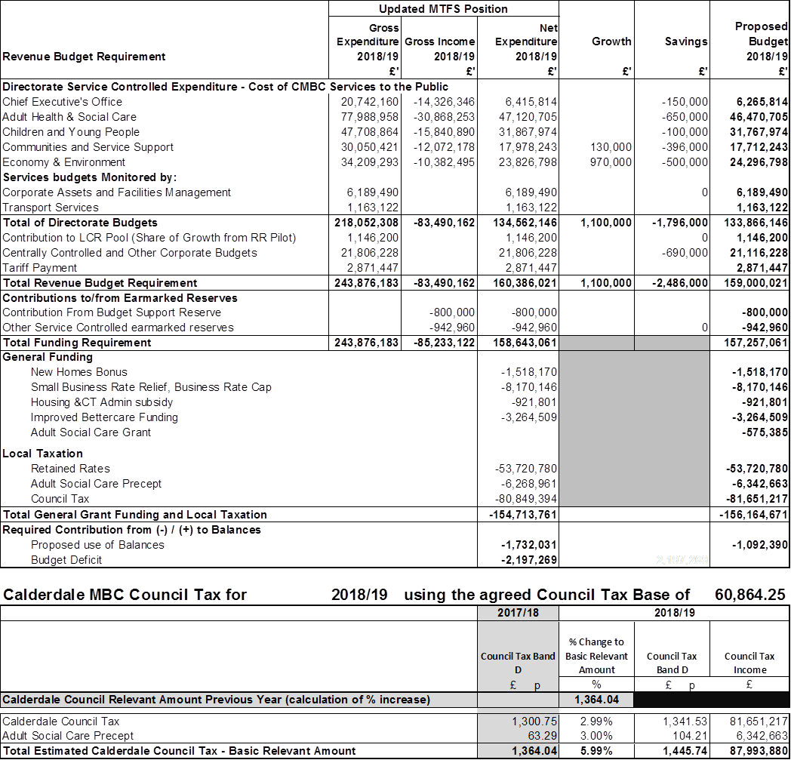

Budget Summary and Council Tax Requirement 2019/20

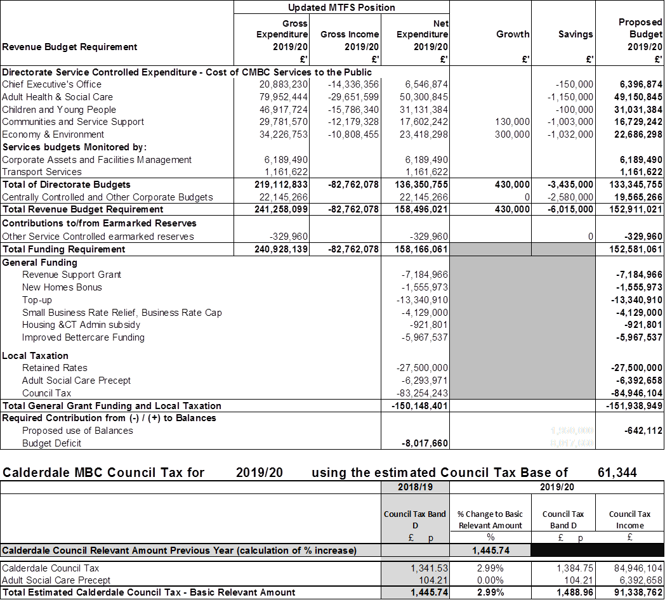

Budget Summary and Indicative Council Tax Requirement 2020/21

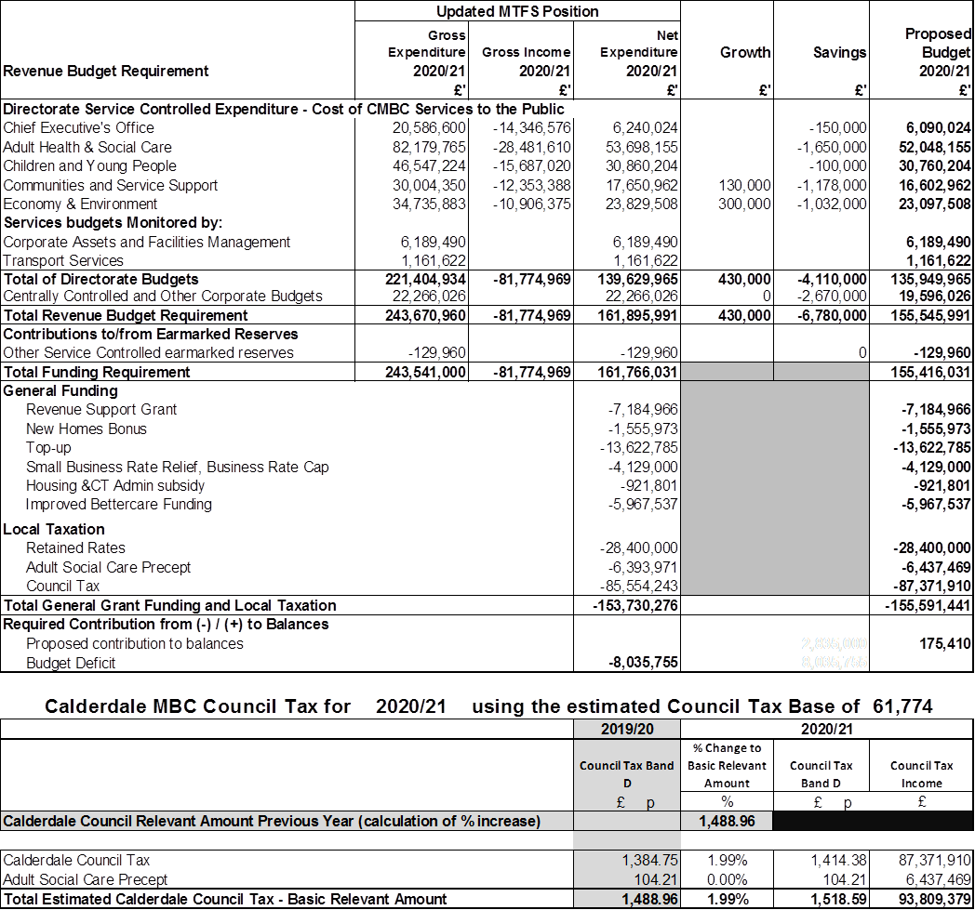

Cabinet Growth and Savings Proposals

Growth Proposals

Savings Proposals

Estimated Available Revenue Balances from 31st March 2018 to 31st March 2021

Head of Finance’s Statement
The Local Government Act 2003 requires that in making decisions in relation to setting its Council Tax that the Authority’s Chief Finance Officer must report on:

- the robustness of the estimates made for the purpose of the calculations, and
- the adequacy of proposed financial reserves.

These, in conjunction with the balanced budget requirement of The Local Government Finance Act (1992), mean that Members are required to have regard to the Head of Finance’s report when making their budget setting decisions.

The budget builds upon the existing savings targets and plans which are in place following previous decisions made at Budget Council and which are summarised in the table below:-

The budget provides clear proposals to deliver the level of savings required to meet the Medium Term Financial Strategy and is in line with the Council’s Efficiency Plan which has been approved by MHCLG. The details behind each savings proposal are set out in the supporting papers. These concentrate on the additional savings which are required over the next three years over and above existing plans. The delivery of existing savings plans also presents risks and a reminder of the level of savings already agreed by each directorate was provided in Cabinet’s original consultation budget document.

In addition, a detailed review of underlying budgets was undertaken in updating the standstill budget position. This included a complete review of identifiable pay and prices changes. All centrally controlled budgets have been updated and a detailed assessment made of debt and borrowing costs over the plan period. The updated standstill position provides, within centrally controlled budgets, an assumed provision for demographic growth and social care demand and cost pressures.

The draft budget maintains unallocated balances (financial reserves) above £5m over the three year plan. The minimum level is in line with my overall assessment of major financial risks, as set out in the Council’s Medium Term Financial Plan. It also reflects the recommendation of the Council’s appointed external auditors. This level of balances relates to non-school spending, as schools retain balances of their own.

There is an opportunity to use any excess balances over and above the minimum level in support of short-term non-recurring budget initiatives. The budget proposals include the use of balances over the period 2018/19 to 2020/21 to support the revenue budget. The proposals also provide some one-off investment in priority areas.

In addition to the unallocated balances referred to above, the Council holds earmarked reserves to cover potential future costs to the Council of issues such as workforce planning and insurance. The earmarked reserves are mainly for specific purposes and do not carry a recommended level or limit. As such it is of vital importance that these reserves are reviewed periodically in order to ascertain their continued validity and level. Regular consideration should be given to whether they could be put to better use elsewhere in subsequent years.

The earmarked reserves are formally reviewed three times a year. Firstly, this is done as part of the development of the Medium Term Financial Strategy, secondly as part of the formal budget setting process and finally as part of the closedown procedures at the end of the financial year. Monitoring and further reviews are also undertaken throughout the year as part of the quarterly Revenue Monitoring processes.

The adequacy of all major reserves and balances has been examined to ensure that they are sufficient to support the key financial assumptions held within the Medium Term Financial Strategy which also underpins the Cabinet Revenue Budget Proposals being recommended to Budget Council for the three year period 2018/19 to 2020/21. The latest review, as part of the budget monitoring process, identified reserves of around £4m which could be used in the current year to address specific budget pressures in 2017/18.

Given the uncertainties of the economic environment and the scale of the expenditure reductions required, there will inevitably be significant risks involved in delivering a balanced budget. The Head of Finance has therefore taken a risk management approach to the budget process and has set out below the key risks associated with the proposed budget and how they can be managed.

Each agreed saving identifies the risk associated with each proposal. These have been considered by the Head of Finance who is confident that Directors are aware of the risks involved and their potential impact.

Although the Council continues to manage its finances in a prudent manner some assumptions and forecasts have necessarily had to be made where information is not yet available. The key assumptions and risks within the budget are considered to be:-

- Revenue Support Grant will reduce over the period 2018/19 to 2019/20 in line with the figures included within the Local Government Finance Settlement and in line with our approved Efficiency Plan. Beyond 2019/20 there is a much greater level of risk and uncertainty as the Government intends to implement a new local government finance system including 75% business rate retention. For the purposes of the MTFS it has been assumed that in 2020/21 the Council will maintain the same level of Government support as in 2019/20. In practice it is likely that if public sector austerity continues, Government funding will continue to reduce and further savings will be required.
- The Government has announced that the Leeds City Region has been successful in its application to become a 100% business rate retention pilot in 2018/19. Initially an estimated benefit of £1.1m from the additional business rates generated by the region had been assumed in the standstill budget based on latest business rate projections. This has now been updated to an estimated benefit of £1.4m from business rates. This is dependent however on not just this Council’s ability to raise additional business rates but also the other local authorities in the pool.
- Council Tax increases of 3% per annum in 2018/19 and 2019/20 and 2% thereafter in line with the announced referendum limit. If Council Tax is not increased up to the maximum level allowed without a referendum then this will reduce income not only in the year in question but also every year thereafter. This loss of income and financial resilience in the Council’s base budget would be a particular concern by 2020/21 as the lack of Government funding figures, the introduction of 75% Business Rates Retention and the Fair Funding Review will combine to create even greater uncertainty than normal going forwards.
- An additional social care precept of 3% in 2018/19 to part fund the additional cost of protecting adult social care services. To ensure that councils are using income from the precept for adult social care, councils will be required to publish a description of their plans, including changing levels of spend on adult social care and other services. This must be signed off by the Chief Finance Officer (Section 151 Officer). As the maximum allowable social care precept is 6% over the period 2017/18 to 2019/20 no further social care precept has been assumed for 2019/20.
- All agreed savings targets and budget pressures will be contained within the planned budgets after taking into account the additional resources provided for in the MTFS, particularly in relation to the cost of Children’s Social Care.
- One of the savings included in the Cabinet budget proposals for 2019/20 would result from a change in the Council’s policy on Minimum Revenue Provision (MRP). This would need to be determined within the new regulations which are due to be announced this year on the calculation of MRP and to be agreed with the Council’s external auditors. For this reason my advice is that this should not be assumed within the budget earlier than 2019/20.
- Since the final Revenue Monitor in 2017/18, it has become clear that pressure on the Winter Maintenance Budget as a result of the severity of this year’s Winter is likely to result in an overspend in the region of £0.5m. As this has not yet been reflected in our plans to deal with 2017/18’s forecast overspend, Members will need to take account of this in their budget proposals.
The Council has an embedded savings monitoring process already in place to help ensure that savings targets are achieved.

Finally, due to the three year planning process in place, there is sufficient lead-in time for contingency plans to be formulated in future budget rounds should problems become apparent.

- FUTURE OF TODMORDEN COLLEGE BUILDING/SITE
Councillor B Collins, Deputy Leader and Cabinet Member for Regeneration and Economic Strategy presented a written report of the Director, Regeneration and Strategy seeking consideration of the two proposals for the future of Todmorden College building/site. One seeking to acquire the site and incorporate it into plans for a new store on the adjacent site, subject to provision of a new build Children’s Centre and Youth Services Facility attached at appendix 1 and one from Todmorden Learning Centre and Community Hub Limited to retain the existing building, bring it into community ownership and use it for education, business and the community, retaining the Children’s Centre in the heart of Todmorden attached at appendix 2.

The report set out in detail the features, benefits and risks of each proposal. For the reasons set out in paragraph 5.6.7 of the Director, Regeneration and Strategy’s report it was recommended that the Todmorden Learning Centre’s proposal be approved, subject to agreement of detailed lease terms and a Joint Working Agreement.

The report outlined the detailed background information, options considered, financial, legal, environmental, health and economic implications.

A representative of Todmorden Community Group attended the meeting and addressed Cabinet.

Councillor Machell attended the meeting as Ward Councillor and addressed Cabinet thanking Officers and colleagues for all their hard work on this site and sought further assistance from Officers to help the Todmorden Learning Centre and Community Hub Limited going forward.

RESOLVED that

(a) the transfer of Todmorden College to Todmorden Learning Centre and Community Hub Limited on a leasehold basis, subject to agreement of detailed lease terms and a Joint Working Agreement be approved;

(b) the Director, Regeneration and Strategy in consultation with the Head of Legal and Democratic Services be given delegated authority to complete a 125 year lease to Todmorden Learning Centre and Community Hub Limited, subject to agreement of items in the Joint Working Agreement; and

(c) advice, support and guidance be provided to Todmorden Learning Centre and Community Hub Limited to help to mitigate the risks identified during the evaluation process.

- CALDERDALE LOCAL PLAN – HOUSING REQUIREMENTS AND ALLOCATIONS
Councillor Sutherland, Cabinet Member for Planning, Housing and Environment presented a written report of the Director, Regeneration and Strategy seeking consideration of the further information about housing numbers within the Calderdale Local Plan, Housing Requirements and Allocations. The Local Plan had reached a stage where further decisions needed to be taken which would affect the proposals that were considered by Members for consideration at the Publication stage. In this context, it was important that the Council demonstrated clarity of vision around the emerging Plan and maintained momentum towards publication and adoption in accordance with the revised Local Development Scheme.

The Local Plan Working Party considered a report on this topic on 22nd January 2018. That meeting was adjourned in order for further information to be provided about densities, development in town centres, and the case for an increase in housing requirements to reflect employment growth and market flexibility.

The report outlined the detailed background information, options considered, financial, legal, environmental, health and economic implications.

A Member of the public attended the meeting and addressed Cabinet asking for clarification of what a “garden suburb site” was with an explanation given by Councillor Sutherland, Cabinet Member for Planning, Housing and Environment.

Councillor Mrs Greenwood attended the meeting and addressed Cabinet.

RESOLVED that

(a) option B in the table at Appendix 1 of the Director, Regeneration and Strategy’s written report be used as a basis to prepare the Local Plan for Publication; and

(b) the indicative list of housing site allocations in Appendix 2, of the Director, Regeneration and Strategy’s written report based on a sequential approach, and the impact of a preferred option upon that list, be noted subject to further consideration of consultation results and other relevant factors.

- LOW EMISSIONS STRATEGY AND ACTION PLAN
Councillor Sutherland, Cabinet Member for Planning, Housing and Environment presented a joint written report of the Director, Regeneration and Strategy and Public Health seeking consideration of the Low Emission Strategy 2018-2023 at Appendix 1 of the report and the Air Quality Action Plan at Appendix 2 for consultation. Calderdale Council had a statutory obligation to develop a process for reducing air pollution. The Council had a robust policy framework which sat well within a National Framework for delivering against the objectives in this strategy. The challenges were significant but must not be shied away from if the Council were to reduce emissions and protect the health and well-being of communities.

The context within which the Council were delivering against these objectives was favourable. It was undertaking massive capital expenditure on the highway network and this provided a unique opportunity to act, and act now to deliver against some of the objectives in the Strategy. Government was introducing measures to support transition to a low emissions future with financial support for innovation in this area, legislation on diesel and petrol engines, for example. The Council’s Strategy supported the creation of a smart system for parking, traffic light management and the creation of platforms for future mobility. The way to a low emission future was an evolving process and would take a degree of cultural change for both the way we operated and managed the networks, for how people chose to travel and the vehicles they drove.

This was a new strategy for Calderdale Council and sought to provide a policy framework and action plan to address the air quality issues in the Borough. The Strategy would enable the Council to fulfil its responsibility to support reduction in air pollution and compliance with both EU and UK Directives and to protect public health.

Councillor Lynn attended the meeting and addressed Cabinet highlighting the need to encourage the reduction of parking around schools and to encourage walking to school.

Councillor Payne attended the meeting and addressed Cabinet commenting on the content of the report. The Leader, Councillor T Swift responded.

RESOLVED that

(a) the Calderdale Low Emissions Strategy and Air Quality Action Plan be approved for consultation; and

(b) the Directors, Regeneration and Strategy and Public Health be requested to submit a further report on the results of the consultation prior to final approval of the Calderdale Low Emissions Strategy and Air Quality Action Plan.

- COMMUNITY MANAGEMENT OF ASSETS: GRANT A NEW LONG LEASE TO LUDDENDENFOOT COMMUNITY ASSOCIATION – LUDDENDEN CIVIC INSTITUTE, LUDDENDEN
Councillor B Collins, Deputy Leader and Cabinet Member for Regeneration and Economic Strategy presented a written report of the Director, Regeneration and Strategy seeking consideration of the Council entering into a new 125 year lease on Luddendenfoot Civic Institute to Luddendenfoot Community Association (the Association) to enable the Association to obtain grant funding to carry out major improvements to the building. The proposal from the Association required Cabinet approval, as stipulated by the policy and procedure.

Calderdale Council was under a legal obligation contained within S123 of the Local Government Act 1972 to obtain best consideration when disposing of land and property assets. Furthermore, the Council’s Corporate Property Policy and Strategy required that land and property assets should normally be sold or leased at full market value. Cabinet must approve exercising the provisions contained within the General Consents Disposal Order 2003, in order to facilitate transfer of the land at less than best consideration.

The proposal from the Association fit well with the Council’s agreed Framework for Community Management of Assets. It met several Council priorities and would intensify the use of the building and the local community.

The report outlined the detailed background information, options considered, financial, legal, environmental, health and economic implications.

A representative from the Luddendenfoot Community Association attended the meeting and addressed Cabinet.

RESOLVED that

(a) the existing lease to Luddendenfoot Community Association be surrendered and a new 125 year lease be granted to the Association, subject to agreement of detailed lease terms and a revised Joint Working Arrangement; and

(b) the Director, Regeneration and Strategy be given delegated authority in consultation with the Cabinet Member for Regeneration and Economic Strategy and the Head of Legal and Democratic Services, to complete a 125 year lease to Luddendenfoot Community Association, subject to agreement of the items set out in the Joint Working Arrangement.

(Councillor Scullion declared an interest in the above item as she was a strong supporter of the Luddendenfoot Community Association).

- CALDERDALE CARES – MOVING FORWARD ON HEALTH AND SOCIAL CARE
The Leader, Councillor T Swift presented a written report of the Chief Executive providing information on the Health and Social Care Leadership Approach and Calderdale Cares. Given the present context of intense fiscal challenge, and increasing demand on the Health and Social Care system, there was renewed impetus to establish a clear trajectory for integration of health and social care in every area of England, at each level (Health and Care Partnership, district) by 2020. In response, a range of contracting and organisational forms were emerging that enabled the delivery of joined up GP, Hospital, Mental Health and Community Care Services. These included regional approaches, alignment of NHS commissioning and provision, and integration of Clinical Commissioning Group (CCG) functions into a local authority as seen in a number of authorities in Greater Manchester and other Councils like North East Lincolnshire.

In Calderdale, there was a strong desire to move towards a place based approach to health and social care, harnessing the contribution of both the statutory and community sectors, ensuring effective governance both clinical and democratically accountable, and defining better the role of the primary and acute system. There was a real opportunity to harness what was described as the ‘collaboration imperative’ to develop new relationships, a parity of esteem across the system and a strong sense of place utilising the role of community anchors in early prevention and supporting wider agendas such as inclusive growth. There were important principles which were important to reaffirm; sustaining the NHS as free at the point of delivery, and commitment to what was being described as ‘left shift’ into the community with a strong focus on the social and wider determinants of health.

This shift sought to deliver improved access to primary care, effective delivery of services in the community and to support people in their own homes, improved access to mental health oriented around patients’ needs, and the ongoing development of evidence based emergency and acute services.

Mr M Walsh, Chief Officer, Calderdale Clinical Commissioning Group attended the meeting, addressed Cabinet and welcomed the conversations, collaboration and cooperation.

RESOLVED that

(a) the approach to delivering a place-based integrated health and social care system that would enable neighbourhoods to develop at their own pace be endorsed in principle;

(b) the alignment of in-scope service budgets be endorsed in principle;

(c) a shared commitment to reducing inequalities in both access and outcomes in health and social care be maintained;

(d) a clarity about the boundaries between health and social care in terms of payment and means testing, ensuring that health remained free at the point of access be maintained;

(e) the People Scrutiny Board be invited to consider and comment on the proposals; and

(f) an agreement to a memorandum of understanding between key partners, which sets out the basis of our partnership approach to realise our ambition for better health and care in Calderdale be sought.

(Councillor Shoukat declared an interest in the above item as he has a business partnership with a member of the Clinical Commissioning Group and left the room for the discussion and voting thereon).

- REPORT OF THE STRATEGY AND PERFORMANCE SCRUTINY BOARD – COMMERCIALISATION AT CALDERDALE DETAILED SCRUTINY REVIEW
The Leader, Councillor T Swift, presented a written report of the Strategy and Performance Scrutiny Board seeking consideration of the findings and recommendations of the Scrutiny Board on the detailed review on Commercialisation at Calderdale Council undertaken by the review group in the 2017/18 Municipal Year.

Councillor Payne (Chair) and Councillor Bellenger (Deputy Chair) of the Strategy and Performance Scrutiny Board attended the meeting and addressed Cabinet outlining the background and recommendations highlighted from the Commercialisation at Calderdale Detailed Scrutiny Review.

RESOLVED that:

- Councillors Payne and Bellenger be thanked for attending; and

(b) Cabinet formally received and thanked Members for their report and a detailed response to the findings and recommendations of the Strategy and Performance Scrutiny Board, Commercialisation at Calderdale Council Review Group would be prepared.

- MUSEUM SERVICE OPERATIONAL REVIEW
(E) Councillor Press, Cabinet Member for Communities and Neighbourhood Services presented a written report of the Acting Director, Public Services seeking consideration of an Operational Review of the Museum Service. The Museum Service was important to many of the Council’s agendas: the Borough’s historic built environment; the social/educational value and significance of its collections; the tourism potential of visitor attractions at Shibden Hall, Bankfield, Smith Art Gallery and Heptonstall; and not least the local pride and community cohesion built on common heritage. Savings of £72,440 were required in 2018/19. A review of the service had taken place and options which would achieve the savings were proposed. The review included the staff structure, opening hours, income generation and potential asset transfer of Heptonstall Museum.

The savings proposals had been drawn up to meet the required savings through looking at new ways of service delivery and to increase prices judiciously coupled with income generating activities. Appended to the Acting Director, Public Services report was the existing structure and the proposed structure for consideration.

The report outlined the detailed background information, options considered, financial, legal, human resources, environmental, health and economic implications.

RESOLVED that:

(a) the proposed changes to the Museum Service structure and opening hours be approved;

(b) the commencement of a maximum 45 day consultation period with affected staff with effect from March 2018 be approved;

(c) the Acting Director, Public Services be given delegated authority to commence discussions with interested parties in relation to the possible asset transfer of Heptonstall Museum; and

(d) the Acting Director, Public Services be given delegated authority in consultation with the Cabinet Member with responsibility for Communities and Neighbourhood Services to implement the recommendations.

- TRANSFER OF SPECIAL EDUCATIONAL NEEDS AND DISABILITY
(E) INFORMATION, ADVICE AND SUPPORT SERVICE
Councillor MK Swift, Cabinet Member for Children and Young People’s Services presented a written report of the Director, Adult and Children’s Services seeking consideration to integrate the Special Educational Needs and Disability, Information, Advice and Support Service (SENDIASS) for Calderdale and Kirklees Councils from 1st April 2018. The Local Authority had a statutory duty to deliver impartial information, advice and support as defined in the Special Educational Need and Disability (SEND) Code of Practice: 0-25 years; relating to part 3 of the Children and Families Act 2014 and associated regulations. SENDIASS was an independent service that offered free, confidential and impartial information, advice and support to parents and carers of children and young people, aged 0-25 years with SEND, as well as young people themselves.

The issue for consideration was with regard to the acceptance of the ‘Delegation of Functions’ under The Local Government Act 1972 (LGA, 1972). The functions that would be subject to the delegation by Kirklees Council to Calderdale Council, relating to the Kirklees SENDIASS.

The report outlined the detailed background information, options considered, financial, legal, environmental, health and economic implications.

*RESOLVED that it be recommended to the Council that:

(a) the integration of Calderdale Council and Kirklees Council SENDIASS Services under a Delegation of Functions Agreement, subject to Kirklees subsequently approving from 1st April 2018, be approved; and

(b) the Delegation of Functions by Kirklees Council, in relation to SENDIASS be approved for 5 years, reviewed each year; with a notice period of 6 months, subject to agreement with Kirklees Council.

